KS3 Homework
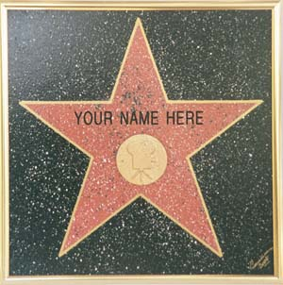
Fame
Year 8
What is fame?

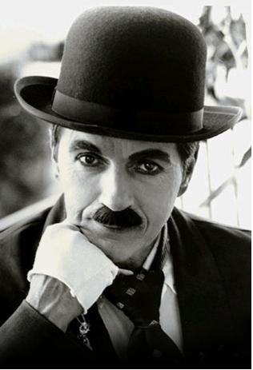
Fame, stardom, celebrity status – what is the difference? This extract, from a book about fame in the 21st century, analyses how the idea of fame has changed in the last 200 years.
Charlie Chaplin, the famous actor
Fame – everyone seems to want it. Of course there are those who try to avoid being in the spotlight. But on the whole, people are keen to be the centre of media attention and are impressed by other people who are in the public eye. Celebrities and celebrity TV programmes, magazines and other products are now a multi-million pound business. So, how did we end up here? What is fame and why do people want it?
Famous people in the 19th century were those who gained recognition for what they achieved. These individuals included distinguished engineers such as Brunel, or writers such as Dickens. The public were interested in what they did but not necessarily in their personal lives.
In the 20th century public interest in the lives of the famous really took off. The popularity of radio alongside the emerging film industry gave rise to a new kind of fame – ‘stardom’. People could hear their favourite actors and actresses on the radio and see them in the cinema every week, and so they became familiar voices and faces. Actors like Charlie Chaplin first became well known for appearing in films but then, as their popularity grew, they became ‘stars’. In other words, they became as famous for being who they were as for doing what they did. The number of people achieving fame increased with the invention of the television because the faces of actors were thrust directly into the family home. As a result, stars of the small screen were created too.
Today, in the 21st century, fame has expanded beyond stardom to include the ‘celebrity’. Celebrities are famous for… being famous. They may have done something initially to get themselves into the public eye, such as appearing on a TV show or marrying a football player, but they are not necessarily talented. Celebrities attract attention because of their glamorous lifestyle; the public are fascinated by what they have and how they live.
Robert Pattinson signs autographs at the premier of Twilight
The growing number of TV channels, the internet and numerous magazines and newspapers not only promote celebrity culture but also depend on it. There are not enough famous people to go round so the same celebrities appear over and over and over again – making them more well known. Celebrity status is something our society aspires to – and nowadays everyone has the opportunity to achieve it. With so-called reality television programmes, ordinary people have instant fame within their grasp, simply by being themselves.

1People flocked to take part in Big Brother
So, has this obsession with fame gone too far? Certainly we seem to be addicted to celebrity culture; people are practically trampled underfoot in the stampede to be in the spotlight and zillions have flocked to join endless queues to take part in reality TV shows like Big Brother and The X Factor – just to appear on TV. Perhaps it has reached the point where fame for doing something worthwhile is less significant than it used to be, because you can be more famous for simply putting yourself in front of a camera.

You are advised to spend no more than 35 minutes on this question.
Answer all three parts of this question – 1(a), 1(b) and 1(c).

1.

(a) From paragraph two (beginning, ‘Famous people in the 19th century were…’ ), write down two different facts about why people were famous.

Fact 1

______________________________________________________________[1] Fact 2

______________________________________________________________[1]
Strand 1 – identify and interpret explicit and information and ideas. Select and synthesise evidence from different texts

(b) In this extract the writer has a negative attitude towards celebrities and reality television programmes.

Complete the table below to explain how the writer shows her negative attitude in each quotation.

Phrase showing a negative attitude towards celebrity and reality TV programmes | The effect of these phrases on the reader
Famous for… being famous  (Paragraph 4) | The writer makes the reader feel that there is no reason for modern celebrities to be famous.

The same celebrities appear over and over and over again

(Paragraph 5)

So-called reality television programmes

(Paragraph 5)

[2]
Strand 2 – explain, comment on and analyse how writers use language to achieve effects and influence readers using relevant subject terminology to support their views

(c) Re-read the passage carefully.

Using your own words as far as possible, outline the main ideas the writer has about how fame has changed from the 19th century to now.

Do not use quotations in your answer.

______________________________________________________________________________________________________________________________________________________________________________________________________________________________________________________________________________________________________________________________________________________________________________________________________________________________________________________________________________________________________________________________________________________________________________________________________________________________________________________________________________________________________________________________________

___________________________________________________________________________________________________________________________________________________________________________________________________________________________________________________________________________________________________________________________________________________________________

___________________________________________________________________________________________________________________________________________________________________________________________________________________________________________________________________________________________________________________________________________________________________

___________________________________________________________________________________________________________________________________________________________________________________________________________________________________________________________________________________________________________________________________________________________________

___________________________________________________________________________________________________________________________________________________________________________________________________________________________________________________________________________________________________________________________________________________________________

___________________________________________________________________________________________________________________________________________________________________________________________________________________________________________________________________________________________________________________________________________________________________

___________________________________________________________________________________________________________________________________________________________________________________________________________________________________________________________________________________________________________________________________________________________________
Strand 4 – identify and compare writers’ ideas and perspectives and how well these are conveyed in texts

[14]
Welcome to the Brit School
At first glance, the neighbourhood appears to be a gloomy jungle of grey tower blocks. And from the outside, the school blends into its dull surroundings. Inside, however, there is a sense of youthful energy and the buzz of non-stop activity. Welcome to the Brit School – fast becoming the heart of Britain’s music industry.
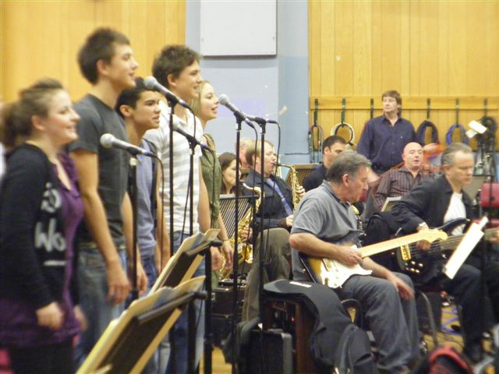
Teenagers are acting and dancing in a state-of-the-art theatre, experimenting in film and video, broadcasting from their own radio station or making music in a digital studio. One group of 16-year-olds is interrogating members of a successful pop group about how to make it in one of the world’s most unpredictable professions.
Students performing at the school
The Brit School for Performing Arts and Technology is jointly funded by the government and the British Record Industry Trust, and students pay no fees. It has grown as a centre of excellence, open to those from all backgrounds. Ella-Louise Brown, a student at the school, says: ‘I want to improve my singing and songwriting. I didn’t come here because I want to be famous; that’s not what it’s about. There is a very special mood here. At breaktimes people are in the corridors singing and playing the guitar together.’
Talents
The school’s aim is to allow students to build on their individual talents. Nick Williams, the Headteacher, says: ‘Pupils are encouraged to explore different musical styles. In Britain, the public has become unadventuous about music. Record producers are cautious about what will sell and what won’t. The music world is becommnig a record factory: we’re more than that. We choose students who care about their academic future – we want them to excel on all fronts.’
Each year the school takes in around 450 young people aged 14 to 16. Students study a full range of subjects along with performing arts courses. Thet are encouraged to gain experience in the industry through workshops, work placements and auditions. They are also taught about the practical side of the music business and are prepared for employment.
Dedication
A caasual visitor is struck by the students’ attitude toward their work; they are dedicated to music and focussed on developing their careers. Tony Castro, the director of music, says: ‘All the students are here because they want to be. We are not about producing cloned singers or overnight celebrities. We want all our students to find the thing that makes them different. We inspire them, give them a hard time and don’t settle for anything less than excellence.’
Leona Lewis is a former pupil at the school
Castro adds: ‘Students have got to be multi-talented if they’re going to have anything more than a five-minute career. We want to find kids with talent wherever thet are and the variety here is staggering. It’s culturally, socially and emotionally diverse. There isn’t a “Brit School tyope”, and that’s the key.’
Adapted from ‘Out of Croydon, the Real Fame Academy’ by David Smith, from The Observer.

You are advised to spend no more than 35 minutes on this question.

Question 2

- How do the presentational features of this article add to its effect on the reader?
You should try to talk about:
- The images chosen;
- The headline and sub-headings.

______________________________________________________________________________________________________________________________________________________________________________________________________________________________________________________________________________________________________________________________________________________________________________________________________________________________________________________________________________________________________________________________________________________________________________________________________________________________________________________________________________________________________________________________________________________________________________________________________________________________________________________________________________________________________________________________________________

[6]

Strand 3 – explain, comment on and analyse how writers use structure to achieve effects and influence readers using relevant subject terminology to support their views

- How does the writer create the impression that the Brit School is an important and exciting place?
In your answer, you should write about:
- The information and examples he gives;
- Some of the words and phrases he uses.

_______________________________________________________________________________________________________________________________________________________________________________________________________________________________________________________________________________________________________________________________________________________________________________________________________________________________________________________________________________________________________________________________________________________________________________________________________________________________________________________________________________________________________________________________________________________________________________________________________________________________________________________________________________________________________________________________________________________________________________________________________________
______________________________________________________________________________________________________________________________________________________________________________________________________________________________________________________________________________________________________________________________________________________________________________________________________________________________________________________________________________________________________________________________________________________________________________________________________________________________________________________________________________________________________________________________________________________________________________________________________________________________________________________________________________________________________________________________________________
_______________________________________________________________________________________________________________________________________________________________________________________________________________________________________________________________________________________________________________________________________________________________________________________________________________________________________________________________________________________________________________________________________________________________________________________________________________________________________________________________________________________________________________________________________________________________________________________________________________________________________________________________________________________________________________________________________________________________________________________________________________
____________________________________________________________________________________________________________________________________________________________________________________________________________________________________________________________________________________________________________________________________________________________________________________________________________________________________________________________________________________________________________________________________________________________________________________________________________________________________________________________________________________________________________________________________________________________________________________________________________

[14]
Strand 2 – explain, comment on and analyse how writers use language to achieve effects and influence readers using relevant subject terminology to support their views
Strand 4 – identify and compare writers’ ideas and perspectives and how well these are conveyed in texts

You are advised to spend no more than 35 minutes on this question.
Writing

3. A local newspaper is featuring a series of stories from local people called ‘My Five Minutes of Fame.’

Write your account for the newspaper about a time when you were ‘famous’ or the centre of attention.

You could write about starring in a school play, scoring the winning goal in a football match, talking a DJ on the radio, having your picture in the local paper or use an idea of your own.

This answer will be marked for writing. Plan your answer using the model drop below and write it carefully. Leave enough time to check through what you have written.
Fame

Paragraph one:
- ________________
- ________________
- ________________
- ________________
Paragraph two:
- ________________
- ________________
- ________________
- ________________

Paragraph three:
- ________________
- ________________
- ________________
- ________________

Paragraph five:
- ________________
- ________________
- ________________
- ________________

Paragraph four:
- ________________
- ________________
- ________________
- ________________

Strand 6 – communicate clearly, effectively and imaginatively, selecting and adapting tone, style and register for different forms, purposes and audiences
Strand 7 – organise information and ideas, using structural and grammatical features to support coherence and cohesion of text

You are advised to spend no more than one hour on this question.
Text development
4. Read the following passage from Harry Potter and the Philosopher’s Stone and then answer the question which follows:
‘Can’t, Tom, I’m on Hogwarts business,’ said Hagrid, clapping his great hand on Harry’s shoulder and making Harry’s knees buckle.
‘Good Lord,’ said the barman, peering at Harry, ‘is this – can this be - ?’
The Leaky Cauldron had suddenly gone completely still and silent.
‘Bless my soul,’ whispered the old barman. ‘Harry Potter … what an honour.’
He hurried out from behind the bar, rushed towards Harry and sized his hand, tears in his eyes.
Harry didn’t know what to say. Everyone was looking at him. The old woman with the pipe was puffing on it without realising it had gone out. Hagrid was beaming.
Then there was a great scraping of chairs and, next moment, Harry found himself shaking hands with everyone in the Leaky Cauldron.
‘Doris Crockford, Mr Potter, can’t believe I’m meeting you at last.’
‘So proud, Mr Potter, I’m just so proud.’
‘Always wanted to shake your hand – I’m all of a flutter.’
‘Delighted, Mr Potter, just can’t tell you. Diggle’s the name, Dedalus Diggle.’

Write a short story that includes at least one of the characters from the extract above. This should be your own story and should describe events that do not happen in the extract.

You could describe Tom the Barman, Doris Crockford or Dedalus Diggle’s feelings about meeting Harry; or a conversation between the two characters; or Harry’s reaction to being famous when he didn’t realise it.
[21]
Strand 6 – communicate clearly, effectively and imaginatively, selecting and adapting tone, style and register for different forms, purposes and audiences
Strand 7 – organise information and ideas, using structural and grammatical features to support coherence and cohesion of text

