KS3 Homework
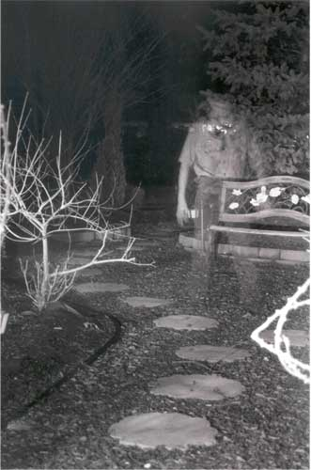
Ghosts
WORK STOPS ON CHINESE GHOST TOWN

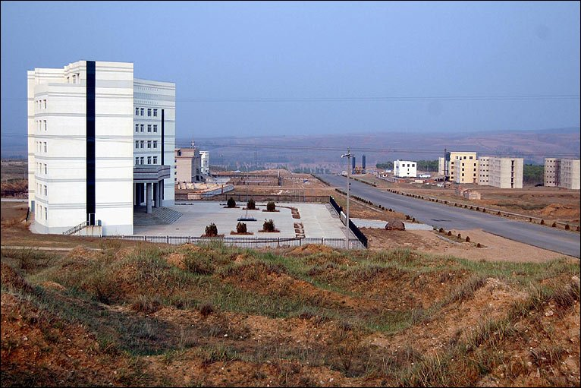
On a series of barren, wind-swept hills in China's Inner Mongolia, a new town stands half-finished and deserted.

Several buildings have been completed; others are empty concrete shells, abandoned by workmen before their job was done.

Wide boulevards stretch out in four directions, but there is little traffic. An occasional tractor potters along what should be busy streets.

This was supposed to be a brand new town, but local leaders who planned it ran out of money long before it was finished.
The town lies empty and unfinished

Thousands of local residents who were supposed to be enjoying new homes, offices and schools are still crammed into the old town.

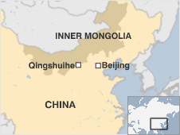
Many of them are angry at the waste of money - millions of dollars are already thought to have been spent on the scheme. All of that is now wasted as it is unlikely that the new town will ever be completely finished.

Chinese media reports said the scheme would have cost more than $6b yuan ($880m, £610m) in total, many times more than the county government's annual expenditure. The project was supposed to take five years to complete.

Qingshuihe was apparently not expecting to foot the entire bill, but local people are still angry at the waste of resources.
The location of the Ghost Town
'No oversight'

One resident, Li Xianrong, said local leaders had sold land and businesses to fund the new town project. However the money wasn’t enough to complete the project.

Now it had no money to spend on other things, such as social welfare programmes or sprucing up the shabby old town, added the 70-year-old. “This project has set us back ten years,” an unhappy Mr. Li said. “We wasted all the money.”
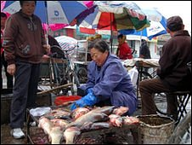
Residents still live in the cramped and shabby old town

"This project has set the town back 10 years. We've even squandered the money we get from the regional and central government. People are very unhappy," said Mr Li.

The new town, which is more than 20km north of the old one, is currently deserted. Construction firms have even taken away some building materials to use on other projects.

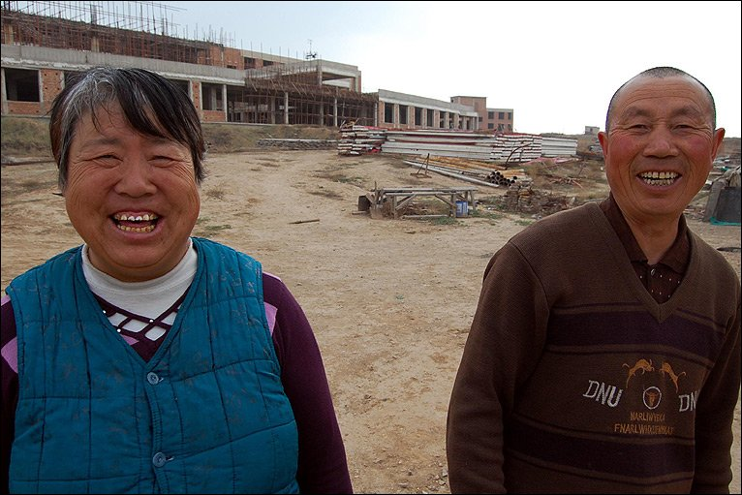
The caretaker Mr. Jing and his wife. They are the only people who live in the town
Caretaker Jing Wen, who watches over a half-finished hotel, said work began on the new town in 2005, but ended two years later - and nothing has happened since.

"All the building work was for nothing," said Mr Jing, who added that he and his wife were the new town's only two residents.

Adapted from an article by Michael Bristow, from www.bbc.co.uk/news.

You are advised to spend no more than 35 minutes on this question.
Answer all three parts of this question – 1(a), 1(b) and 1(c).

1.

(a) From paragraph seven (beginning, ‘Chinese media reports said…’ ), write down two different facts about the building of the town.

Fact 1

______________________________________________________________[1] Fact 2

______________________________________________________________[1]
Strand 1 – identify and interpret explicit and information and ideas. Select and synthesise evidence from different texts

(b) In this extract the writer uses words with negative connotations (suggested meanings) to describe what the town is like.

Complete the table below to explain how the writer shows this positive attitude in each quotation.
Phrase showing a negative view of the Ghost Town | The effect of these phrases on the reader
Barren… hills  (Paragraph 1) | This suggests that the hills are empty and that there is nothing near the town. This makes the reader think it is a lonely place.

Wind-swept

(Paragraph 1)

Half-finished and deserted

(Paragraph 1)

[2]
Strand 2 – explain, comment on and analyse how writers use language to achieve effects and influence readers using relevant subject terminology to support their views

(c) Re-read the passage carefully.

Using your own words as far as possible, why is was the town not finished? What does it mean to the people who should live there?

Do not use quotations in your answer.

______________________________________________________________________________________________________________________________________________________________________________________________________________________________________________________________________________________________________________________________________________________________________________________________________________________________________________________________________________________________________________________________________________________________________________________________________________________________________________________________________________________________________________________________________

___________________________________________________________________________________________________________________________________________________________________________________________________________________________________________________________________________________________________________________________________________________________________

___________________________________________________________________________________________________________________________________________________________________________________________________________________________________________________________________________________________________________________________________________________________________

___________________________________________________________________________________________________________________________________________________________________________________________________________________________________________________________________________________________________________________________________________________________________

___________________________________________________________________________________________________________________________________________________________________________________________________________________________________________________________________________________________________________________________________________________________________

___________________________________________________________________________________________________________________________________________________________________________________________________________________________________________________________________________________________________________________________________________________________________

___________________________________________________________________________________________________________________________________________________________________________________________________________________________________________________________________________________________________________________________________________________________________
Strand 2 – explain, comment on and analyse how writers use language to achieve effects and influence readers using relevant subject terminology to support their views

[14]

The Day of the Dead
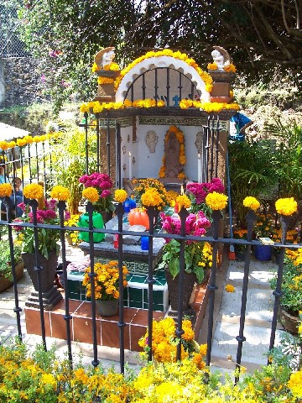
A grave decorated with flowers and offerings during the festival
At first glance, the Mexican custom of El Día de los Muertos — the Day of the Dead — may sound much like our traditional celebration of Halloween. After all, the celebration traditionally starts at midnight the night of October 31st and the festivities are abundant in images related to death.
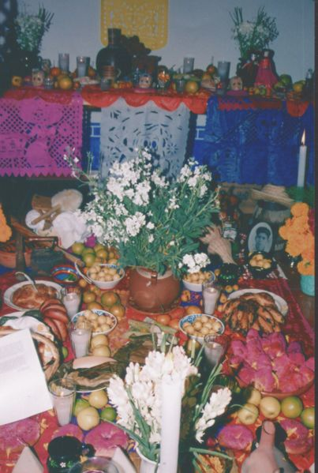
But the customs have different origins, and their attitudes toward death are different. In the typical Halloween festivities, death is something to be feared. We dress up in scary costumes and try to frighten people. We call on houses asking people if they want a trick or a treat. But in the Day of the Dead, death — or at least the memories of those who have died — is something to be celebrated.
An ofrenda of food and gifts
People go to cemeteries and the graves of family members and friends who have died. Once they are there they build alters to put food, drink and items like photographs that remind them of the person. Toys are put on the graves of children (known in the festival as Little Angels), and alcohol is often left for adults. The idea is that this will encourage the souls of the dead to come and visit the family and hear the comments that the living make to them.
People do things to make the spirits feel at home. Large ofrenda of food are prepared. Mexicans believe that the ghosts eat these to get energy (and even when they eat them at the end of the festival they feel they have no taste). One of the most exciting foods is pan de muerto (bread of the dead), which can have a miniature skeleton hidden inside. Pillows and blankets are left outside homes so that the ghosts can rest after their long journey.
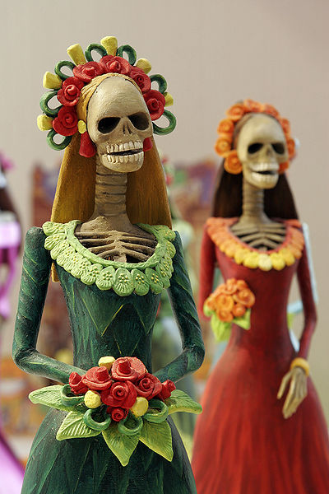
A common symbol used in the celebrations is the skull. People wear skull masks, and make treats in the shape of skulls out of chocolate or sugar. Sugar skulls are a gift that is given to both the living and the dead. Dolls of richly dressed women with skull faces called Catrinas are seen throughout Mexico during the festival.
Images of catrina dolls
This celebration isn’t depressing, it becomes fun when people remember funny or amusing things that happened in the person’s life. On Halloween black is the most popular colour. The Day of the Dead is far more colourful as people celebrate using many bright colours, flowers and costumes. Some people wear shells on their clothes so that their dancing will make a noise and wake the dead.
Unlike Halloween, the Day of the Dead also has religious significance as it is linked to the Catholic Church, which celebrates All Saints Day on November 1st and All Souls Day on November 2nd.
Celebrations like this take place all over the world in lots of cultures where people like to remember family and friends that they have lost.

You are advised to spend no more than 35 minutes on this question.

Question 2

- How do the presentational features of this article add to its effect on the reader?
You should try to talk about:
- The images chosen – what they mean and why they’re important;
- The headline and sub-headings.

______________________________________________________________________________________________________________________________________________________________________________________________________________________________________________________________________________________________________________________________________________________________________________________________________________________________________________________________________________________________________________________________________________________________________________________________________________________________________________________________________________________________________________________________________________________________________________________________________________________________________________________________________________________________________________________________________________

[6]

Strand 3 – explain, comment on and analyse how writers use structure to achieve effects and influence readers using relevant subject terminology to support their views

- How does the writer that the Day of the Dead is a celebration?
In your answer, you should write about:
- The information and examples he gives;
- Some of the words and phrases he uses.

_______________________________________________________________________________________________________________________________________________________________________________________________________________________________________________________________________________________________________________________________________________________________________________________________________________________________________________________________________________________________________________________________________________________________________________________________________________________________________________________________________________________________________________________________________________________________________________________________________________________________________________________________________________________________________________________________________________________________________________________________________________
______________________________________________________________________________________________________________________________________________________________________________________________________________________________________________________________________________________________________________________________________________________________________________________________________________________________________________________________________________________________________________________________________________________________________________________________________________________________________________________________________________________________________________________________________________________________________________________________________________________________________________________________________________________________________________________________________________
_______________________________________________________________________________________________________________________________________________________________________________________________________________________________________________________________________________________________________________________________________________________________________________________________________________________________________________________________________________________________________________________________________________________________________________________________________________________________________________________________________________________________________________________________________________________________________________________________________________________________________________________________________________________________________________________________________________________________________________________________________________
____________________________________________________________________________________________________________________________________________________________________________________________________________________________________________________________________________________________________________________________________________________________________________________________________________________________________________________________________________________________________________________________________________________________________________________________________________________________________________________________________________________________________________________________________________________________________________________________________________

[14]
Strand 2 – explain, comment on and analyse how writers use language to achieve effects and influence readers using relevant subject terminology to support their views
Strand 4 – identify and compare writers’ ideas and perspectives and how well these are conveyed in texts

You are advised to spend no more than 35 minutes on this question.
Writing

3. From time to time all of us get frightened by things. Whether it is something big or small, we’ve all felt scared.

Write a dairy entry describing a time you were really scared.

You could write about what happened, including where you were, what you were doing and who you were with. Also describe how the fear affected you, physically and mentally.

This answer will be marked for writing. Plan your answer using the model drop below and write it carefully. Leave enough time to check through what you have written.
Fear

Paragraph one:
- ________________
- ________________
- ________________
- ________________
Paragraph two:
- ________________
- ________________
- ________________
- ________________

Paragraph three:
- ________________
- ________________
- ________________
- ________________

Paragraph five:
- ________________
- ________________
- ________________
- ________________

Paragraph four:
- ________________
- ________________
- ________________
- ________________

Strand 6 – communicate clearly, effectively and imaginatively, selecting and adapting tone, style and register for different forms, purposes and audiences
Strand 7 – organise information and ideas, using structural and grammatical features to support coherence and cohesion of text

You are advised to spend no more than one hour on this question.
Text development
4. Read the following passage from Skellig by David Almond and then answer the question which follows:
I hardly slept that night. Every time I did drop off I saw him coming out of the garage door and coming through the wilderness to the house. I saw him in my bedroom. I saw him come right to the bed. He stood there all dusty and white with the dead bluebottles all over him.

‘What do you want?’ he whispered. ‘I said, what do you want?’

I told myself I was stupid. I’d never seen him at all. That had all been part of a dream as well. I lay there in the dark. I heard Dad snoring and when I listened hard I could hear the baby breathing. Her breathing was cracked and hissy. In the middle of the night when it was pitch black I dropped off again but she started bawling. I heard Mum getting up to feed her. I heard Mum’s voive cooing and comforting. Then there was just silence again and Dad’s snoring again. I listened hard for the baby again and I couldn’t hear her.

It was already getting light when I got up…

Write a short story that includes at least one of the characters from the extract above. This should be your own story and should describe events that do not happen in the extract.

You could describe why Michael has the bad dream, who the ghostly figure was and what he wanted. Or you could describe the figure visiting his Dad, Mum or baby sister. Or you could make something else up of your choice.
[21]
Strand 6 – communicate clearly, effectively and imaginatively, selecting and adapting tone, style and register for different forms, purposes and audiences
Strand 7 – organise information and ideas, using structural and grammatical features to support coherence and cohesion of text

