KS3 Homework
Aliens

UFOs? Aliens? Area 51 Revealed

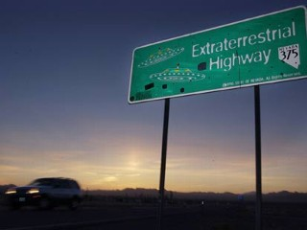
Nevada State Route 375 - "Extraterrestrial Highway"
It's the centrepiece of virtually every modern UFO theory and a symbol for everything governments don't tell us.

About an hour's bus ride or 83km northwest of Las Vegas, Area 51 is one of the most famous military bases in the world. This is because the American government barely acknowledges the existence of the base, also known as Dream Land and Paradise Ranch. According to UFO lore, Area 51 (near Nevada State Route 375, otherwise known as "Extraterrestrial Highway") is where the Pentagon has, for decades, stored frozen extraterrestrials and recovered alien spacecraft. In the movie "Independence Day," it was where the heroes led a final attack against alien invaders.
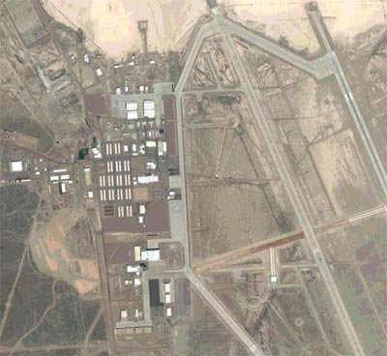
A satellite image of the site
But now the Central Intelligence Agency, CIA, has started to declassify top secret programs developed at Area 51. Former military officers and engineers are beginning to shed some light on the enigmatic airfield and give the UFOlogists some new information to consider.
"No one really knew we existed," said Thornton "T.D." Barnes, aged 72. He was a former special-projects engineer at Area 51. "Even our wives didn't know where we were going when we left Monday morning and came back Friday evening."
A specialist in advance radar and Soviet MiG fighter aircraft, Barnes said he was recruited by the CIA to join a team of experts that could handle any kind of military project.

People Reported Seeing Flashes of Light

As an electronics engineer for NASA, he worked on the country's first rocket plane, the X-15, the Apollo space capsule and lunar lander research vehicles.
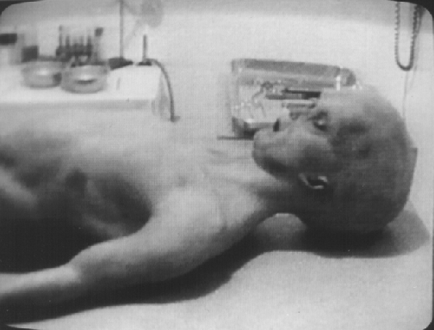
At Area 51, he helped develop the A-12 OXCART, a super-secret spy plane built by the Lockheed Corporation. Barnes said his colleagues conducted 2,850 test flights of the A-12 out of Area 51.
An image from the famous Alien Autopsy video that is supposed to have happened at Area 51
Travelling 2,200 mph at 90,000 feet, nothing could catch the planes. But, he said, people would see flashes of light. That is what he thinks started the rumours of an extraterrestrial safe haven.
In some ways, Barnes said, the UFO myths actually helped keep the site's true activities under wraps.
"We considered it to be a bonus," he said. "They made it easier to conceal what we were doing." If anything, he emphasized, "We were the UFOs."
No ETs, No Alien Spacecraft, No Underground Tunnels?
In reality, he said, compared to previous positions with frequent missions, "Area 51 was the most boring place I ever worked. There were no aliens, no spacecraft from far-flung planets, no underground passageways.” In fact, new documents show that the only underground area he recalled was beneath a nuclear testing site at neighbouring Jackass Flats.
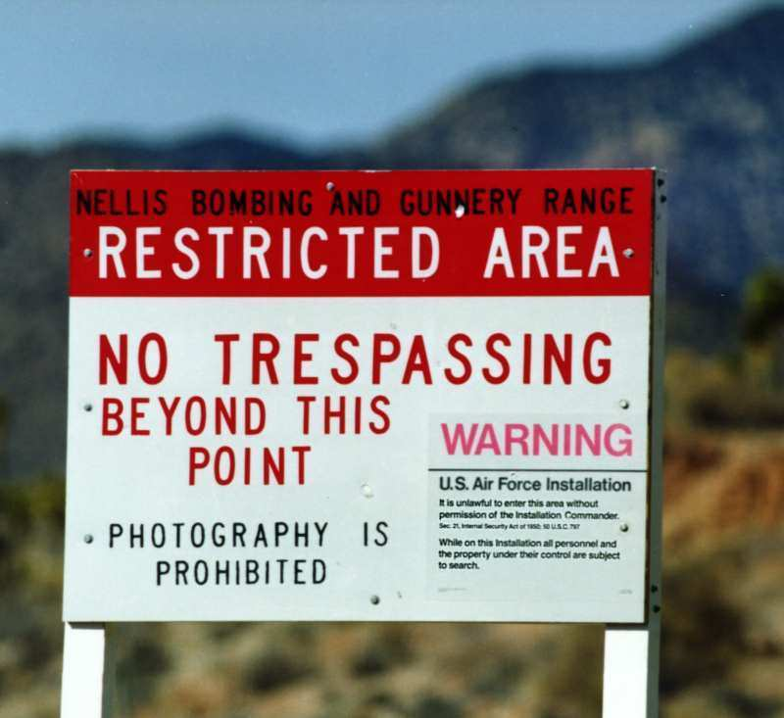
Maybe They Just Didn't Know
A keep out sign - does the American government have something to hide?
Harry A. Martin, 77, who supervised the fuelling of the spy planes for four years, said his time at Area 51 was also one of the highlights of his career.
"I was real proud of what we accomplished," he said. "I'd never worked with a group of people who were better than those."
As for the aliens and UFOs, "people have an imagination," he said. "We laughed at it."
But some UFO experts say the former insiders' accounts don't necessarily eliminate the possibility that Area 51 is indeed home to some UFO-related activities.
"Those guys who came forward may very well be telling the truth, with the caveat that they wouldn't know if there was something going on," said Stanton T. Friedman, a nuclear physicist, lecturer and top UFO researcher. “The absence of evidence of UFOs on their part doesn’t mean there isn’t anything hidden.”
Friedman said it's still conceivable that wreckage from what some people believe was a UFO crash in Roswell, N.M., could have been transported to Area 51. And, he added, "of course" the military has an underground base out there.

Related
But, regardless of whether or not Area 51 is indeed connected to UFO activities, Friedman pointed out that the facility has captured the imagination of Americans for another important reason. It has become a symbol of government secrets and the universe of information too sensitive for public consumption.
As a scientist for who has worked for lots of famous high-tech companies, Friedman said he's worked on a variety of classified projects that have shown him government secrets are a fact of life.
Area 51 is just one example of that.
"National security has a real place in all of this stuff. There is no way to tell your friends without telling your enemies," he said. "A lot of Americans woke up to the fact that there's a lot going on that they don't get told about."

You are advised to spend no more than 35 minutes on this question.
Answer all three parts of this question – 1(a), 1(b) and 1(c).

1.

(a) From paragraph two (beginning, ‘About an hour’s bus ride…’ ), write down two different facts about the base.
Strand 1 – identify and interpret explicit and information and ideas. Select and synthesise evidence from different texts

Fact 1

______________________________________________________________[1] Fact 2

______________________________________________________________[1]

(b) In this extract the writer uses words that suggest that people believed there were things hidden at Area 51.

Complete the table below to explain how the writer shows these ideas in each quotation.

Phrase showing there might be something to hide in Area 51 | The effect of these phrases on the reader
The enigmatic airfield  (Paragraph 3) | The word enigmatic suggests a mystery, making the reader think that the government are hiding something at the base.

Shed some light

(Paragraph 3)

UFO myths actually helped

(Paragraph 9)

[2]
Strand 2 – explain, comment on and analyse how writers use language to achieve effects and influence readers using relevant subject terminology to support their views

(c) Re-read the passage carefully.

Using your own words as far as possible, outline what does the writer thinks Area 51 was used for.

Do not use quotations in your answer.

______________________________________________________________________________________________________________________________________________________________________________________________________________________________________________________________________________________________________________________________________________________________________________________________________________________________________________________________________________________________________________________________________________________________________________________________________________________________________________________________________________________________________________________________________

___________________________________________________________________________________________________________________________________________________________________________________________________________________________________________________________________________________________________________________________________________________________________

___________________________________________________________________________________________________________________________________________________________________________________________________________________________________________________________________________________________________________________________________________________________________

___________________________________________________________________________________________________________________________________________________________________________________________________________________________________________________________________________________________________________________________________________________________________

___________________________________________________________________________________________________________________________________________________________________________________________________________________________________________________________________________________________________________________________________________________________________

___________________________________________________________________________________________________________________________________________________________________________________________________________________________________________________________________________________________________________________________________________________________________

___________________________________________________________________________________________________________________________________________________________________________________________________________________________________________________________________________________________________________________________________________________________________
Strand 2 – explain, comment on and analyse how writers use language to achieve effects and influence readers using relevant subject terminology to support their views

[14]
Aliens – are they out there?
One common thread with most Sci-Fi films and television shows is that the universe is full of alien life (and they all speak English), so just how realistic is this?
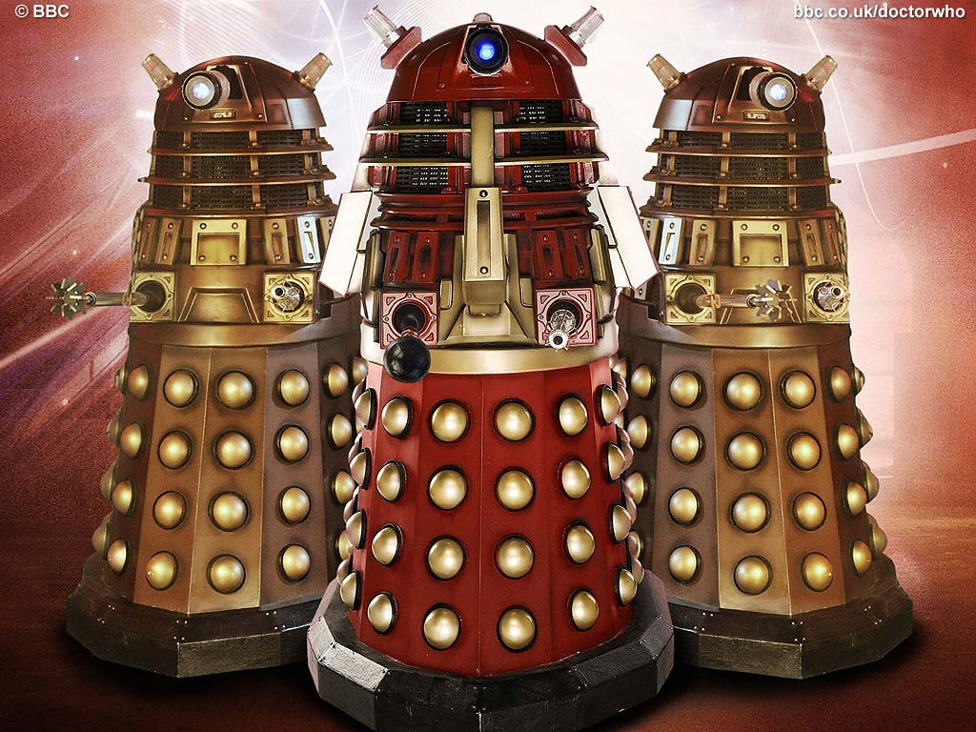
There is an unimaginably huge number of planets in our galaxy, and there are billions of galaxies in the Universe. The probability that there is life on other planets must be high, although the probability of them speaking English has got to be pretty low. Seriously, the question should be not whether there is life on other planets, but whether there is intelligent life on other planets.
The Daleks were created by Terry Nation. Are there real aliens out there?
We believe if the conditions are right, then life will spontaneously appear. That life will continue to evolve and develop in complexity over time until the life matches the needs of the environment. For example dinosaurs were the dominant species on Earth for millions of years, compared with hardly any time at all for humans. However, they never evolved any significant levels of intelligence. They didn't need to. Man learnt to walk upright, freeing his hands to use tools. He had the need to think, to plan, to develop strategies for survival. Man became intelligent. Now don't get confused between intelligence and technology; a cave man, a Roman soldier and a "modern" man are all just as intelligent. The difference between them is time - the time needed to develop technology, to record progress for future generations and the desire to discover.
What about aliens? The same applies.
Some people think that aliens might be friendly and help us.
If the conditions are right on a planet then we believe life will emerge. Whether the life will become intelligent will depend on the environment and the needs of the life form. How intelligent they become will depend on the time they have - just imagine a civilisation that was technologically as advanced as us now a million years. We could not even begin to imagined what they could be like now (we believe that at that level of technology their biological processes will be blended with technological innovations, so that the two are merged together, but that is just our opinion).
Civilisations will have a life span, some could swing between technological brilliance and the stone age. The reasons could be natural disasters (the probability of a large meteor hitting the Earth is small but over 100,000 years the chances don't look so good), wars, diseases, or even self destruction. Even so, the universe is sufficiently large that we believe there are alien worlds out there right now which have a wide range of technological abilities, from planets where the highest form of life is bacteria to planets with such advanced technology we could not even begin to imagine.

Have Aliens ever visited Earth?
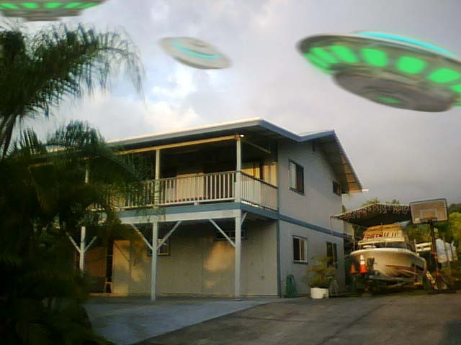
Assuming there are civilisations out there sufficiently technologically advanced to travel here (no mean feat), and they know we are here (the galaxy is a big place and we are a very small planet), then it is possible they could have visited Earth. We do not think it is at all likely for the following reasons:
1. Even with our current level of technology we are watching the sky very closely. Indeed, we have just photographed planets from Earth (nothing the size of Earth yet, but in time). We could soon be approaching the stage where we will be able to see evidence of extraterrestrial activity - so far we're seen nothing in our neighbourhood. Don't forget though, when looking out into space we're also looking back into time !
While some people think that aliens would be hostile.
2. It's our opinion that if an alien race did come here then they would let themselves be known. I have heard arguments, mainly drawn from Sci-Fi, that they would merely watch and observe us, but we don't think so. We think it will be a global event, if it ever happened.

Adapted from http://www.scifiscience.co.uk/themes/aliens.html.

You are advised to spend no more than 35 minutes on this question.

Question 2

- How do the presentational features of this article add to its effect on the reader?
You should try to talk about:
- The images chosen;
- The headline and sub-headings.

______________________________________________________________________________________________________________________________________________________________________________________________________________________________________________________________________________________________________________________________________________________________________________________________________________________________________________________________________________________________________________________________________________________________________________________________________________________________________________________________________________________________________________________________________________________________________________________________________________________________________________________________________________________________________________________________________________

[6]

Strand 3 – explain, comment on and analyse how writers use structure to achieve effects and influence readers using relevant subject terminology to support their views

- How does the writer persuade the reader that aliens might exist?
In your answer, you should write about:
- The information and examples he gives;
- Some of the words and phrases he uses.

_______________________________________________________________________________________________________________________________________________________________________________________________________________________________________________________________________________________________________________________________________________________________________________________________________________________________________________________________________________________________________________________________________________________________________________________________________________________________________________________________________________________________________________________________________________________________________________________________________________________________________________________________________________________________________________________________________________________________________________________________________________
______________________________________________________________________________________________________________________________________________________________________________________________________________________________________________________________________________________________________________________________________________________________________________________________________________________________________________________________________________________________________________________________________________________________________________________________________________________________________________________________________________________________________________________________________________________________________________________________________________________________________________________________________________________________________________________________________________
_______________________________________________________________________________________________________________________________________________________________________________________________________________________________________________________________________________________________________________________________________________________________________________________________________________________________________________________________________________________________________________________________________________________________________________________________________________________________________________________________________________________________________________________________________________________________________________________________________________________________________________________________________________________________________________________________________________________________________________________________________________
__________________________________________________________________________________________________________________________________________________________________________________________________________________________________________________________________________________________________________________________________________________________________________________________________________________________________________________________________________________________________________________________________________________________________________________________________________________________________________________________________________________________________________________________________________________________________________________________________________
[14]
Strand 2 – explain, comment on and analyse how writers use language to achieve effects and influence readers using relevant subject terminology to support their views
Strand 5 – show understanding of the relationships between texts and the contexts in which they were written

You are advised to spend no more than 35 minutes on this question.
Writing

3. A local newspaper is featuring a series of stories from local people called ‘You Wouldn’t Believe It Could Happen.’

Write the words of an article describing an experience that people would find hard to believe.

You could write about a mystery that interests you, an experience you’ve had that is hard to believe (e.g. seen a ghost or alien) or anything of your choice. If you haven’t experienced anything unbelievable you can make something up.

This answer will be marked for writing. Plan your answer using the model drop below and write it carefully. Leave enough time to check through what you have written.
Unbelievable

Paragraph one:
- ________________
- ________________
- ________________
- ________________
Paragraph two:
- ________________
- ________________
- ________________
- ________________

Paragraph three:
- ________________
- ________________
- ________________
- ________________

Paragraph five:
- ________________
- ________________
- ________________
- ________________

Paragraph four:
- ________________
- ________________
- ________________
- ________________

Strand 6 – communicate clearly, effectively and imaginatively, selecting and adapting tone, style and register for different forms, purposes and audiences

Strand 7 – organise information and ideas, using structural and grammatical features to support coherence and cohesion of text (AO5)
Strand 8 – use a range of vocabulary and sentence structures for clarity, purpose and effect, with accurate spelling and punctuation (AO6)
You are advised to spend no more than one hour on this question.
Text development
4. Read the following passage from The War of the Worlds by HG Wells and then answer the question which follows:
A sudden chill came over me. There was a loud shriek from a woman behind. I half turned, keeping my eyes fixed on the cylinder still, from which other tentacles were now projecting, and began pushing my way back from the edge of the pit. I saw astonishment giving place to horror on the faces of the people about me...

A big greyish rounded bulk, the size, perhaps of a bear, was rising slowly and painfully out of the cylinder. As it bulged up and caught the light, it glistened like wet leather.

Two large dark-coloured eyes were regarding me...

Write a short story that based on the extract above. This should be your own story and should describe events that do not happen in the extract.

You could describe what happens when the alien leaves the cylinder, or the reactions of the crowd or the narrator.
[21]
Strand 6 – communicate clearly, effectively and imaginatively, selecting and adapting tone, style and register for different forms, purposes and audiences

Strand 7 – organise information and ideas, using structural and grammatical features to support coherence and cohesion of text (AO5)
Strand 8 – use a range of vocabulary and sentence structures for clarity, purpose and effect, with accurate spelling and punctuation (AO6)

