Year 9 and 10 Revision Name………………………………………
Standard form and Indices

Expanding and Factorising including quadratics

Factorise:
- x² + 6x + 8 2) x² + 8x + 15 3) x² + 9x + 20

4) x² + 8x + 7 5) x² + 10x + 16 6) x² + 6x - 7

7) x² + x – 6 8) x² + 9x + 20 9) x² - 2x - 35

Solving Equations and Inequalities

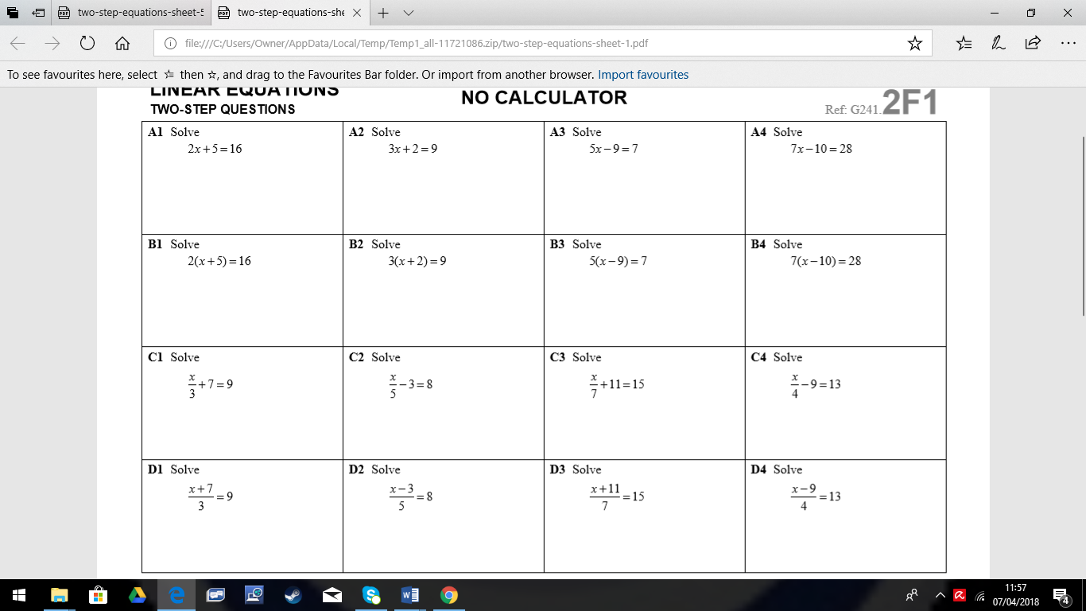

Rearranging Formulae

Make y the subject of the following formulae:
- Ay=c

- y + gb=s

- y – h2 = p

- y + c +r = s

- y + r = 3r

Pythagoras’ Theorem and Trigonometry

Rounding and Estimation

- Round each of the following numbers to 1 significant figure:

- 46, 313 ________________ i. 0.04785 _________________

- 57,123 ________________ j. 0.000876 _________________

- 30,569 ________________ k. 9.9 _________________

- 94,558 ________________ l. 89.5 _________________

- 85,299 ________________ m. 90.78 _________________

- 0.5388 ________________ n. 199 _________________

- 0.2823 ________________ o. 999.99 _________________

- 0.00584 ________________

- Round each of the following numbers to 2 significant figures:

- 56,147 _________________ i. 8.0089 __________________

- 26,813 _________________ j. 41.564 __________________

- 79,611 _________________ k. 0.8006 __________________

- 30,578 _________________ l. 0.458 __________________

- 14,009 _________________ m. 0.0658 __________________

- 1.689 _________________ n. 0.9996 __________________

- 4.0854 _________________ o. 0.00982 _________________

- 2.658 _________________

- Round each of the following to the certain number of significant figures

a. 57,402 (1sf) _______________ g. 0.261 (1sf) _______________

b. 5288 (1sf) _______________ h. 0.732 (1sf) _______________

c. 89.67 (3sf) _______________ i. 0.42 (1sf) _______________

d. 105.6 (2sf) _______________ j. 0.758 (1sf) _______________

e. 8.69 (1sf) _______________ k. 0.185 (1sf) _______________

f. 1.087 (2sf) _______________ l. 0.682 (1sf) _______________

- Find approximate answers to the following:

- 5,435 x 7.31 _________________ d. 354 ÷ 79.8 _________________

- 5,280 x 3.211 _________________ e. 5,974 ÷ 5.29 _________________

- 63.24 x 3.514 x 4.2 _________________ f. 208 ÷ 0.378 _________________

Ratio and proportion

Volume

Similar Shapes including area

Probability

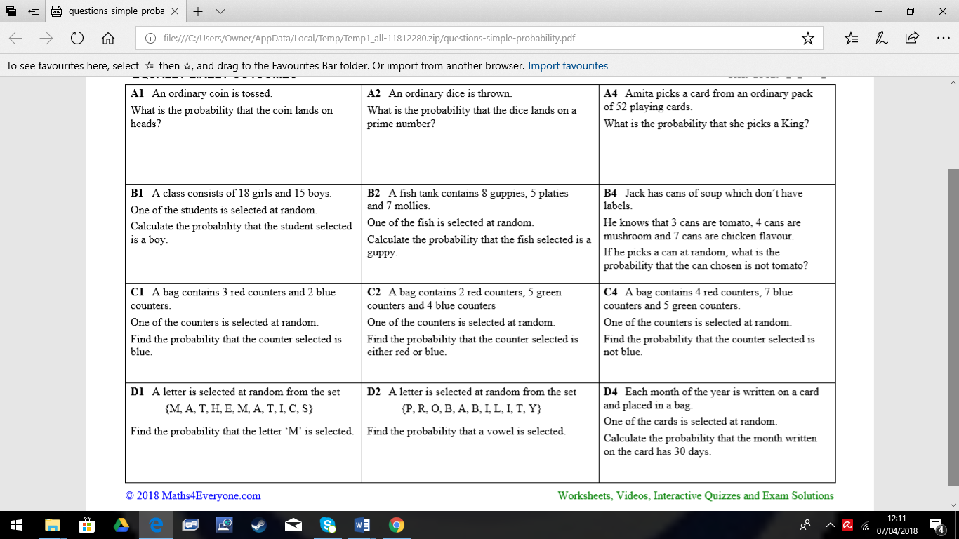

Averages from grouped data

- The lifetime of 100 batteries are shown in the table below. Calculate an estimate of the mean, the class in which the median lies and state the modal class.

Time (hours) | 0< x ≤3 | 3< x ≤6 | 6< x ≤9 | 9< x ≤12 | 12< x ≤15 | 15< x ≤18 | 18< x ≤21
Frequency | 2 | 3 | 16 | 34 | 27 | 13 | 5

- The grouped frequency table shows information about the number of hours worked by each of 200 head teachers in one week. Calculate an estimate of the mean, the class in which the median lies and state the modal class.

Number of hours  worked (t) | Frequency
0< t ≤ 30 | 0
30< t ≤ 40 | 4
40< t ≤ 50 | 18
50< t ≤ 60 | 68
60< t ≤ 70 | 79
70< t ≤ 80 | 31

Simultaneous equations

Elimination

Substitution
 | Equations | Solve by substituting for first unknown | Solve by substituting for remaining unknown | CHECK by substituting
3x – y = 1
y = 2x
x + 2y = 15
y = 2x
2x + y = 17
y = 6x + 1
3x + 2y = 4
x = y – 2

Sequences

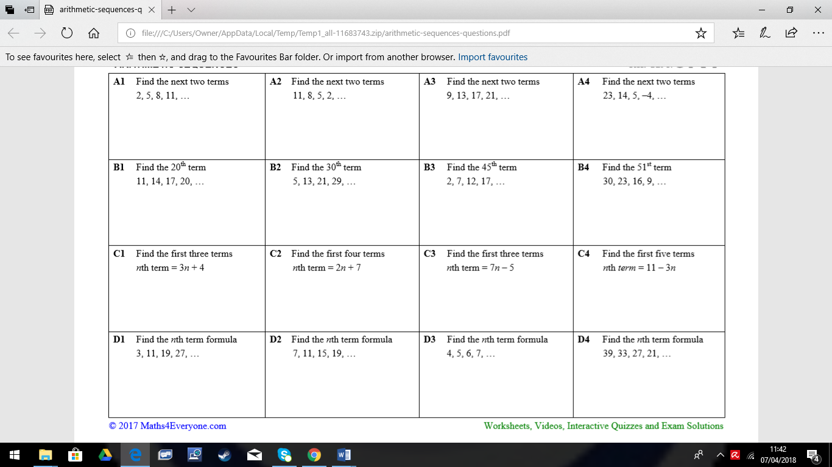

Upper and lower bounds

Percentages

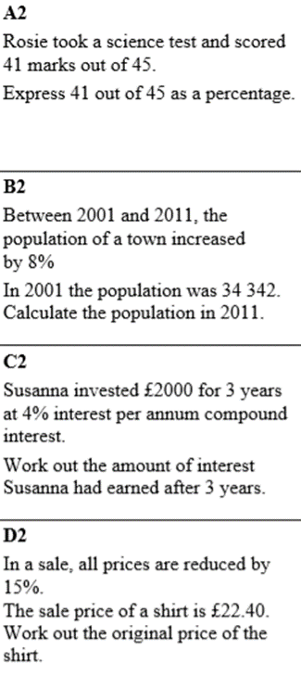

Frequency polygons

- The table shows the age in years of 60 people.
  - On the grid, draw a frequency polygon for the information in the table.
Age (in years) | Frequency
0 < a ≤ 10 | 5
10 < a ≤ 20 | 14
20 < a ≤ 30 | 12
30 < a ≤ 40 | 10
40 < a ≤ 50 | 7
50 < a ≤ 60 | 4
60 < a ≤ 70 | 8

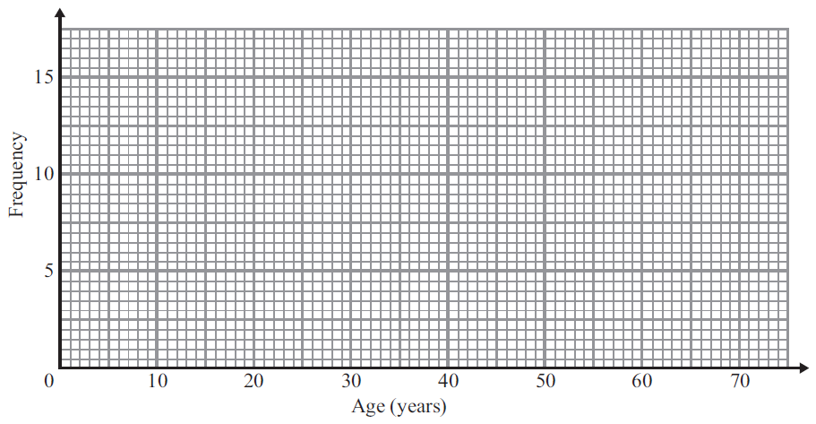

- Sean and Sarah are telephone sales assistants.
The length and frequency of the telephone calls made by them during one day are shown in the table.
Length, t (minutes) | Sean  Frequency | Sarah  Frequency
0 < a ≤ 2 | 0 | 15
2 < a ≤ 4 | 35 | 26
4 < a ≤ 6 | 48 | 37
6 < a ≤ 8 | 32 | 40
8 < a ≤ 10 | 0 | 4
  - Draw a frequency polygon for this data.
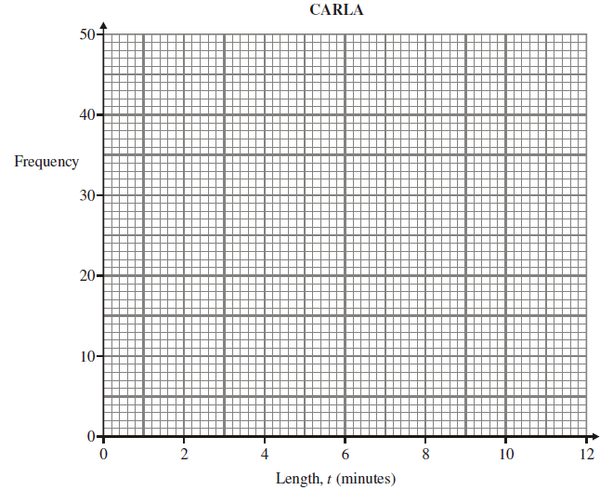

Enlargement

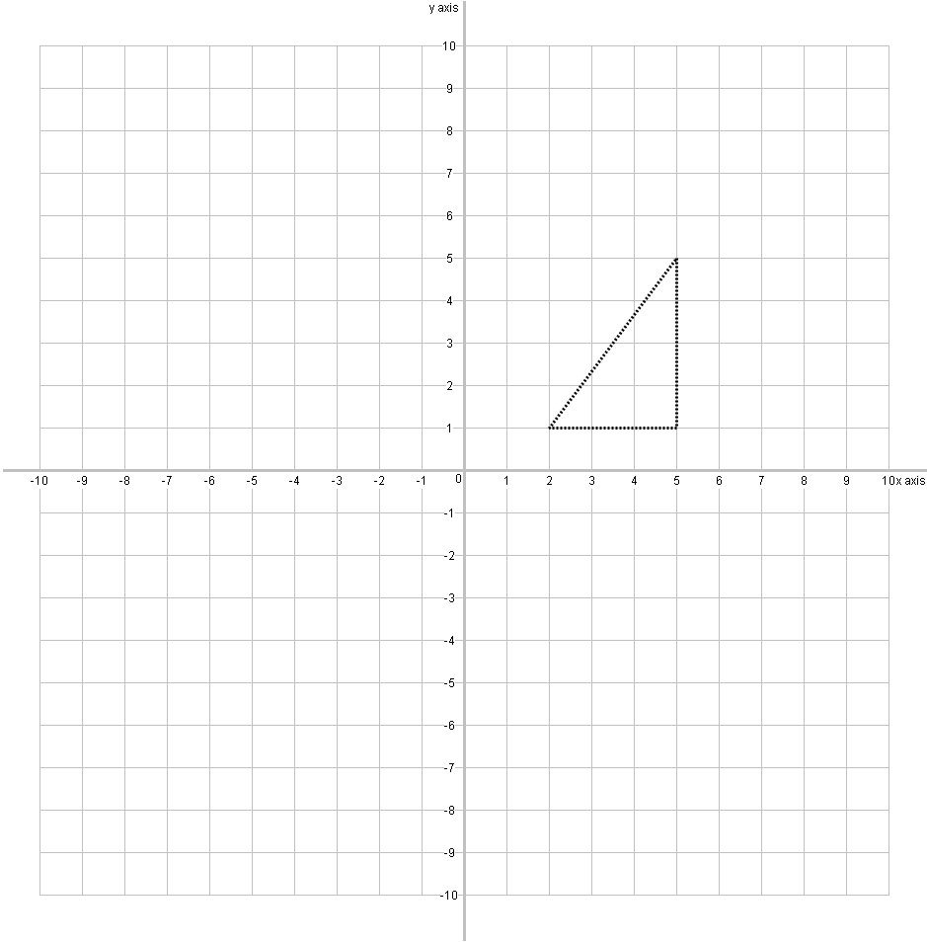
Enlarge by scale factor
2

Centre of enlargement (0,0)

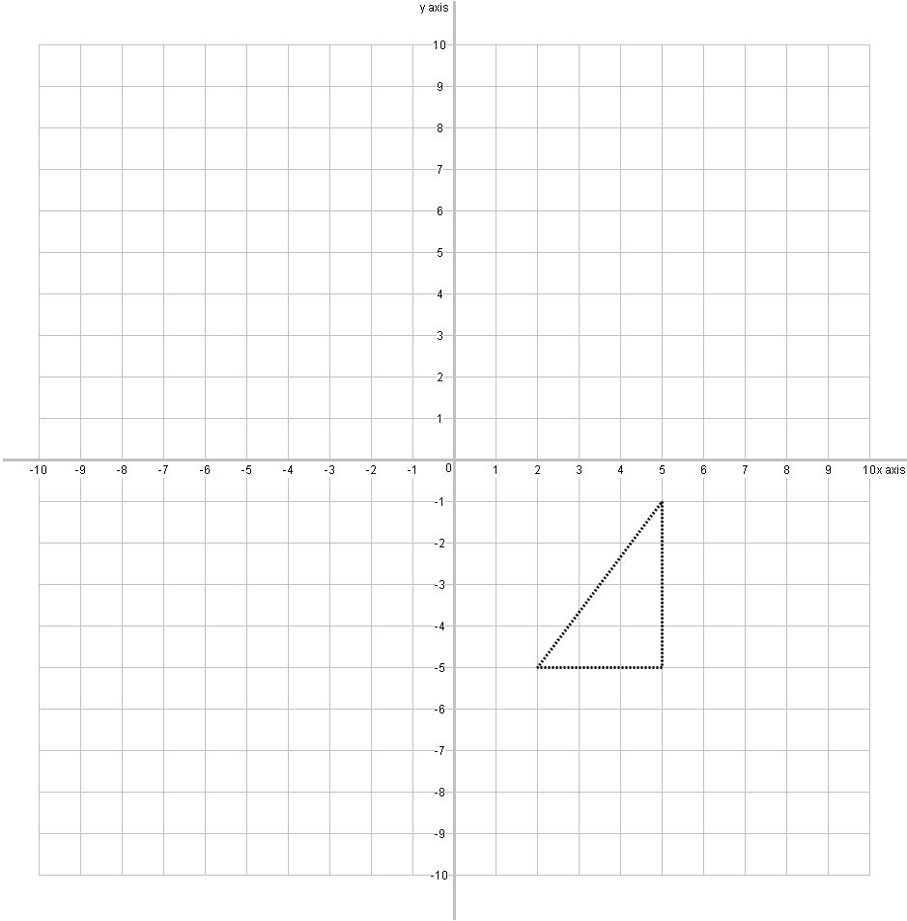

Enlarge by scale factor
3

Centre of enlargement (7,-6)

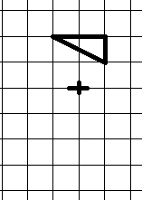

Enlarge by Scale factor -2 from the centre marked

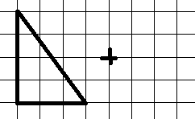Enlarge by Scale factor –$\frac{1}{2}$ from the centre marked
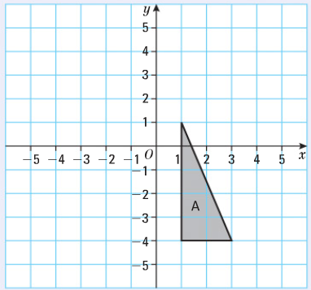
Scale factor -1/2, centre (-1,-2)

