Year 9 Work – Please complete on paper
If you are unsure on any topics please use the PIXL Maths App. Please mark your work as you complete each section.
Any issues please email your teacher.

School Id: MF2916
Login : Surnames and initial (Joe Bloggs = BloggsJ)
Password: PASSWORD

NUMBER
Prime numbers

Square numbers Square roots

Cube numbers Cube roots

Multiples Factors

LCM HCF

Product of prime factors

4 RULES OF NUMBER

1)
Here is a list of eight numbers
4 5 4 25 29 30 33 39 40
From the list, write down
(i) a factor of 20 . . . . . . . . . . . . . . . . . . . . . .
(ii) a multiple of 10 . . . . . . . . . . . . . . . . . . . . . .
(iii) the prime number that is greater than 15 . . . . . . . . . . . . . . . . . . . . . .

2)
Veena bought some food for a barbecue. She is going to make some hot dogs.
She needs a bread roll and a sausage for each hot dog.
There are 40 bread rolls in a pack. There are 24 sausages in a pack.
Veena bought exactly the same number of bread rolls and sausages.
(i) How many packs of bread rolls and packs of sausages did she buy?

. . . . . . . . . . . . . . . . . . . . . . packs of bread rolls
. . . . . . . . . . . . . . . . . . . . . . packs of sausages.
(ii) How many hot dogs can she make?

..............................................................................................................................................

3)
Here is a list of numbers.
1 | 2 | 4 | 5 | 7 | 11 | 13 | 14 | 15 | 17
From the list, write down three different prime numbers that add together to make 20

..............................................................................................................................................

4)(a) Write down the value of .....................................................................

(b) Write down the cube of 3 ..........................................................................

5)
(a) Write down the value of 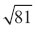 . . . . . . . . . . . . . . . . . . . . . .

(b) Work out the value of 5² + 2³ . . . . . . . . . . . . . . . . . . . . . .

6)
(a) Write down the value of 7² ..........................................................................................

(b) Write down the value of .............................................................................................

(c) Write down the value of 2³ .........................................................................

problems with all four operations

1) Mrs Orange decides to share her savings between her six grandchildren. She has £350 in her savings tin and £1450 in her savings account. How much will each of her grandchildren get?

2) Green lollipops come in packs of 5, yellow lollipops come in packs of 6 and blue lollipops come in packs of 4. A school buys 32 packs of blue lollipops and 18 packs of green lollipops. How many lollipops will they buy altogether?

3) The baker’s oven can bake 28 loaves of bread at a time. In a day, it can go through 30 full bakes. How many loaves of bread would be baked after 1 week?

4) Ms Purple sells cars for a living. In one day, she sells 2 blue cars (at £4500 each), 7 yellow cars (at £6000 each) and 12 black cars (at £8000 each). How much money does she take in car sales in that one day?

5) Coaches carry 58 people. A school decides to take its 300 pupils and 38 staff on a visit to the beach. A single coach costs £128. How much will the total cost of the coaches come to?

RATIO, PROPORTION AND BEST BUYS
Questions: | Answers:
Simplify
a) 3 : 6
b) 15 : 5
c) 12 : 36
d) 16 : 56
e) 20 : 44
f) 18 : 81
g) 5 : 10
h) 12 : 18
i) 26 : 52
j) 21 : 28
k) 15 : 55
l) 24 : 56

Fill in the blanks to find the equivalent ratios.  a) 3 : 6 = 6 : ......  b) …... : 5 = 30 : 10  c) 18 : 4 = …... : 2  d) 3 : 5 = 15 : ……  e) 1 : 6 = …… : 18  f) 5 : 13 = …… : 26  g) 5 : …… = 30 : 6  h) …… : 9 = 6 : 27 | i) 2 : 17 = 4 : ……  j) 23 : 7 = …… : 14  k) 150 : 50 = 15 : ……  l) 7 : …… = 49 : 70  m) …… : 13 = 30 : 39
- There are 32 pupils in a class. 20 of them are girls. What is the ratio of boys to girls in its simplest form?

- A fruit drink is made by mixing 60ml of orange juice with 180ml of pineapple juice. What is the ratio of orange juice to pineapple juice in its simplest form?
- There are 50 sweets in a mixed pack. 25 are jellies, 10 are fizzy cola bottles and the rest are boiled. Write the ratio of each type of sweet in its simplest form.
- Concrete is made by mixing sand, water and concrete mix in the ratio of 6 parts sand, 3 parts water and 3 parts concrete mix. What ratio is this in its simplest form?

Divide in these ratios.
- Divide £50 into the ratio 1 : 4
- Divide 40 litres into the ratio 1 : 3
- Divide 500g into the ratio 2 : 3
- Divide £10 in the ratio 2 : 3
- Divide 100ml into the ratio 3 : 7
- Divide 30cm into the ratio 2 : 4

- Mr Martin has 120 CDs. The ratio of indie CDs to dance CDs is 5 : 7. How many of each type of CD does he have? | - Mr Martin has 36 calculators in a box. The ratio of ordinary calculators to scientific is 5 : 1. How many of each calculator does he have?
- There are 1400 students in Plantsbrook School with a ratio of 4 : 3 boys to girls. How many boys and how many girls are there? | 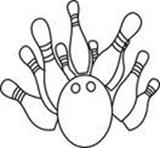  - 180 people go bowling, the ratio of adults to children is 5 : 4. How many adults and how many children go bowling?
Proportion

- An orange drink is made using one part orange juice to 4 parts water. How many litres of orange juice and water are needed to make:
  - 5 litres of orange drink?
  - 20 litres of orange drink?

- A supermarket uses ¾ of its space for food and the rest to non-food items. It had 100 square metres for food items. How many square metres did it have for food?

- A green paint is made by mixing three parts of blue paint with seven parts of yellow paint. How many litres of blue and yellow paint are needed to make:
  - 20 litres of green paint?
  - 5 litres of green paint?

- 5 miles is approximately 8km.
  - How many miles are equal to 24km?
  - How many km are equal to 25 miles?

- 30cm is approximately 1 foot. Approximately how many feet are there in:
  - 120cm?
  - 15cm?
  - 45cm?

- Four cakes cost £10. How much will twelve cakes cost?

- Six towels cost £18. What will three towels cost?

- Ten candles cost £12. What will fifteen candles cost?

- A lorry travels at 60 miles per hour on the motorway.
  - How far will it travel in 3 hours?
  - How far will it travel in 15 minutes?
  - How far will it travel in 3 hours and 15 minutes?

* Plants are sold in three different sizes of tray.

A small tray of 30 plants costs £6.50.
A medium tray of 40 plants costs £8.95.
A large tray of 50 plants costs £10.99.

Kaz wants to buy the tray of plants that is the best value for money.

Which size of tray of plants should she buy?
You must show all your working out.

EXPANDING, FACTORISING, SUBSTITUTION AND SOLVING

Simplify

Expand

Factorise

Substitute

Solve

Questions: | Answers:
Question 1
Write the expressions:
a) 5 less than h
b) 6 more than c
c) v more than 8
d) y less than 3

Question 2
Write down expressions for the perimeter of the following:
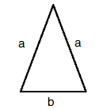
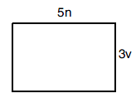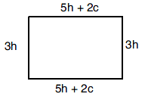
Question 3
Simplify:
- 3a x a =
- 4c x 8d =
- 3b² x 7b =
- a x a x b x a x b =
- b³ ÷ b =
- (b⁴ ÷ b) x b =
Question 4
If a = -2, b = 5 and c = -9,
find the value of:

a) a + 5
b) 3b - 1
c) bc
d) c² – b²
e) a(b + 2c)
f) 7a – 3b + c
g) (abc) – (bca)

Question 5
Solve:
- x + 3 = 12
- f - 7 = 13
c) 7m = 35
$$\frac{t}{4}$$
d) = 8

Question 6
Expand and simplify:
a) 3(a + 2)
b) 2v + 3(2v – 4)
c) 15x – 4(3x - 5)
d) 9y – 4(3 + 2y)
e) 2(a -4) + 7(x + 2)

Question 7
Factorise:
- 2x + 4 =
- 7x – 35 =
- 12b – 8 =
- 45 – 30x =
- 9y + 12x – 3z =
- 84z + 60y =
Question 8
Solve:
a) 4x + 1 = 9
b) 2x – 3 = 7
c) 6 = 8x - 2
d) 9 + 6x = 33
Question 9
Solve:
a) 4(x + 2) =24
b) 2(x-4) =12
c) 5(x – 3) = 25
d) 6(x + 2) =30

- I think of a number. I multiply it by 6 and add 3. If my answer is 75, calculate the number I started with.

- I think of a number. If I multiply it by 5 and divide by 8 I get my answer 10. Form an equation and work out what number was I thinking off.

- The perimeter of the rectangle below is 42cm. Calculate the lengths of the sides by forming an equation and solving it.

x - 2

ROUNDING AND ESTIMATION

Decimal places

Significant figures

Estimation

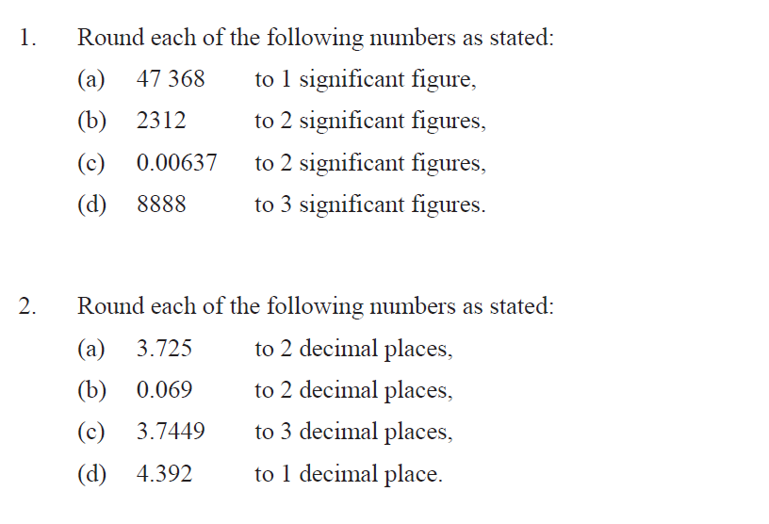

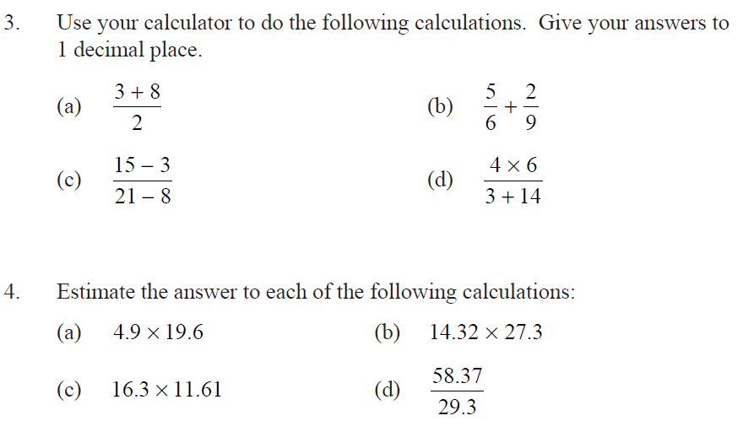

- A box of books weighs 26kg. Estimate the weight of 38 boxes.

- The floor of a rectangular room measures 3.8m by 4.1m. Estimate the area of the room in m².

- A school purchases 194 calculators at a cost of £8.16 each. Estimate the total cost of the purchase.

- A can of soda costs £0.59. Estimate the total cost of 25 cans.

PROBABILITY

1. What fractions would you use to describe:
- the chance of picking a red card at random from a pack of 52 cards?
- the chance of picking a club card?

2. What is the probability of rolling, on a normal dice :
a. a 5?
b. an odd number?
c. zero?
d. a number greater than 2?
e. a number lying between 0 and 7?

3. A newsagent delivers these papers, one to each house.

Sun 250 Times 120
Mirror 300 Mail 100
Telegraph 200 Express 80

What is the probability that a house picked at random has:
a. the Times?
b. the Mail or the Express?

4. A class is going to play three games. In each game some cards are put into a bag. Each card has a square or a circle on it. One card will be taken out, then put back. If it is a circle, the girls will get a point. If it is a square, the boys will get a point.
a. Which game are the girls most likely to win? Why?
b. Which game are the boys least likely to win? Why?
c. Which game is impossible for the girls to win?
d. Which game are the boys certain to win?
e. Which game is it equally likely that the boys or girls win?
f. Are any of the games unfair? Why?
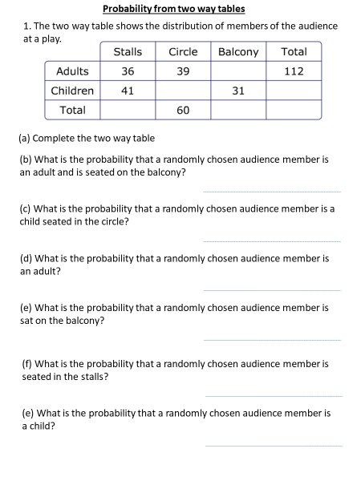

AVERAGES
Mode: | Median:
Mean: | Range:

From a table
Find the mean, median, mode and range for the number of glasses of lemonade drunk by people at the following party:
Glasses of Lemonade | Frequency
1 | 3
2 | 7
3 | 3
4 | 1

- Find the average age:

- The number of goals scored in 15 hockey matches is shown in the table.
Number of goals | Number of matches
1 | 2
3 | 1
5 | 5
6 | 3
9 | 4
Calculate the mean number of goals scored.

What is the modal number of goals scored?

What is the range for the number of goals scored?

PERCENTAGES

- Find the following percentage of amount.
a.50% of 320 b. 25% of 280

c. 10% of 45 d. 60% of 200

e. 5% of 58 f. 20% of 40

g. 15% of 65 h) 99% of £70

- Increase/Decrease the following:

  - Increase £40 by 30%? b. Decrease 60cm by 12%

- Increase 420kg by 15% d. Decrease 900lb by 45%

- Increase £50 by 24% f. Decrease 70 metres by 10% then increase it by 10%.

AREA

Rectangle Triangle

Circle

- Find the area of the following rectangles:
3cm
3cm
5cm
- b) c)
2cm
3cm
4cm

1cm
2cm
d) e) f)
4cm
7cm
1cm
3cm

- Find the area of the following triangles.

a) b) c)
2cm
3cm
6cm
4cm

4cm
1cm

3) Find the area of each of the shapes.

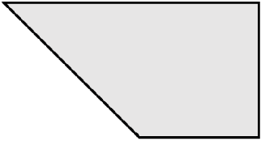  $$7$$  $$2$$  $$4$$ | $$5$$  $$6$$  $$3$$  $$8$$ | $$7$$  $$3$$  $$9$$  $$5$$

SCATTERDIAGRAMS

correlation

Positive

negative

line of best fit

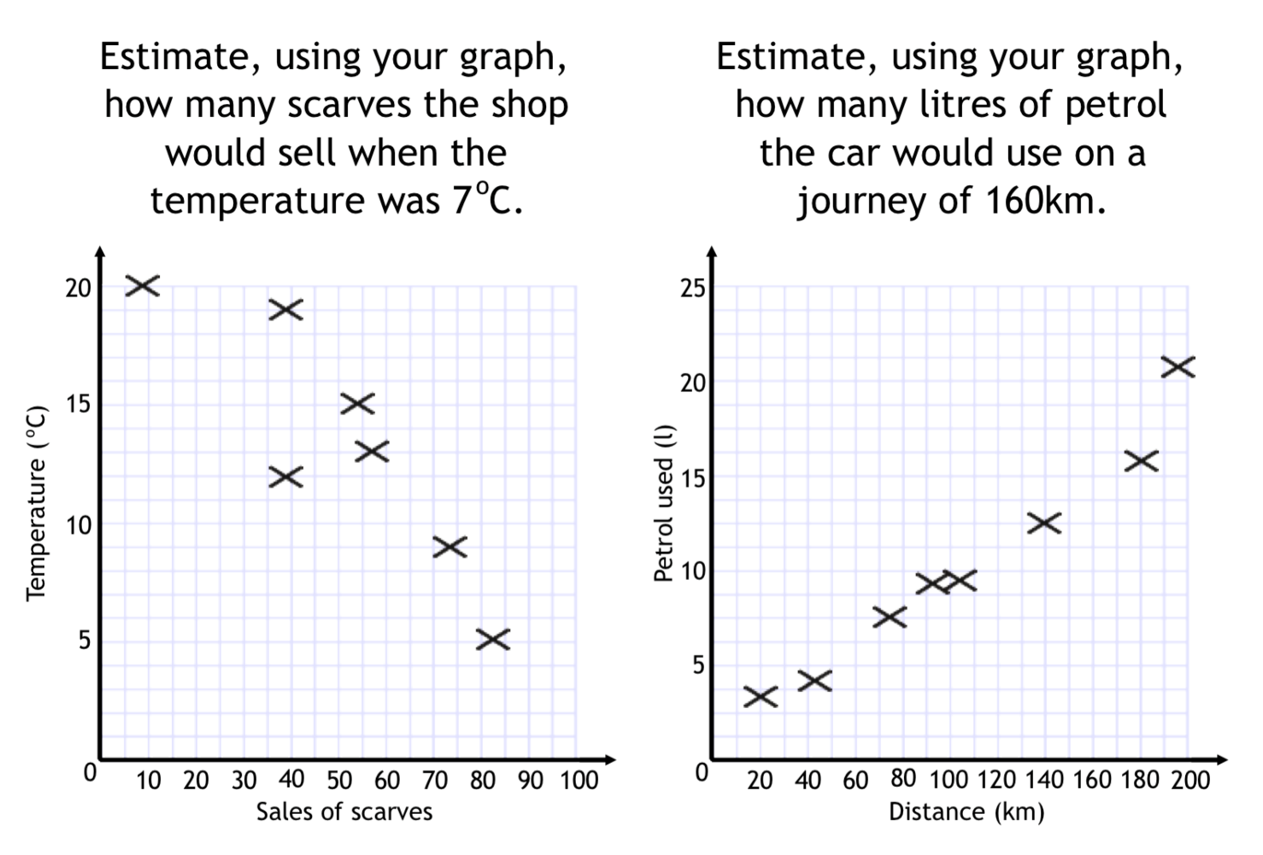

ENLARGEMENT

Scale factor

Centre of enlargement

Enlarge by scale factor
2

Centre of enlargement (0,0)
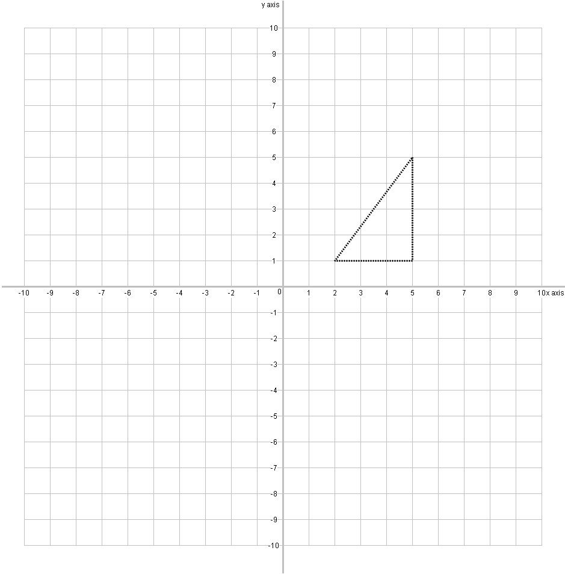
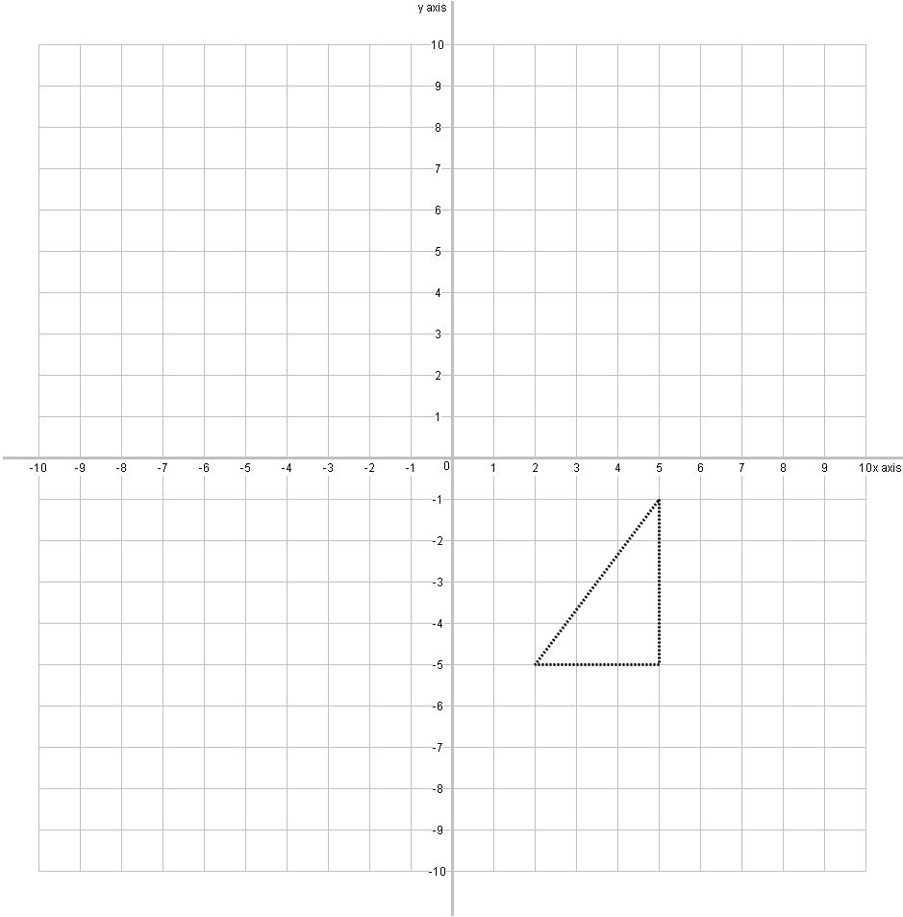
Enlarge by scale factor
3

Centre of enlargement (7,-6)

DISTANCE TIME GRAPHS

Speed Time

Distance

Time

Q1. Here is a distance-time graph for a train journey.
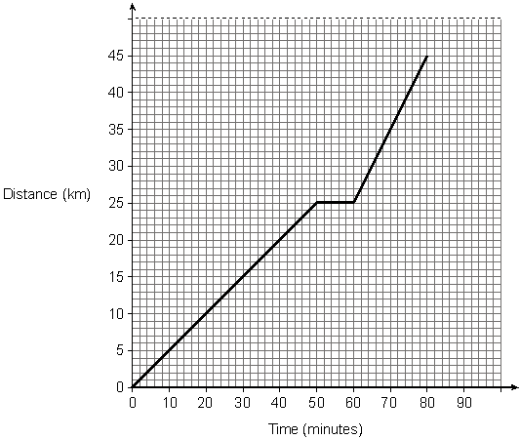
(a) For how long does the train stop on the journey?
Answer ..................................... minutes

(b) (i) On which part of the journey does the train travel fastest?
Put a circle around the part of the graph that shows this.

(ii) Explain how you know

Q2. Wayne cycles from Newcastle to Ashington, a distance of 20 miles.
The diagram shows the distance-time graph of his journey.
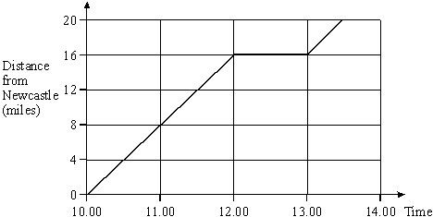

(a) How far from Newcastle is Wayne at 11.00?
Answer .......................................... miles

(b) Describe what is happening between 12.00 and 13.00
.........................................................................................................................
.........................................................................................................................

(c) How far does Wayne travel in the first 2 hours of his journey?
Answer .......................................... miles

(d) What is Wayne’s average speed over the first 2 hours of his journey?
.........................................................................................................................
.........................................................................................................................
Answer ........................................... mph

