GCSE ENGLISH LANGUAGE: Paper 1
NAME:

- Your local radio station is running a creative writing competition for charity.

EITHER: Write a description suggested by this picture:
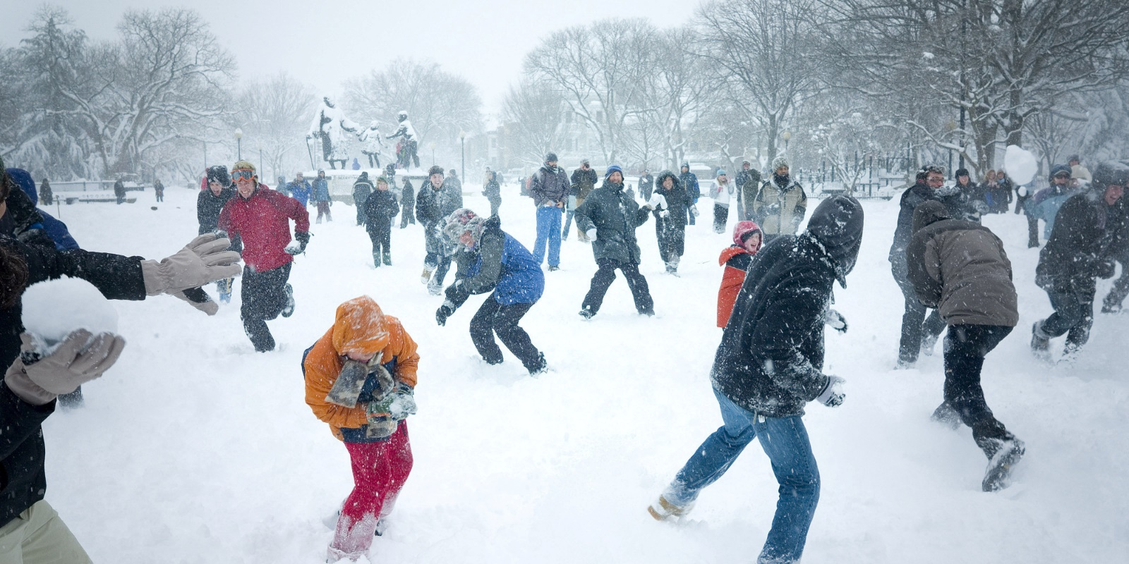
OR: Write a story starting with the sentence:
The weather outside was frightful but, frankly, I didn’t mind at all.
(24 marks for content and organisation, 16 marks for technical accuracy)
[40 marks]

