The Importance of a Balanced Diet
To have enough energy and muscle to perform sports, an athlete needs to consume enough energy and muscle foods. By eating enough calories from a variety of foods, you will satisfy your need for carbohydrates, proteins, fat and vitamins and minerals to create that energy. Work through the task below:
1. Write down three reasons why a balanced diet is important when doing exercise.
(i).............................................................................................................................................................................................................(ii)............................................................................................................................................................................................................(iii)...........................................................................................................................................................................................................
- Carefully planned nutrition must provide an energy balance and a nutrient balance. Fill in the missing words using the text and Food Guide Pyramid provided as a guide.
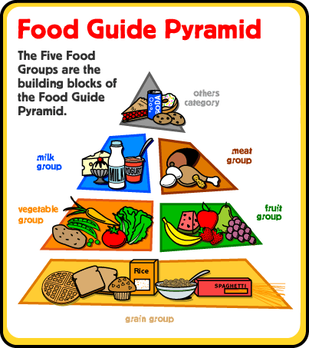
F................................. - one source of energy and important in relation to fat soluble vitamins
V........................... - play important roles in many chemical processes in the body
P........................... - essential to growth and repair of muscle and other body tissues
C...........................- our main source of energy
M..........................- inorganic elements occurring in the body which are critical to its normal functions
W......................... - essential to normal body function if only because 60% of the human body is water

3. Complete the table below, see example for guidance.
Nutrition | Source’s | Needed for | Lack of: the effects
PROTEIN | Meat, fish | Muscle and tissue development and repair | Loss of muscle (e.g flu)
CARBOHYDRATES

FATS

VITAMINS

WATER

