DANCE
KEY STAGE 3
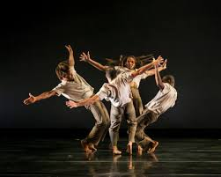

Name: _________________
Tutor: _________________
Dreams & Nightmares
Task: You are creating a dance about dreams and nightmares. Mind map as many ideas as you can think of.

Dreams
& Nightmares

Dreams & Nightmares
Task: Write down the different movements and dynamics you will use e.g. running in slow motion, crawling in a sharp, isolated way. Try think of as many as possible

Movement | Dynamic
Dreams & Nightmares
Task: Draw the opening of your dance, use stick men and floor plans (as if looking down on the stage) add notes to describe what is happening.

Dreams & Nightmares
Task: Design the costume for your dance, be detailed and add in descriptions. You might need different characters and to include any props.

Dreams & Nightmares
Task: Design the set for your dance work. This should include a backdrop and any physical elements e.g. a backdrop of a scary wood with trees along the front of the stage. Include any specific lighting e.g. dark blue with a yellow spotlight for the moon.

Dreams & Nightmares
Task: Write a description of your dance that will be included in the programme, include a title and any specific details.

Title: ________________________________________________________
Programme notes: __________________________________________
________________________________________________________________________________________________________________________________________________________________________________________________________________________________________________________________________________________________________________________________________________________________________________________________________________________
Safe Practise
Task: Dancers have to be safe to avoid injury, write down some key rules dancers need to remember to be safe and explain why it’s important.
Rule | Why its important

Safe Practise
Task: Create a poster for the dance studio detailing why its important to warm up (including cardio, stretching, strengthening) and reminding students

Safe Practise
Task: Design a dance uniform – it needs to be professional, show the dancers bodies clearly, have the school logo and be suitable for dance

Safe Practise
Task: Drinking water and eating healthily is important for a dancer, create a poster to remind dance students of this

Safe Practise
Task: Miss Haley needs a new dance studio, you must design her one. It needs to be big with windows and mirrors, a water fountain, speakers and a dance floor. Draw a floor plan to show the layout.

Dance Styles
Task: There are loads of different dance styles, read through the descriptions and tick any you have tried.
Dance Style | Description | Tick if you’ve tried
Ballet | Turned out feet and curved arms, ballet is the foundation of all dance. The men perform big leaps and jumps, the women perform turns on pointe (the tip of their toes) in special shoes. Originated in France and Italy.
Street dance | There are different variations of street dance including popping and locking, break, hip-hop, bboy and more commercial styles.
Tap | Dancers wear shoes with metal parts to create sound and rhythms.
Jazz | Usually used in musical theatre, Jazz is ballet but without the turn out, using straight lines and isolations. Originated in America.
Indian dance | There are several different types of Indian dance, sometimes each movement represents a word and tells a story through hand gestures. Other times its high energy with intricate use of the arms, linked to Bollywood.
Ballroom | Partnered dancing with many different styles such as the waltz, salsa, tango, cha cha cha and jive.
Contemporary | A mixture of different styles blended together, contemporary dance reflects what is happening now. There can be different focuses such as breath, falling and releasing etc.

Dance Styles
Task: Match the picture to the dance style, use the sheet before to help you.
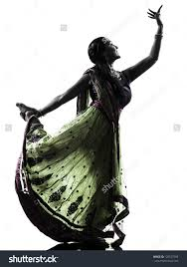
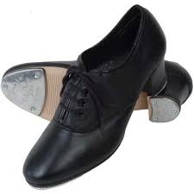

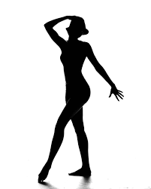

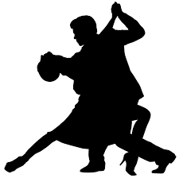

Dance Styles
Task: Pick a dance style you don’t know a lot about, research it and complete the following fact file.
Dance style:

Key features:

Key people:

Examples of dance works in this style:

What do you think about the style? What stands out to you?

Dance Styles
Task: You have been asked to choreograph a dance that has three sections- each section uses a different dance style. Complete the plan of how you will order this including ideas, music you will mix together, costume etc.

Section one
Dance Style:

Ideas:

Section two
Dance Style:

Ideas:

Section three
Dance Style:

Ideas:

Show Time
Task: Design a poster for the end of year dance show, you need to include a date, ticket price, title and a picture linked to dance that will attract people

Show Time
Task: You have been given a budget of £200 for the dance show, Miss Haley needs you to decide how you will spend the money, complete the budget sheet.

Item | Cost for 1 unit | How many would you like? | Total cost
Costumes | £10 per dancer
Programmes | 50p per person
Posters | £1 per poster
Tea and Coffee | 10p per person
Water for dancers | £1 per bottle
Snacks for dancers | £2 per bottle
Renting the lighting | £50 for basic lights, £100 for full set

Total costs _____________
This should be £200 or under

Show Time
Task: Miss Haley has decided she needs to charge for tickets into the show but she doesn’t know how much. She thinks either 60, 80 or 100 people will come based on last year. Complete the table and decide what you think she should charge.

 | 60 tickets sold | 80 tickets sold | 100 tickets sold
£1 for a ticket

£2 for a ticket

£2.50 for a ticket

£3.00 for a ticket

How much should she charge and why? Remember high price tickets might put people off . . .
________________________________________________________________________________________________________________________________________
Show Time
Task: The dance show needs to have a range of dance styles to different music. Create a playlist with a description of each dance we could include.
Music  Try include a range of different styles | Dance idea  Include style, number of dancers and brief description

Street Dance Crew
Task: You are the leader of a street dance crew, you need to create a name for your crew and logo, be creative!

Street Dance Crew
Task: Your crew need hoodies, make the design eye catching and include your name and logo

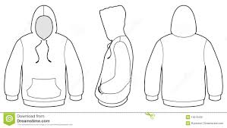
Street Dance Crew
Task: You want to create a street dance wearing masks. Mind map as many ideas as you can then select your favourite.

Mask
ideas

Favourite idea : _______________________________________

Street Dance Crew
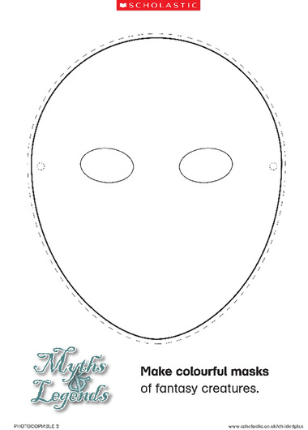
Task: You need to design your masks – make sure they link to the idea you selected
Performance Skills
Task: Read through the following performance skills, think back to your last dance performance, note down which you think are a strength or improvement

Expressive skill | S or I
Focus: looking at your audience and specific places throughout the dance e.g. at your partner, watching your hands
Projection: performing with energy and connecting with your audience
Spatial Awareness: being aware of the space around you and how to use it well
Sensitivity to others: being aware of other dancers and connecting with them
Musicality: the ability to make the qualities of the music come out through your performance
Facial Expression: Using your face to show mood, feeling or character
Choreographic Intention: the aim of the dance, showing what the choreographer wants to communicate

Select a skill you said you needed to improve:
Think of 3 ways you could improve this, be detailed . . .
1.

2.

3.

Physical Skills
Task: Read through the following physical skills, think back to your dance lessons and performances and rate yourself out of 5 for each (1 being very difficult, 5 being something you can confidently do) – remember to be positive about your abilities!
Physical skill | Mark out of 5
Balance: holding a position or being steady

Control: stopping and starting movements well, changing direction and holding things
Coordination: using several body parts at once

Extension: lengthening muscles and limbs fully

Flexibility: the range of movement in your limbs or joints
Isolation: moving just one part of the body separately to others
Posture: how you hold the body (good posture is when you lift up and out, not slump)
Stamina: ability to perform over a period of time

Strength: how much muscular power you have

Select a skill you said you needed to improve:
Think of 2 ways you could improve this, be detailed . . .
1.

2.

Teamwork Skills
Task: Read through the following statements and tick either Yes (I agree), Sometimes (sometimes yes, sometimes no) or No (I don’t agree)
Creative skill | Yes | Sometimes | No
I like working with different people

I have ideas in my dance lessons

I share my ideas in dance lessons with my group
I like coming up with different movements

I enjoy creating dances based around different topics
When I watch other dances I get ideas

I enjoy working in smaller groups

I can give people ideas on how to improve the dance
I motivate my group to get the work done

I listen to everyones ideas

If someone is struggling I will help them

When do you feel you work the best in a group and why?

Logo Challenge
Task: Design a Brakenhale Dance Company Logo – it needs to be professional, relate to dance and be creative/eye catching

