Week 1  Addition | Use these cards to make calculations with their answers,  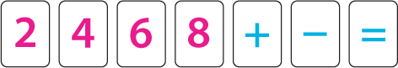 | 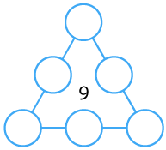  Arrange the numbers 1 to 6 in the set of circles. The total of each row of 3 should equal the middle number. | Marcus had some coins in his pocket.  Sadly he lost 7 of them, now he only  has three coins. How many coins  were there before he lost them? | When Spain played Belgium in the preliminary round of the men's hockey competition in the 2008 Olympics, the final score was 4−2.  What could the half time score have been?  Can you find all the possible half time scores? | In the calculation below, the box represents a missing digit:  What could go in the box? What would the total be each time?  Which is the highest/lowest total?  Which totals are odd/even?
Week 2  Subtraction | Some children were walking to school together.  Three more joined them.  Now there were 9 children altogether.  How many were walking together first? | Place the numbers 1 to 6 in the circles so that each number is the difference between the two numbers just below it.  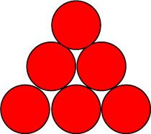 | 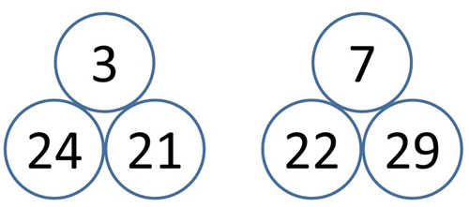  The number above is always the difference between the two beneath it.  Can you find different pairs of numbers with a difference of 1 or 2 or 3 or 4 ... and so on?  Can you find more than one way of doing it? | Can you place three different numbers in them so that their differences are odd?  Can you make the differences even?  What do you notice about the sum of each pair in each case?  Try with different numbers of squares around the ring.  What happens with 5 squares? 6 squares?  What do you notice? | You have £1 to spend on 2 items. You spend it and receive 50p change. What are the different possible prices that the 2 items could be?
Week 3  Multiplication | There are more ways to make 12 than 15 using the multiplication operation only. Reason why you agree or disagree. | The splitting plant grows in a special way.In the first week, the stem splits into two branches.  In the second week, each of these two branches split into another two branches - making four branches altogether.  This keeps happening every week, until at the end of the sixth week each branch grows a flower. How many flowers will the plant have? | If you count from 1 to 20 and clap more loudly on the numbers in the two times table, as well as saying those numbers loudly, which numbers will be loud? | 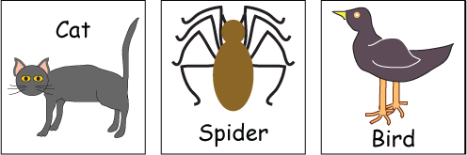  How many legs does each of these three creatures have?  How many pairs is that?  How do you know? | This challenge is about doubling multiples of 5.  Pick a multiple of 5. Double it.  What is your answer? How many 10s is this?  Can you spot any patterns?  Can you explain the patterns?
Week 4  Division | Noah saw 12 legs walk by into the ark.  How many creatures could he have seen?  How many different answers can you find?  Can you explain how you found out these answers? | On a farm there were some hens and sheep.  Altogether, there were 8 heads and 22 feet.  How many hens were there? | There are three baskets, a brown one, a red one and a pink one, holding a total of ten eggs.  The Brown basket has one more egg in it than the Red basket.  The Red basket has three eggs fewer than the Pink basket.  How many eggs are in each basket? | Sahila is going to give everyone five juggling balls to take home after the party.  Will 55 balls be enough? | You have 2 birthday cakes! You need to cut it up equally for 20 friends. How many slices do you need to divide the 2 cakes into?  If you have 2 slices left over, how many slices will you need to cut the cakes into? Why?
Week 5  Shape | Always, sometimes or never?  - When you add 2 squares together, you could get a rectangle.  - Hexagons have 6 sides of equal length. | 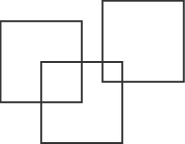  What is the greatest number of squares you can make by overlapping three squares of the same size? | 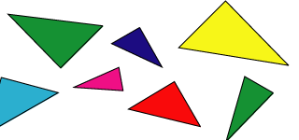  All the triangles in a family are the same shape.  Can you sort them out and explain how you did it? | Which of these shapes are triangles? | Using squares only, draw a school building.  Is it possible? Why/why not?

