How to use AR at home:

- Type Mayfield school homepage into google and go to the Mayfield school homepage. Or go to: https://mayfield.portsmouth.sch.uk/student-homepage
- This screen will come up.
- 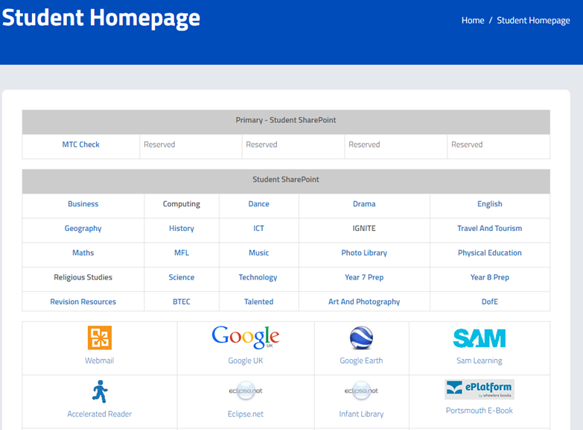

- Click onto the Blue Man icon and the following screen will pop up.

- 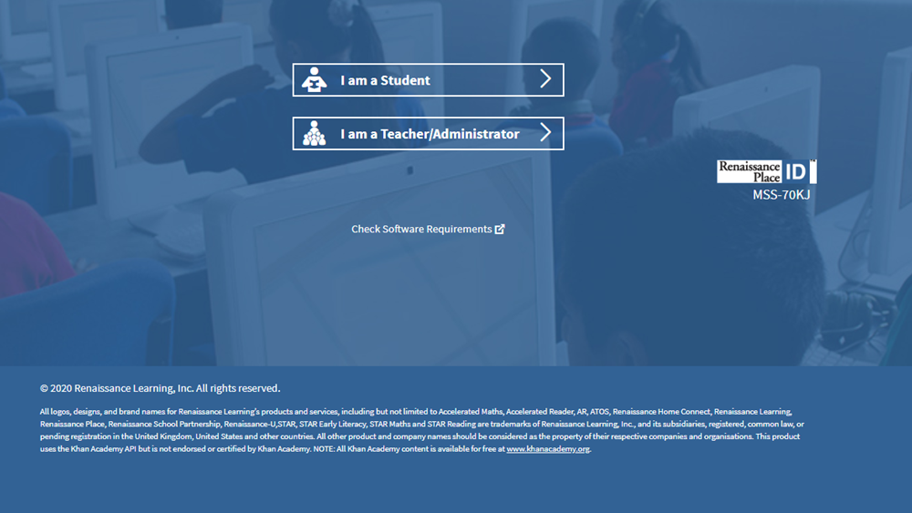

- Click ‘I am a Student’

- You will see a log in screen.

- User Name: First letter of first name followed by first four letters of surname.
Example:
John Smith = JSMIT
Tom Jones = TJONE
Password: Mayfield
Some pupils may have a 1 after their name if they have similar names to other pupils, so if you are unable to log in they need to add a 1 afterwards.
John Smith = JSMIT1
- You will see a screen like this:

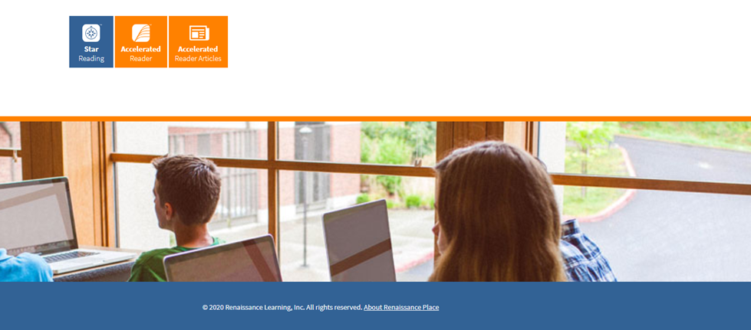

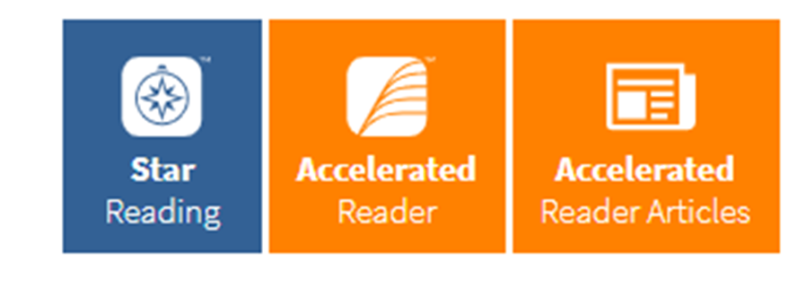
Use the two orange icons to either take a reading quiz or an article quiz.
Do not click the blue icon. If you do simply refresh the page by pressing F5 on your keyboard and log in again.

When you log on you can select the name of your teacher.
You will get a screen like this:
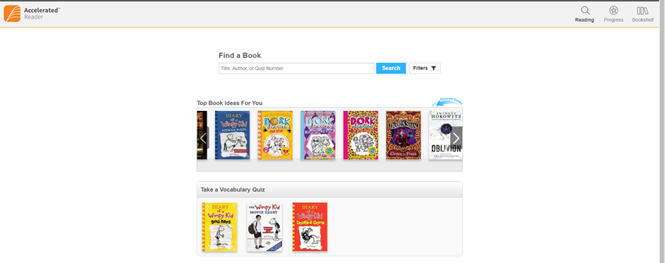
From here you can type in the name of your book and you will be able to take a quiz on it. You can also check your progress which will help to improve your word count. To log out simply click on your name on the top right and select ‘log off’.

