Mαthεmαtics ∂εpαrtmεnt

To support our students over the coming weeks there are a few things that we would request our students complete:

The accompanying booklet contains practice questions for the high frequency 1- or 2-mark questions. Whilst there is no guarantee that any of these topics will appear in the next sitting, it is essential that our students are confident in these areas to gain as many marks as possible and by being able to swiftly answer these early topics the time gained can be used when answering the tougher 3, 4 or 5 mark questions.

We have included worksheets in this booklet that students can use alongside watching the tutorials on JustMaths Online for:

1. **Recap / Revision work** – a selection of topics that we feel students need to revise based on the recent mocks.
2. **Preparation work** – a selection of upcoming topics.

In addition to this, students can also use JustMaths Online for any topics that were identified as areas for improvement in their recent mocks if they wish. They will also shortly be provided with the RAG papers from their recent mocks which include worked solutions and video support.

Should there be a need to provide work over the longer term the school will be in touch accordingly but in the meantime please don’t hesitate to contact either of us if you have any maths queries.

Mr Ralph

|  |
| --- |
| **Useful websites:** |
| [www.justmaths.co.uk/online](http://www.justmaths.co.uk/online)  Username = MayfieldStudent  Password = Mayfield |

­­­

**REVISION / RECAP: BEST VALUE – CLIP 07**

Potatoes cost £9 for a 12.5 kg bag at a farm shop.

The same type of potatoes cost £1.83 at a supermarket for a 2.5kg bag.

Where are the potatoes better value, at the farm shop or the supermarket?

You must show your working.

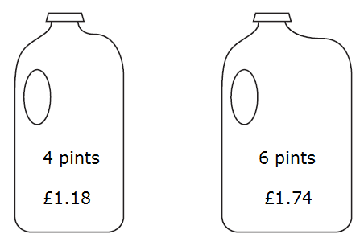Milk is sold in two sizes of bottle.

A 4 pint bottle of milk costs £1.18

A 6 pint bottle of milk costs £1.74

Which bottle of milk is the best value for money?

You must show all your working.

Plants are sold in three different sizes of tray.

A small tray of 30 plants costs £6.50

A medium tray of 40 plants costs £8.95

A large tray of 50 plants costs £10.99

Mel wants to buy the tray of plants that is the best value for money.

Which size tray of plants should she buy?

You must show all your working.

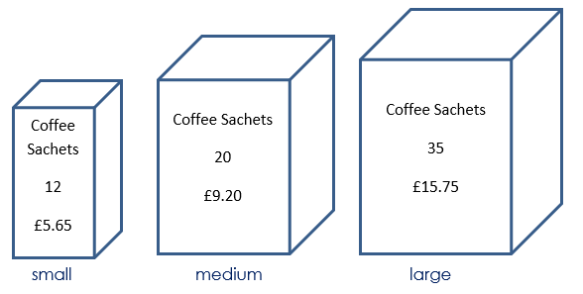Coffee sachets are sold in three different sizes of box.

A small box has 12 coffee sachets and costs £5.65

A medium box has 20 coffee sachets and costs £9.20

A large box has 35 coffee sachets and costs £15.75

Work out which size of box gives the best value for money.

You must show all your working.

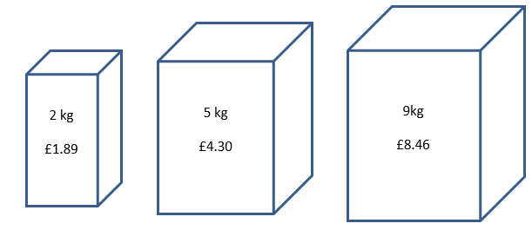

Soap powder is sold in three different sizes of box.

A 2 kg box of soap powder is £1.89

A 5 kg box of soap powder is £4.30

A 9 kg box of soap powder is £8.46

Work out which size of box of soap powder gives the best value for money.

You must show how you get your answer.

**REVISION / RECAP: EXCHANGE RATES - CLIP 08**

Rosie and Jim are going on holiday to the USA. Jim changes £350 into dollars ($).

The exchange rate is £1 = $1.34

1. Work out how many dollars ($) Jim gets.

C:\Users\muldowneym\AppData\Local\Microsoft\Windows\Temporary Internet Files\Content.IE5\G5XWVUEF\MC900113338[1].wmfIn the USA Rosie sees some jeans costing $67.

$67

In London the same make of jeans costs £47.50

The exchange rate is still £1 = $1.34

1. Work out the difference between the cost of the jeans in the USA

and in London. Give your answer in pounds (£)

£47.50

In August 2008, Eddie hired a car in Italy. The cost of hiring the car was £620

The exchange rate was £1 = €1.25

1. Work out the cost of hiring the car in euros (€).

Eddie bought some perfume in Italy. The cost of the perfume in Italy was €50. The cost of the same perfume in London was £42

The exchange rate was still £1 = €1.25

1. Work out the difference between the cost of the perfume in Italy and the cost of the perfume in London. Give your answer in pounds (£).

Linda is going on holiday to the Czech Republic. She needs to change some money into koruna.

She can only change her money into 100 koruna notes.

Linda only wants to change up to £200 into koruna. She wants as many 100 koruna notes as possible.

The exchange rate is £1 = 25.82 koruna

How many 100 koruna notes should she get?

The exchange rate in London is £1 = €1.14

The exchange rate in Paris is €1 = £0.86

Elaine wants to change some pounds into euros.

In which of these cities would Elaine get the most euros? You must show all your working.

**REVISION / RECAP: INTEREST & GROWTH – CLIP 11**

£600 is invested for 3 years at 3% simple interest per year.

Work out the total interest.

£650 is invested in a bank account for 2 years at 1.5% simple interest per year.

How much is in the account at the end of the 2 years?

Christian invested £6500 for 2 years in a savings account.

He was paid 4% per annum compound interest.

How much money did Christian have in his savings account at the end of 2 years?

Ben invests £400 for 2 years in a bank account.

The account pays compound interest at a rate of 2.3% per year.

Calculate the total amount of interest Ben has at the end of 2 years.

Sam wants to invest £2000 for 2 years in the same bank.

|  |  |  |
| --- | --- | --- |
| **Super Savings Bank**  Compound Interest  4% for the first year  1% for each extra year |  | **Bonus Bank**  Compound Interest  5% for the first year  0.5% for each extra year |

At the end of 2 years, Sam wants to have as much money as possible.

Which bank should Sam use?

Here are the interest rates advertised by two different banks:

|  |  |  |
| --- | --- | --- |
| **Account X**  3% per year compound interest |  | **Account Y**  4% for the first year  3% for the second year  2% for the third year |

Peter has £10,000 to invest.

Which account would give him the most money if he invests his money for three years?

Mel invests £6400 for 5 years in a savings account. She gets 3% per annum compound interest.

How much money will Mel have in her savings account at the end of 5 years?

The population, *P*, of a town *t* years after January 1st 2016 is given by this formula:

*P* = 4300 x 1.04*t*

1. What was the population of the town on January 1st 2016?
2. Explain how you know that the population is not declining.
3. Using this formula, what should the population be on January 1st 2019?

Rob wants to invest £10,000 for 7 years.

It will earn compound interest at 3.5% per year.

Rob is trying to work out how much his investment will be worth in 7 years:

|  |
| --- |
| **Balance in 7 years = 10,000 x 0.35 x 8** |

What is wrong with Rob’s method?

Work out the total interest that will be earned.

Bob invests £500 on the 1st January 2016 at a compound interest rate of *I*% per annum.

The value £*V*, of this investment after *n* years is given by the formula:

*V* = 500 x 1.045*n*

1. Write down the value of *I.*
2. How many years will it take his investment to first go over £600?

**REVISION / RECAP: DEPRECIATION & DECAY – CLIP 12**

The value of a second hand car is £6000.

Each year it loses 20% of its value.

Work out its value in 3 years time.

Emma bought a car for £10,000

Each year the car depreciates by 12.5%

How much will the car be worth in 2 years time?

An IT firm is considering buying a new computer system and is looking at two different brands. Both options will cost £12,000 brand new.

They intend to sell the equipment at the end of two years.

|  |  |  |
| --- | --- | --- |
| **Brand X**  Depreciates by 10% in the first year  Depreciates by 6% every year thereafter |  | **Brand Y**  Depreciates by 12% in the first year  Depreciates by 4% every year thereafter |

Which brand should they purchase?

Mel bought a new car for £8,900.

Each year the value of the car depreciates by 9%

After how many years will the car be first worth less than half its original price?

The value of a car £*V* is given by

*V* = 20 000 x 0.9*t*

Where *t* is the age of the car in complete years.

1. Write down the value of the car when *t* = 0
2. What is the value of *V* when *t* = 3?
3. After how many years will the car’s value first drop below £10,000?

The number of red squirrels in Scotland is 25,000. The number of squirrels decreases by 22% each year.

1. Write a formula for the number of squirrels after *n* years.
2. Use your formula to work out the number of squirrels after 8 years.
3. How long will it take to drop below 1000 squirrels?

**REVISION / RECAP: AVERAGES FROM A TABLE – CLIP 27**

The table shows the marks scored in a mental arithmetic test by 30 students.

|  |  |
| --- | --- |
| **Mark** | **Frequency** |
| 4 | 3 |
| 5 | 1 |
| 6 | 2 |
| 7 | 8 |
| 8 | 6 |
| 9 | 5 |
| 10 | 5 |

1. Which mark is the mode?
2. Which mark is the median?
3. What is the range of the data?
4. Calculate the mean mark

Faisal carries out a survey of 100 students in year 11.

He asks each student how many cars there are at their household. The results are shown in the table.

|  |  |
| --- | --- |
| **Mark** | **Frequency** |
| 0 | 6 |
| 1 | 17 |
| 2 | 52 |
| 3 | 22 |
| 4 | 3 |
| Total | 100 |

Work out the mean number of cars at each household.

Bianca asked 32 women about the number of children they each had. The table shows information about her results.

|  |  |  |
| --- | --- | --- |
| **Number of children** | **Frequency** |  |
| 0 | 9 |  |
| 1 | 6 |  |
| 2 | *7* |  |
| 3 | 8 |  |
| 4 | 2 |  |
| More than 4 | 0 |  |

1. Find the mode
2. Calculate the mean

**REVISION / RECAP: AVERAGES FROM GROUP DATA – CLIP 28**

90 people each exercised for 30 minutes. Each person’s recovery time was measured. The results are summarised in this table.

|  |  |
| --- | --- |
| Recovery time  (*m* minutes) | Number of people |
| 0 < *m* ≤ 4 | 2 |
| 4 < *m* ≤ 8 | 7 |
| 8 < *m* ≤ 12 | 29 |
| 12 < *m* ≤ 16 | 26 |
| 16 < *m* ≤ 20 | 16 |
| 20 < *m* ≤ 24 | 10 |

Calculate an estimate of the mean recovery time.

Write down the modal class.

Caleb measured the heights of 30 plants. The table gives some information about the heights, *h* cm, of the plants.

|  |  |  |  |
| --- | --- | --- | --- |
| Height (*h* cm) of plants | Frequency |  |  |
| 0 < *h* ≤ 10 | 2 |  |  |
| 10 < *h* ≤ 20 | 8 |  |  |
| 20 < *h* ≤ 30 | 9 |  |  |
| 30 < *h* ≤ 40 | 7 |  |  |
| 40 < *h* ≤ 50 | 4 |  |  |

Work out an estimate for the mean height of the plants.

In which class interval does the median lie?

The table shows some information about the weight, in grams of 60 eggs.

|  |  |  |  |
| --- | --- | --- | --- |
| Weight (*w grams*) | Frequency |  |  |
| 0 < *w* ≤ 30 | 0 |  |  |
| 30 < *w* ≤ 50 | 14 |  |  |
| 50 < *w* ≤ 60 | 16 |  |  |
| 60 < *w* ≤ 70 | 21 |  |  |
| 70 < *w* ≤ 100 | 9 |  |  |

Calculate an estimate for the mean weight of an egg.

**PREPARATION: ALTERNATE & CORRESPONDING ANGLES – CLIP 46**

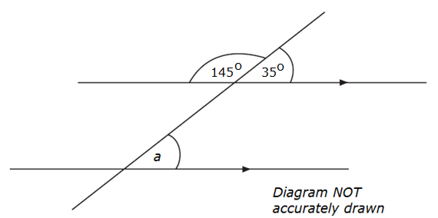

1. Write down the size of the angle marked *a*.
2. Give a reason for your answer.

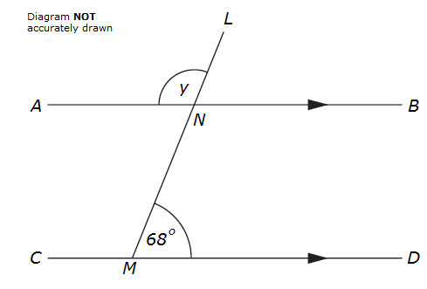

*ANB* is parallel to *CMD.*

*LNM* is a straight line.

Angle *LMD = 68o.*

1. Work out the size of the angle marked *y.*
2. Give reasons for your answer.

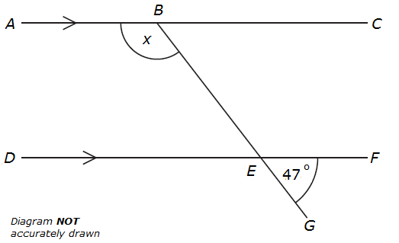*ABC* and *DEF* are parallel lines.

*BEG* is a straight line.

Angle *GEF* = 47o.

Work out the size of the angle marked x.

Give reasons for your answer.

(3)

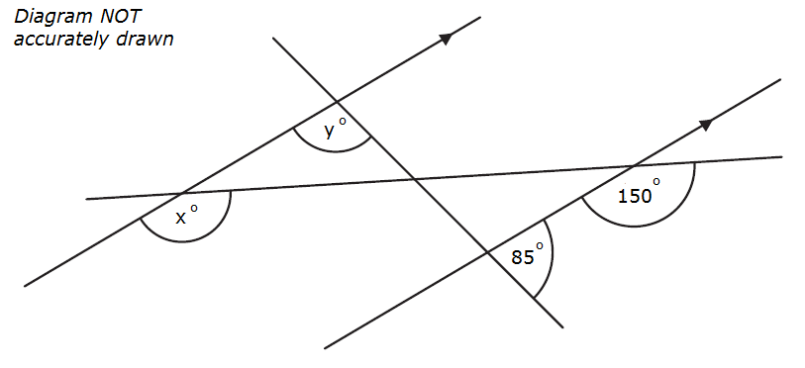

1. Find the value of x.
2. Find the value of y.

Give reasons for your answer.

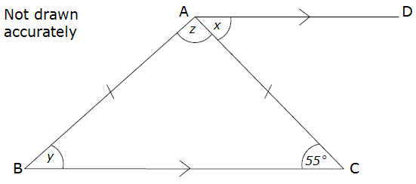

*ABC* is an isosceles triangle with *AB* = *AC*.

*BC* is parallel to *AD* and angle *BCA* = 55o.

Work out the size of the angles marked *x, y* and *z*.

|  |  |  |
| --- | --- | --- |
| Answer *x* = |  | degrees |
| *y* = |  | degrees |
| *z* = |  | degrees |

**PREPARATION: INTERIOR & EXTERIOR ANGLES – CLIP 47**

*WXYZ* is a quadrilateral.

*XYV* is a straight line.

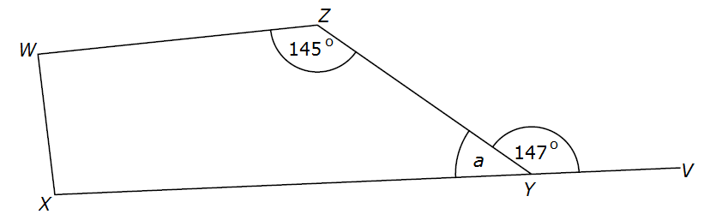

Find the size of the angle marked *a*.

Give a reason for your answer.

Angle *ZWX* = angle *WXY.*

Work out the size of angle *ZWX.*

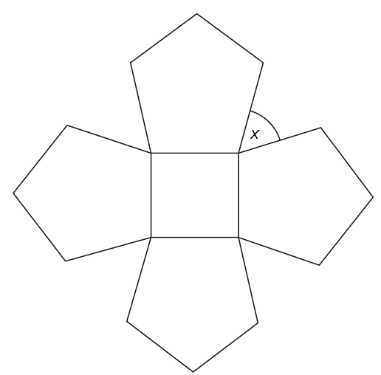

The diagram shows a square and 4 regular pentagons.

Work out the size of the angle marked *x.*

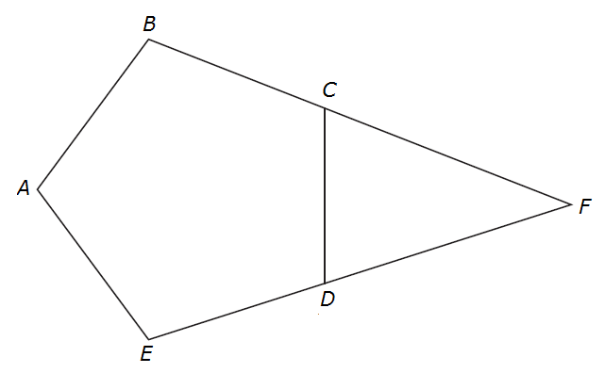*ABCDE* is a regular pentagon.

*BCF* and *EDF* are straight lines.

Work out the size of angle *CFD.*

You must show how you got your answer.

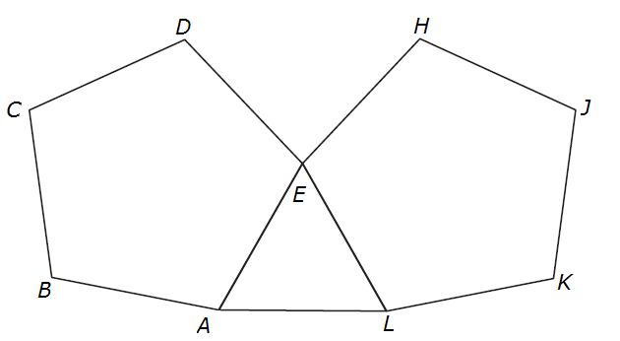*ABCDE* and *EHJKL* are regular pentagons.

*AEL* is an equilateral triangle.

Work out the size of angle *DEH.*

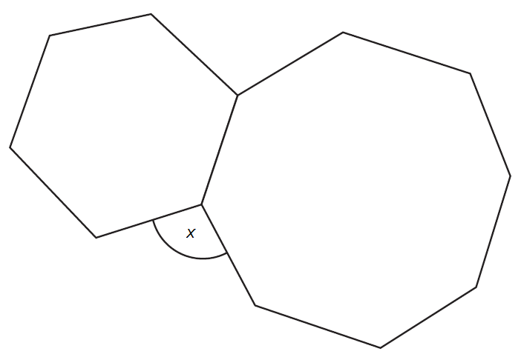

The diagram shows a regular hexagon and a regular octagon.

Calculate the size of the angle marked x

You must show all your working.

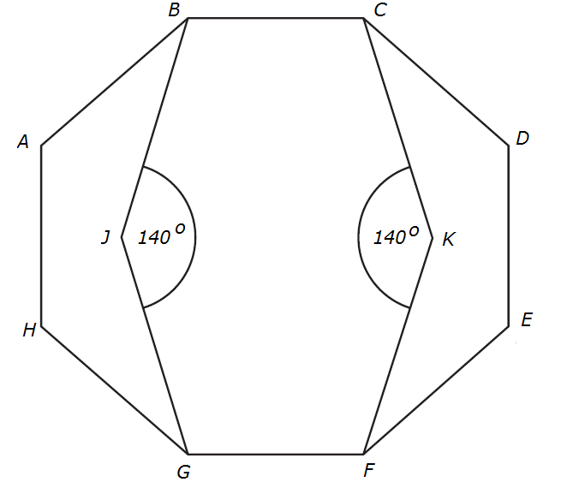

*ABCDEFGH* is a regular octagon.

*BCKFGJ* is a hexagon.

*JK* is a line of symmetry of the hexagon.

Angle *BJG* = angle *CKF* = 140o

Work out the size of angle *KFE*.

You must show all your working.

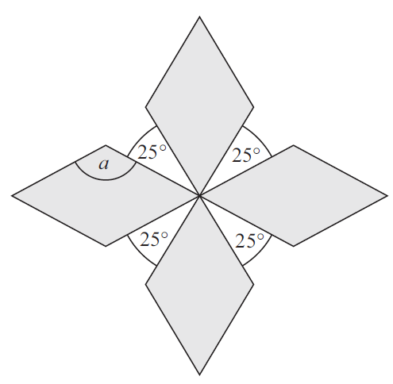The diagram shows a pattern using four identical rhombuses.

Work out the size of the angle marked *a*.

You must show your working.

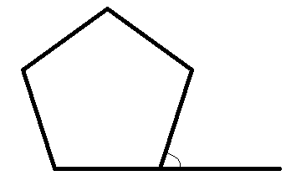

Work out the size of the exterior angle of a regular pentagon.

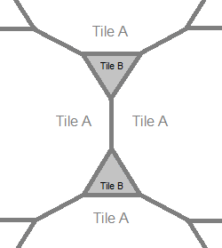

The diagram shows part of a pattern made from tiles.

The pattern is made from two types of tiles, tile A and tile B.

Both tile A and tile B are regular polygons.

Work out the number of sides tile A has.

The size of each exterior angle of a regular polygon is 40o

Work out the number of sides of the polygon.

The size of each interior angle of a regular polygon is 156o

Work out the number of sides of the polygon.

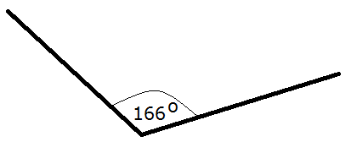

Ian draws this diagram. He says “this is part of a regular polygon”.

Is Ian correct? Explain your answer.

**PREPARATION – SAMPLING – CLIP 48**

Kayleigh and Phil own a sandwich company.

They deliver sandwiches to customers for lunch in 30 offices every day. There are a number of customers in each office.

Kayleigh wants to make changes to the sandwich menu so she decides to find out the opinions of the customers.

1. Describe the population of the survey.

Phil wants to use a census to collect customers’ opinions.

1. Write down one advantage of using a census.

Kayleigh wants to use a sample of the customers, rather than a census.

Give two reasons why a sample may be better.

Reason 1

Reason 2

1. Explain what is meant by a random sample.

Christian wants to find out how often people go to a bowling alley.

He gives a questionnaire to all the men leaving a bowling alley.

His sample is biased. Give two possible reasons why.

Reason 1

Reason 2

The manager of a local gym is planning to build some squash courts. He wants to know how many people will use the squash courts.

The manager plans to give a questionnaire to the first 20 people who get to the gym on Tuesday morning.

Give two reasons why this may not be a suitable sample.

Reason 1

Reason 2

A factory makes 5000 computers.

Fize is going to take a random sample of 25 of these computers.

1. What is meant by the term “random sample”?
2. Describe a method he could use to select the sample.

The table shows the number of students in each year group in a school:

|  |  |  |  |  |  |
| --- | --- | --- | --- | --- | --- |
| Year group | 7 | 8 | 9 | 10 | 11 |
| Number of students | 190 | 145 | 145 | 140 | 130 |

The headteacher wants to carry out a survey about the canteen food.

She uses a stratified sample of 60 students according to year group.

Calculate the number of year 11 students that should be in her sample.

A school has 650 students.

Each student studies one language. They choose from either Italian, Spanish, German or French. The table shows the number of students who study each of these languages:

|  |  |
| --- | --- |
| Language | Number of  students |
| Italian | 145 |
| Spanish | 121 |
| German | 198 |
| French | 186 |

The headteacher wants to look at the work of a stratified sample of 70 of these students.

Find the number of students studying each of these languages that should be in the sample.

Italian ……………

Spanish ……………

German ……………

French……………

258 students each study either Art, Textiles or Photography. The table shows the information about these students:

|  |  |  |  |
| --- | --- | --- | --- |
|  | Subject studied | | |
|  | Art | Textiles | Photography |
| Female | 45 | 52 | 26 |
| Male | 25 | 48 | 62 |

A sample, stratified by the subject studied and by gender, of 50 of the 258 students is taken.

1. Work out the number of male students studying Textiles in the sample.
2. Work out the number of male students in the sample.

**PREPARATION – CIRCLES 1 – CLIP 56**

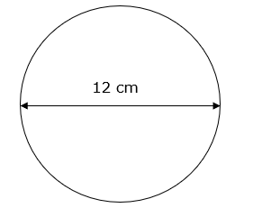A circle has a diameter of 12 cm.

Work out the circumference of the circle.

Give your answer correct to 3 significant figures.

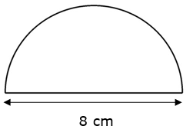

Here is a tile in the shape of a semicircle.

The diameter of the semicircle is 8 cm.

Work out the perimeter of the tile.

Give your answer correct to 2 decimal places.

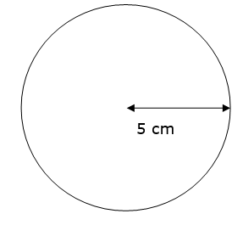A circle has a radius of 5 cm.

Work out the area of the circle.

Give your answer correct to 3 significant figures.

The diagram shows a circular pond with a path around it.

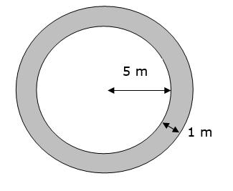The pond has a radius of 5 m.

The path has a width of 1 m.

Work out the area of the path.

Give your answer correct to 3 significant figures.

**PREPARATION – CIRCLES 2 – CLIP 57**

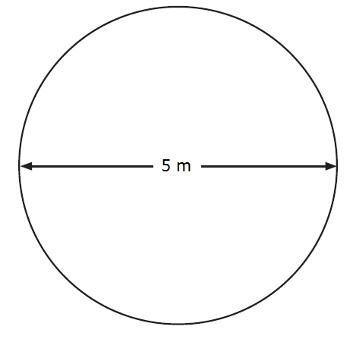Joe has a flower garden in the shape of a circle.

The diameter of the garden is 5 metres.

Joe wants to put fencing around the edge of the garden. The fencing costs £1.80 per metre.

Work out the total cost of the fencing.

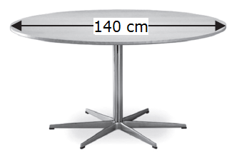Jan is organising a conference.

People at the conference will sit at circular tables.

Each table has a diameter of 140 cm.

Each person needs 60 cm around the circumference of the table.

There are 12 of these tables in the conference room.

A total of 90 people will be at the conference.

Are there enough tables in the conference room?

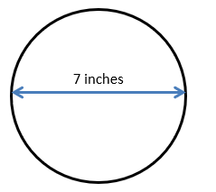The diagram shows the top of Amelie’s birthday cake.

The top of the cake is in the shape of a circle.

The diameter of the cake is 7 inches.

A ribbon is going to be put around the side of the cake.

Ribbons are sold in 50 cm lengths.

1 inch = 2.54 cm

Work out if one length of ribbon is long enough to go all the way around the cake.

You must show your working.

A circular table has a radius of 70 cm.

Calculate the area of the table top in cm2 giving your answer as a multiple of $π$

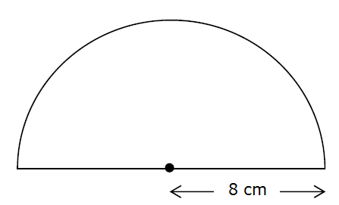The diagram shows a semicircle of radius 8cm

Work out the area of the semicircle. Give your answer in terms of $π$

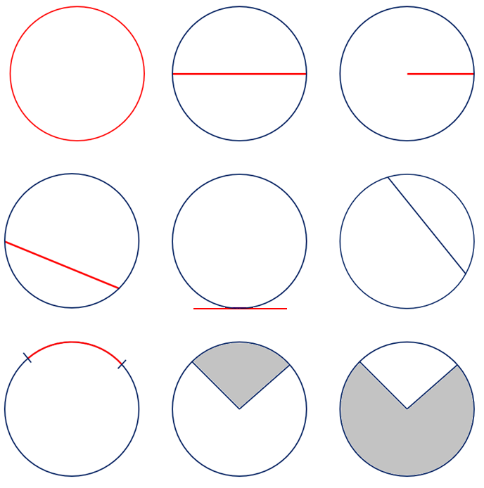**PREPARATION: ARCS AND SECTORS – CLIP 58**

Chris makes a circular pizza with a radius of 12 cm.

1. Work out the circumference of the pizza in terms of $π.$
2. Chris cuts slices of pizza with an angle size of 60o

How many slices of pizza can be cut?

1. What fraction of the pizza is each slice?

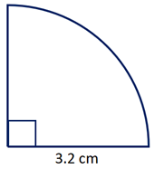Work out the arc length of:

Give your answers:

1. in terms of $π$
2. correct to 3 significant figures.

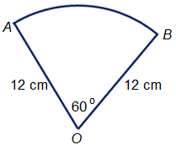

*OAB* is a sector of a circle, centre *O*.

Angle *AOB* = 60o.

*OA* = *OB* = 12 cm.

Work out the length of the arc *AB*. Give your answer correct to 3 significant figures.



*OAB* is a sector of a circle, centre *O*.

Angle *AOB* = 60o.

*OA* = *OB* = 12 cm.

Work out the length of the arc *AB*. Give your answer in terms of $π$.

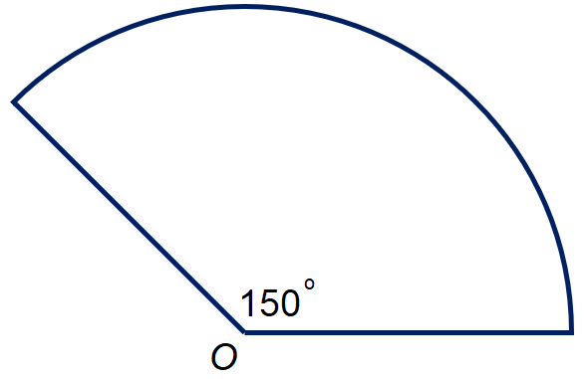The diagram shows a minor sector of a circle with a radius of 13 cm.

Work out the perimeter of the sector.

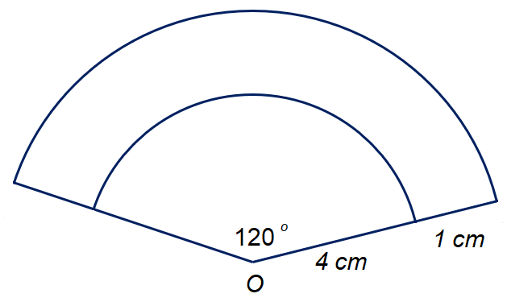

The diagram shows two circular arcs with centre *O.*

How much longer is the big arc than the small arc?

Give your answer correct to 1 decimal place.

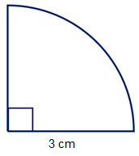

Work out the area of the sector:

Give your answer:

1. in terms of $π$
2. correct to 3 significant figures.

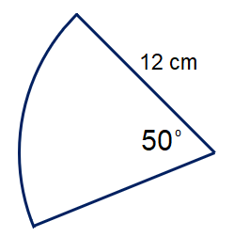Find the area of the sector.

Give your answers correct to 3 significant figures.

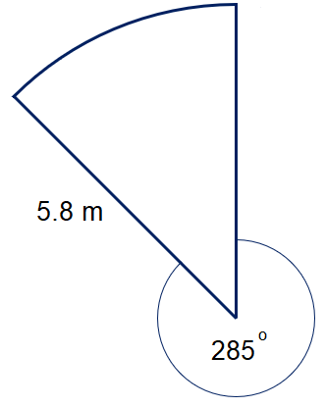Work out the area of the sector, correct to 3 significant figures.

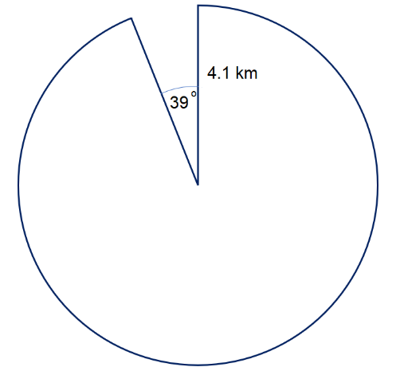

Work out the area of the sector.

Give your answers correct to 3 significant figures.

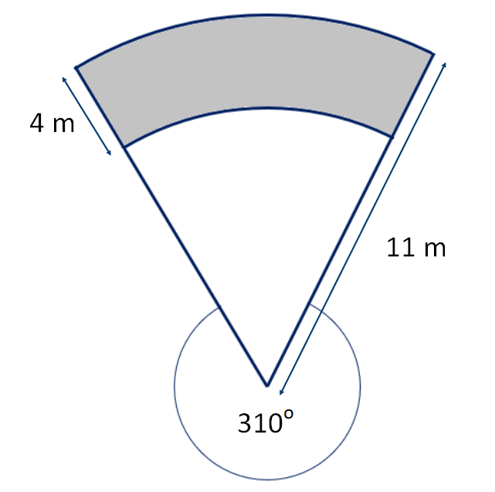Find the shaded area:

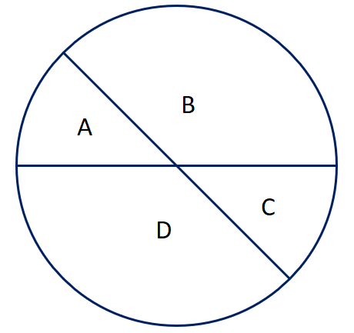

A circle has a radius of 6 cm.

Two diameters split the circle into four sectors as shown:

Area of sector A : Area of sector B = 1 : 3

Work out the area of sector A.

Give your answer in terms of $π$.

**PREPARATION: SURFACE AREA AND VOLUME – CLIP 59**

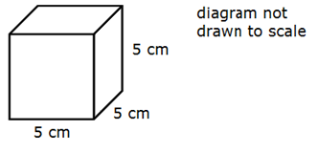

Work out the total surface area of the cube.

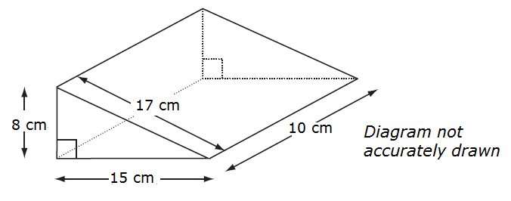

Work out the **total** surface area of the triangular prism.

A triangular prism has dimensions as shown in the diagram.

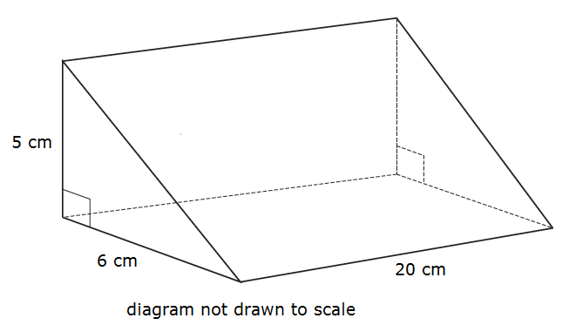

Work out the volume of the prism.

An eraser is a prism with a parallelogram as its cross section.

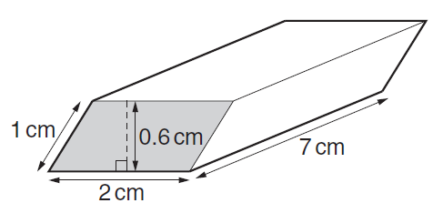

Work out the volume of the eraser. Give the units of your answer.

Here is a solid prism.

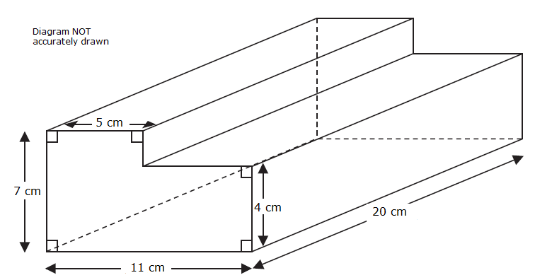

Work out the volume of the prism.

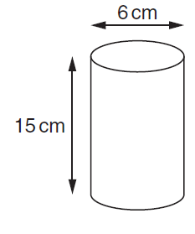A drinking glass is a cylinder. The interior dimensions of the glass are as shown.

Work out the volume of liquid needed to fill the glass.

**PREPARATION – SURFACE AREA AND VOLUME 2 – CLIP 60**

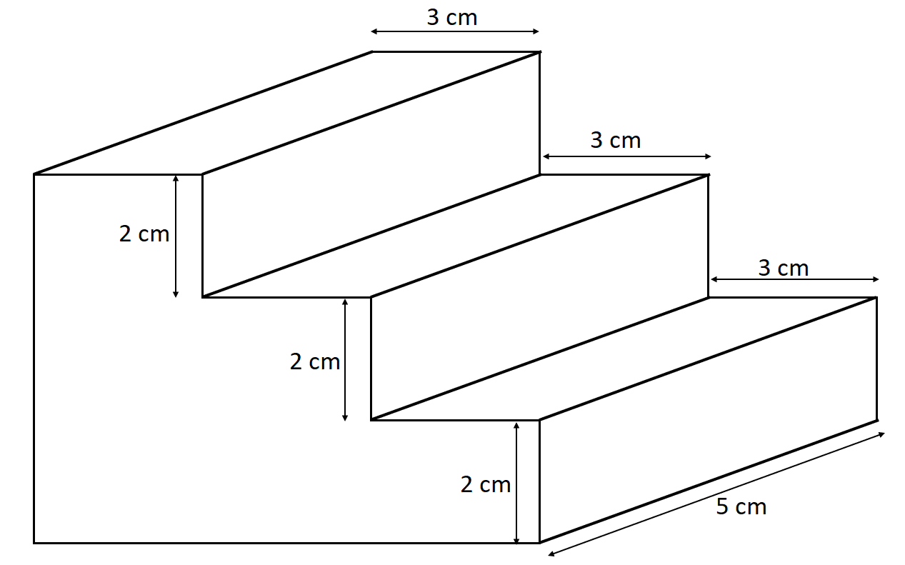The diagram shows a prism.

All the corners are right angles.

Work out the surface area of the prism.

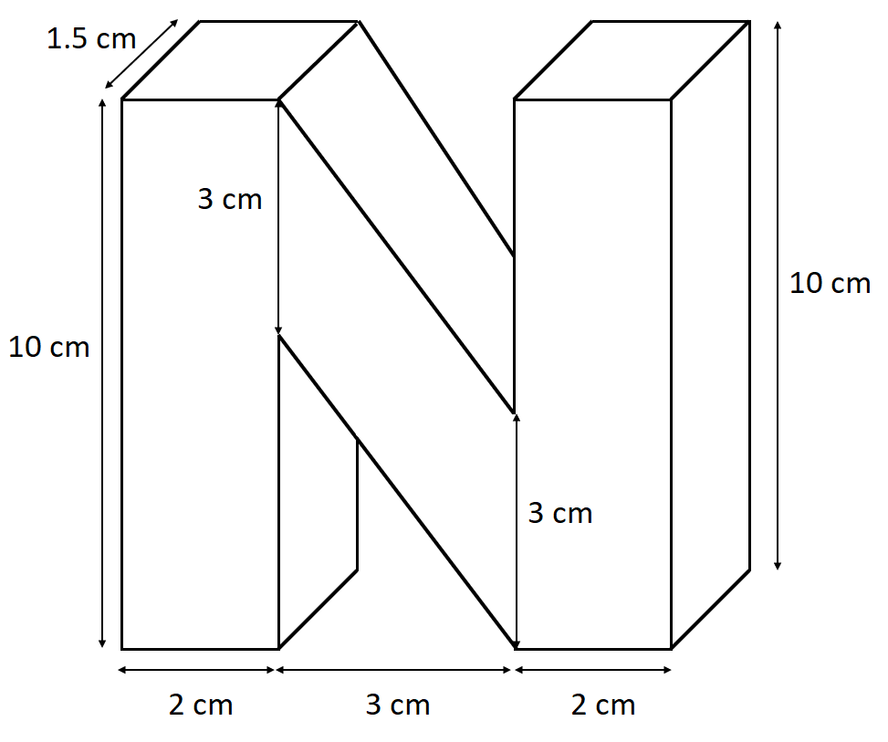

Here is a prism.

Work out the volume of the prism.

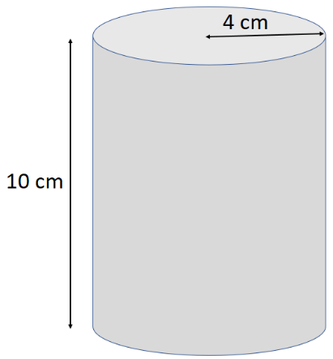

The diagram shows a cylinder with a height of 10 cm and a radius of 4 cm.

1. Calculate the volume of the cylinder.

Give your answer correct to 3 significant figures.

The cylinder is solid.

1. Calculate the total surface area of the cylinder. Give your answer correct to 1 significant figure.

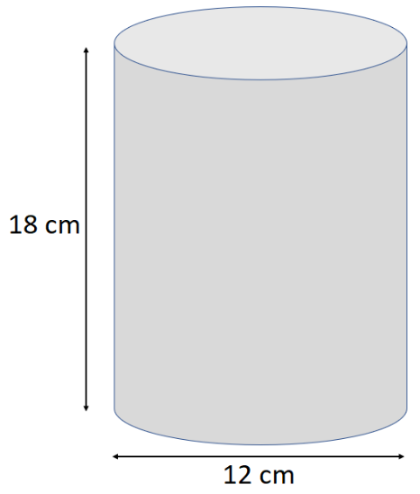The diagram shows a solid cylinder.

The cylinder has a height of 18 cm and a diameter of 12 cm.

Calculate the total surface area of the cylinder.

Give your answer correct to 1 decimal place.

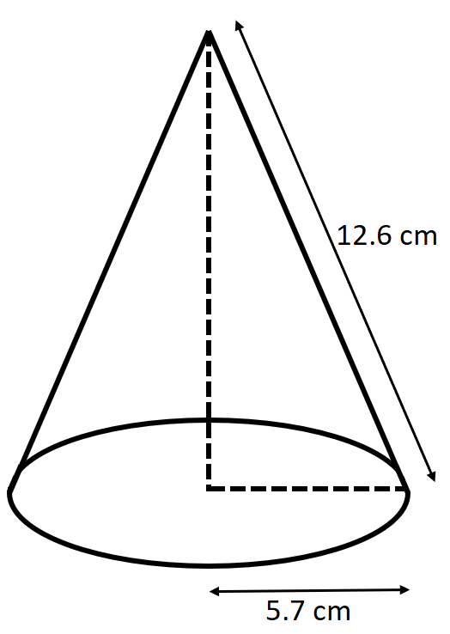The radius of the base of a cone is 5.7 cm.

The slant height is 12.6 cm.

1. Calculate the curved surface area of the cone.

Give your answer correct to 3 significant figures.

b) Calculate the volume of the cone.

Volume of a cone

= $\frac{1}{3}πr^{2}h$

Curved surface area of a cone

= $πrl$

Give your answer correct to 3 significant figures.

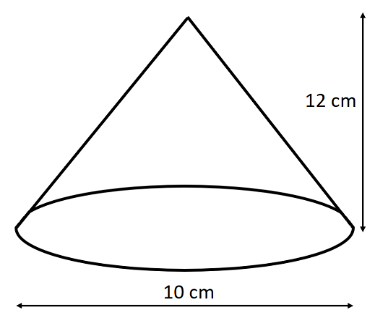The diagram represents a solid cone.

The height of the cone is 12 cm.

The diameter of the base of the cone is 10 cm.

1. Calculate the volume of the cone.

Give your answer correct to 3 significant figures.

Volume of a cone

= $\frac{1}{3}πr^{2}h$

Curved surface area of a cone

= $πrl$

1. Calculate the total surface area of the cone.

Give your answer correct to 3 significant figures.

[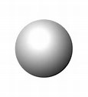](https://www.bing.com/images/search?q=sphere&id=957A0C5D5C37FE981A299D96BAE1680B4090F1B8&FORM=IQFRBA)

A steel sphere, radius 9 cm is shown.

1. Work out the volume of the sphere.

Volume of a sphere

= $\frac{4}{3}πr^{3}$

1. Work out the surface area of the sphere.

Curved surface area of a sphere

= 4

[](https://www.bing.com/images/search?q=sphere&id=957A0C5D5C37FE981A299D96BAE1680B4090F1B8&FORM=IQFRBA)

A steel sphere, radius 4 cm is shown.

1. Work out the volume of the sphere.

Volume of a sphere

= $\frac{4}{3}πr^{3}$

1. Work out the surface area of the sphere.

Curved surface area of a sphere

= 4 $πr^{2}$

A square of side length 4 cm forms the base of a pyramid.

Volume of a pyramid

= $\frac{1}{3} × base area × vertical height$

The pyramid has a vertical height 5 cm.

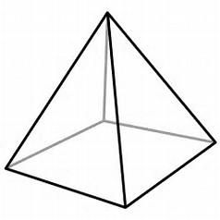Using the above formula, work out the volume of the

pyramid. Give your answer correct to 1 decimal place.

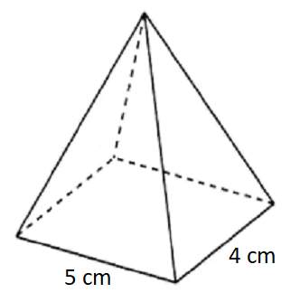

The pyramid shown below has a vertical height of 6 cm.

Work out the volume of the pyramid.

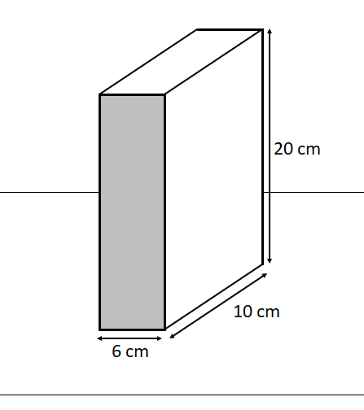Heather has a carton of orange juice.

The carton is in the shape of a cuboid.

The depth of the juice in the carton is 8 cm.

Heather closes the carton. She then turns the carton over so that it stands on the shaded face.

Work out the depth, in cm, of the orange juice now.

A sofa has 8 identical cushions.

Each cushion is a cuboid 18 cm by 80 cm by 95 cm.

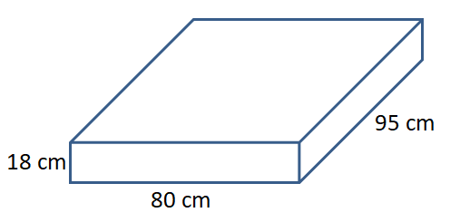

The cushions are covered with a protective spray.

The protective spray is in cans. The label on each can has this information:

Spray in this can covers 4 m2

Work out how many cans are needed to cover the 8 cushions.

The diagram shows a swimming pool.

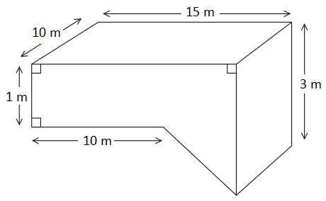

The swimming pool is in the shape of a prism.

The swimming pool is filled with water at a rate of 5 litres per second.

Jeremy has 10 hours to fill the swimming pool.

1 m3 = 1000 litres.

Will he completely fill the swimming pool in 10 hours?