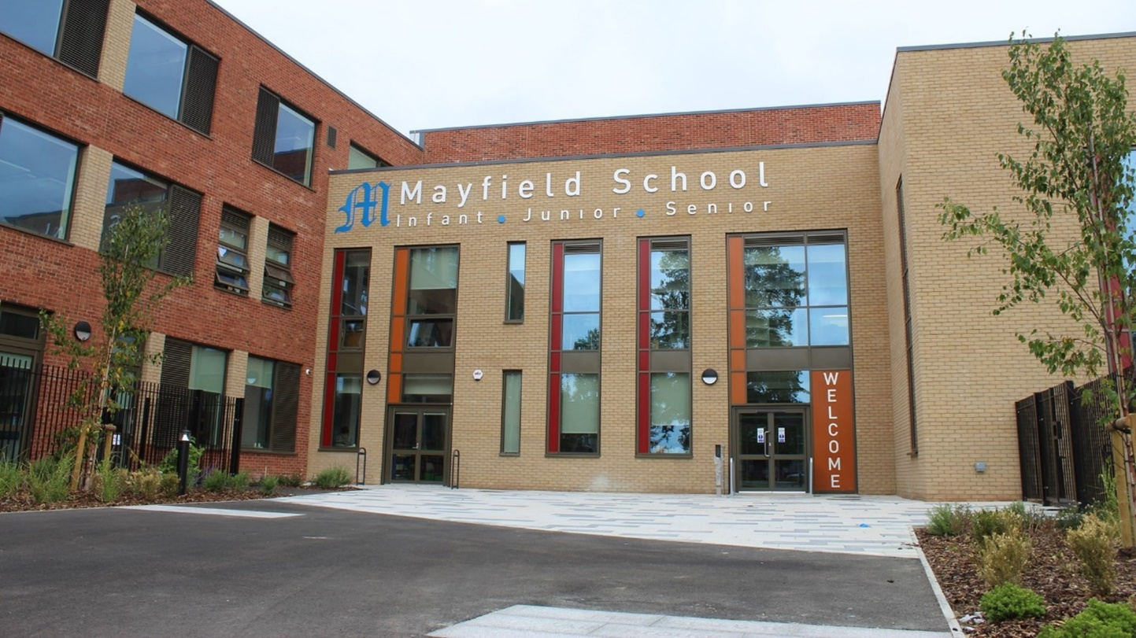

Deputy Head of Primary

Recruitment Pack

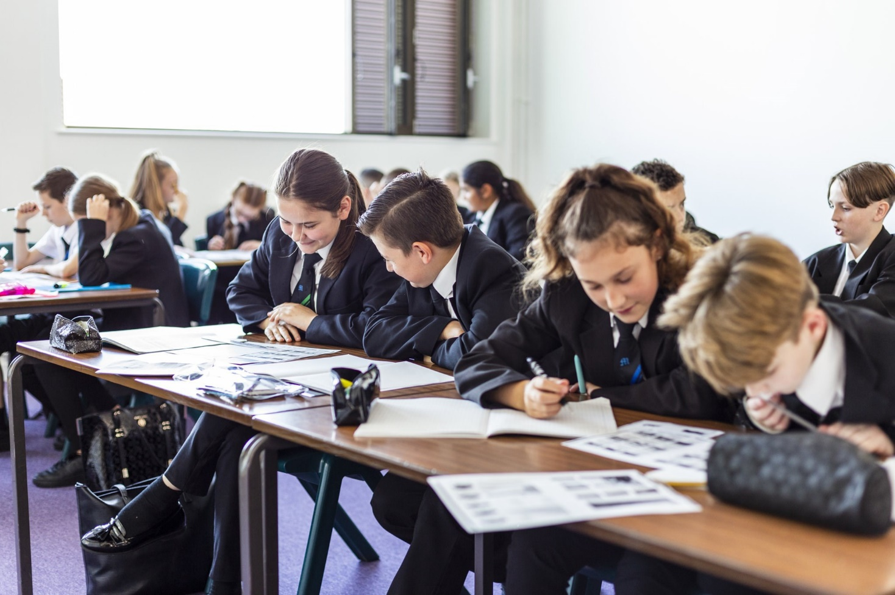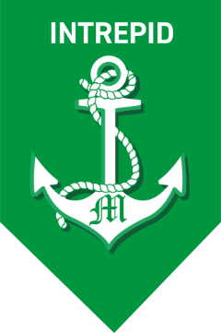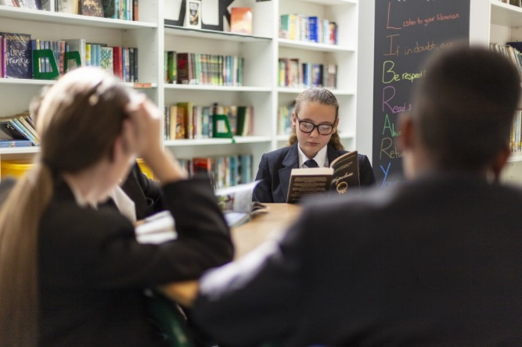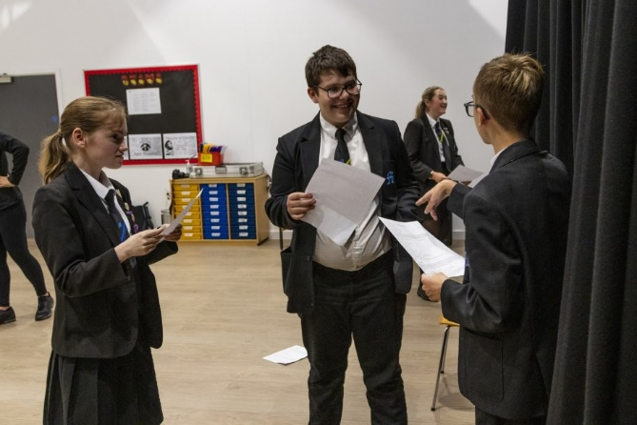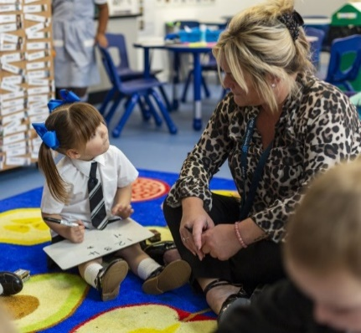

Letter from the Headteacher

Dear Applicant,
Thank you for your interest in becoming the new Mayfield School Deputy Head of Primary.
Firstly, Mayfield School is a fantastic school. A school that does have its challenges, but also a school with huge potential, a school that has made progress in many areas and a school with staff who are committed and dedicated to each and every pupil.
The Governing body is looking for a Deputy Head of Primary who has the drive, the leadership skills and the shared vision of the Head of Primary and the Headteacher of the whole school to ensure the primary section of the school continues to progress. I trust the information contained in this pack will assist you in deciding whether you are the right person to meet this challenge.
We believe Mayfield is a supportive, caring and exciting place to learn. It is a school that has a
curriculum to meet the needs of each pupil, an environment that recognises individual learning needs and we expect the new Deputy Head of Primary to build on the solid foundations, work with the Head of Primary to develop the Curriculum and the staff and to work with the leadership team of the whole school.
As one of the first single-site 'all-through' schools in the country, with a single vision, set of values, staff, and Governing Body we believe that we have a unique opportunity to improve and shape the lives of the
children in our community. In addition, in September 2021 we opened our doors to a brand new purposely built school building deigned to make this vision a reality.
Our school vision is to create a family ethos that raises aspirations and makes a real difference to the life chances of our young people.

Our school mission is for all stakeholders, together, to create an environment of respect and inclusion where all young people are valued, supported, inspired and future ready.
Mayfield is a unique school which offers staff and students great opportunities to develop; a school which truly believes that all pupils can ‘Believe. Achieve. Succeed.’
If you feel you have these skills and qualities, then we would very much welcome your application.
Yours sincerely
Mr Ashley Howard
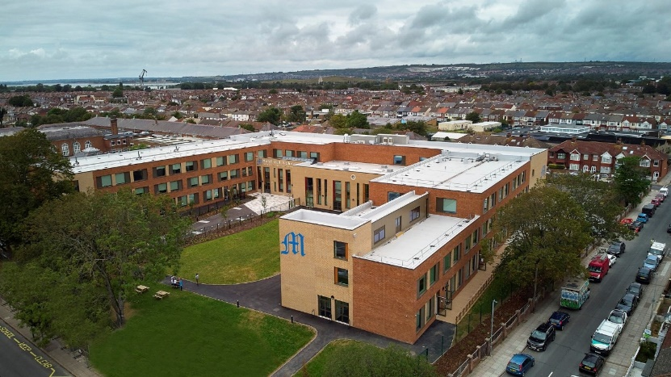
Headteacher
INTERNAL

Job Description
DEPUTY HEAD OF PRIMARY - Curriculum
Job Title: Deputy Head of Primary
Salary: Leadership Scale 10-14
Responsible to: Head of Primary and Headteacher
Line manager of: Designated Staff

Function of the post:
As an inspirational innovative leader you will work with the Headteacher of the school and the Head of Primary to drive the vision and strategic direction of the primary section of the school. You will work with the Head of Primary to empower and motivate staff and pupils to ensure excellence in learning and teaching and the continued rapid improvement of the primary section. Aligning to the culture and ethos of the school, you will work with the Head of Primary to provide a child-centred approach to education, an engaging curriculum and will inspire a sense of collective purpose, with high aspirations for pupils and staff. You will have an excellent knowledge of effective curriculum design and its implementation to ensure all children embed knowledge securely – knowing and remembering more across all subjects. You will also work collaboratively with parents and carers, the head of seniors, the school’s Senior Leadership Team, the Local Authority and other schools within and beyond Portsmouth developing and delivering a dynamic learning partnership and act as a positive role model and advocate for the school.

Principal Accountabilities:
- Design and provide a broad, balanced, relevant and stimulating curriculum, that is engaging and motivational to enable continued progress and improved pupil attainment;
- Take responsibility to ensure primary middle leaders are aligned to the aims and outcomes of year groups/phases to ensure an effective and collaborative contribution for the benefit of all pupils;
- Maintain good order, discipline and respect for others among pupils, promoting understanding of the school rules and values, safeguarding, health and safety and to develop relationships with and between pupils that enhances learning;
- Make a positive contribution to the strategic aims, values and ethos of school.

Deputy Head of Primary Accountabilities:
- Join the Executive Leadership Team consisting of the Headteacher, Head of Seniors, Head of Primary and Deputy Head of Seniors to provide strategic leadership across the whole school;
- Deputise for the Head of Primary as required;
- Provide leadership across the Primary Section
- Act as the key manager for either Year R to 3 or Year 4 to 6
- Play a significant role within the ‘Quality Assurance Team’ which asks three key questions. Are pupils:
-being taught the agreed content at the right times as outlined in the School Curriculum Plan?
- retaining the knowledge and making connections across the curriculum?
-being systematically prepared to be independent learners?
- Support the work of key middle leaders to ensure that there is high engagement in the intent, implementation and the measuring of impact of the Curriculum.
- Devise and implement bench marking tools to detect under performance and trigger interventions;
- Alongside the DSL, provide key leadership for all aspects of safeguarding;
- Work with key teams across the school to help embed the school’s ethos and values in all work undertaken
- To undertake a teaching commitment to be agreed with the Headteacher.

General Duties
ALL Staff members should ensure that they:
- are supportive of and willing to work in an ‘all through’ school environment;
- are clear about their areas of responsibility and how they will be held to account;
- have efficient and effective systems to underpin their work;
- attend meetings as directed by the Headteacher and Head of Primary.
- work collaboratively with all other teams in the school;
- produce any reports, data returns or data captures for the Team/Subject Leader or designate as required using any templates provided;
- support the Team/Subject Leader or designate in reviewing their own work and that of the team to ensure the work of the team is continuously and sustainably improved;
- actively and positively participate in school wide systems such as performance management system, annual leave, absence management etc;
- exploit opportunities to undergo professional development through skill sharing, flexible working or training;
- are prepared to share skills, work flexibly and attend training as required;
- remain "student focussed";
- support any controls on procurement, stock control and waste;
- keep working areas secure and free from clutter;
- support the Team/Subject Leader or designate in ensuring working areas project a highly professional image;
- comply with the school's dress code;
- ensure that any information about individual students is kept confidentially and not discussed with third parties;
- have read, understood and contributed to the school's improvement plan, team action plan or other improvement tools;
- have read, understood and actively promote the staff code of conduct;
- support whole school ethos being an advocate for relational practice.

Additional Responsibilities:

Teaching and Learning
- Plan, resource and deliver effective schemes of work and lessons, setting clear lesson objectives, specifying how children will be taught and clarifying how learning will be differentiated;
- Evaluate own teaching and planning critically and use this to improve own effectiveness;
- Mark and monitor pupils’ class and homework, providing written and oral feedback, and set targets for pupil progress;
- Develop innovative and engaging high quality teaching, along with robust assessment for learning that meets the needs of all pupils and leads to improved learning outcomes and raised standards of education;
- In liaison with colleagues, ensure appropriate educational provision is in place for pupils with SEND and for pupils in other vulnerable groups across all areas of the curriculum;
- Develop and apply appropriate teaching techniques, providing high quality resources, planning adult intervention, and creating real and relevant experiences, to inspire interest, and nurture understanding and enthusiasm amongst pupils;
- Encourage children to think about and reflect upon their own learning, becoming resilient, independent, co-operative and adaptable learners;
- Show commitment to creativity and innovation in the effective use of appropriate technologies to enhance provision, engagement and pupil progress;
- Work with colleagues to support the development of their subject expertise and skills;
- Lead and manage at least one curriculum subject as directed by the Head of Primary or Headteacher of the school, and develop plans which identify clear targets and success criteria for its development and / or maintenance, including subject policy and scheme of work;
- Produce an annual action plan for areas of responsibility;
- Monitor the subject through lesson observation, moderation and work scrutiny, to ensure consistency of standards and high expectations;
- Organise and plan for statutory testing as appropriate to subject and year group;
- Work with the Head of Primary and Head of Seniors to ensure a smooth transition and maintain effective provision for pupils transitioning from KS2 to KS3.

Planning and Managing Resources
- Contribute to the overall development of the school which may include resource management, budget management, programme planning and the strategic planning process;
- Contribute to the primary section of the school pupil assessment and target setting procedures, and moderation and monitoring systems, to ensure a robust analysis of pupil progress is maintained and used to inform intervention and future planning;
- Report on progress to parents and carers regularly including at consultation meetings and through an annual written pupil report;
- Maintain accurate pupil records, working with parents, carers and agencies as required, and with other colleagues including at times of transfer;
- Work collaboratively with the School’s Senior Leadership Team to ensure that the provision, progress and systems across the school lead to continuous improvement and contribute to the ‘All through’ vision.

Communication
- Communicate effectively with primary staff at all levels, pupils, parents and carers, visitors and stakeholders; ensuring statutory requirements are met.
- Report to Governors and staff as required;
- Provide regular information to the Head of Primary, Headteacher and governing body on the evaluation of the implementation and impact of the primary curriculum.

Liaison and Networking
- Develop links with external contacts such as other educational, authoritative and professional bodies to foster collaboration and share good practice;
- Contribute to a community where parents and carers are valued and in which they have access to appropriate up-to-date information, to support and improve their child’s progress.

Teamwork
- Maintain a high standard of professionalism that enables effective working with colleagues to deliver school improvement;
- Act to resolve conflicts effectively within and between teams through a restorative and relational approach.

Pastoral Care
- Take responsibility for ensuring effective and competent management of resolving pupil issues and ensuring support is in place as required;
- Create a positive culture where staff and pupils feel safe and are valued, where all pupils’ needs are supported and where all stakeholders work together effectively for the benefit of the pupils;
- Take responsibility to ensure pupils are aware of and adhere to the expected behaviour and conduct within both the classroom and around the school, in accordance with the school’s behaviour policy and in line with best practice;
- Be committed to safeguarding all children and staff at the school, in accordance with child protection and safeguarding policies;
- Ensure all practices relating to safeguarding and child protection are effective.

Other duties
You are required to undertake such other duties appropriate to the grade and content of the work as may reasonably be required of you. Therefore, the list of duties in this job profile should not be regarded as exclusive or exhaustive. Please note that, in consultation with you, the School reserves the right to update your job profile to reflect changes in, or to, your post.

Data Protection
You will be responsible for ensuring that workplace responsibilities within the School are carried out in compliance with the requirements of the Data Protection Act and the Employment Practices Data Protection Code, especially concerning confidentiality, treatment of personal information and records management.

Health & Safety
To ensure an effective and safe environment that promotes the welfare of children and staff, you will take responsibility to be aware of the risks in the work environment and their potential impact on their own work and that of others. You should familiarise yourself with the School’s Health and Safety policies.
Equality and Inclusion
The School believes that everyone has the right to be treated equally and that the diversity of individuals and groups should be embraced, valued, and respected. We are committed to eliminating any form of discrimination be it direct, indirect, harassment or victimisation. The School has a number of policies to support this commitment that you should ensure you are familiar with and compliant to. Any breaches may lead to termination of employment.
Sustainability and Environment
Mayfield School is committed to sustainable development and environmental initiatives. It accepts its environmental responsibilities and recognises the contributions it can make to the resolution of global, regional and local environmental issues. Staff are required to support these aims.

Right to Work
British and European Law states that a person cannot be employed to this post if they do not have permission to live and work in the UK.

Safer Recruitment:
Mayfield School is committed to safeguarding and promoting the welfare of children and young people and expect all staff to share this commitment. We will ensure that all our recruitment and selection practices reflect this commitment.

New members of staff will be required to apply for Disclosure Service certification as part of the School’s staff recruitment process. Further information about the Disclosure and Barring Service is available from the DBS website at www.gov.uk/dbs. Under the Rehabilitation of Offenders Act 1974 (Exceptions) Order 1075, applicants for teaching posts are among those who are not entitled to withhold information about any previous criminal conviction.

Principal Attributes and Person Specification Essential

Deputy Head of Primary – Person Specification
Essential requirements are those, without which, the candidate would not be able to do the job. It is expected that the post holder will have the knowledge and qualifications indicated or equivalent qualifications and experience.

Desirable requirements are those which would be useful for the post holder to possess and will be considered when more than one applicant meets the essential requirements.

Attributes | Essential | Desirable | Evidence
Education, Training, Qualifications | - Qualified teacher status  - Evidence of recent and relevant CPD  - Understanding of current trends in education both nationally and internationally | Higher degree or qualification  National Professional Qualification or other leadership and management training. | Interview/ Application form/Letter
Experience | - Successful experience at Middle leadership or Deputy level in the primary age range (EYFS, KS1 and 2), with evidence of leading a successful team to bring about rapid and sustainable whole school improvement that has had a positive impact on pupils achieving their full potential  - 10+ Years of successful teaching experience  - Led the development of the school’s Curriculum including EYFS  - Understanding of a relational approach and restorative practice  - Experience of being inspected by OFSTED at a senior level | Working in a variety of Primary Settings | Interview/ Application form/Letter
Skills and Abilities | - An “Outstanding” classroom teacher  - Anticipate problems and develop creative solutions within the context of a large ‘all through’ school  - Evidence of demonstrable leadership qualities, with the ability to set and achieve challenging goals which achieve improvement  - Evidence of strong emotional intelligence and the ability to work with staff in a way that motivates and engages staff and develops a strong team approach to delivery.  - Able to build and maintain positive relationships with individuals and groups. Excellent people skills; managing issues in a sensitive, supportive but appropriate manner.  - A skillful communicator with strong, interpersonal and presentation skills, both verbal and written, which naturally adapts to a diverse audience, e.g. governors, parents and carers, staff, pupils and the wider community on a wide range of issues to provide clarity of vision, influence and direct or challenge others  - Prioritise, plan and organise self. Good ICT and administrative skills to enable effective implementation of tasks required of a Deputy Headteacher  - Networking skills that build a professional learning community and enable good practice to be shared for the benefit of the school. | Use of systems such as SIMS, CPOMS, Classcharts etc | Application  Interview  Presentation  References
Personal Attributes | - Desire to work in an ‘all through’ environment  - Attributes that enable and empower individuals and teams to innovate and achieve, where success is celebrated and individuals are motivated to achieve high goals and accept responsibility for outcomes  - Commitment to equality and inclusivity which allows the academic, spiritual, moral, social, emotional and cultural development of pupils, celebrating and recognising the differing needs of pupils and staff in a diverse and multicultural Britain, challenging assumptions and preconceived ideas.  - An ability to foster an open, innovative, equitable culture, dealing with difficult decisions or situations in a timely manner, making reasoned judgements, conveying conclusions clearly, positively and sensitively  - The personal resilience required of a leader, with the ability for self-reflection and a positive approach that enables constructive relationships and feedback to aid continuous improvement.  - A commitment to the mission and values of the whole school community and to collaborative working for the benefit of all pupils personal and academic successes. |  | Interview  Presentation  References

Application and selection procedures:

Your application should relate specifically to the person specification and also include information on:
- your education philosophy;
- your view of the role of the Headteacher;
- what you feel you could bring to this school.

Completed application forms should be returned no later than 3pm, Friday 21st April 2023
to hollis@mayfield.portsmouth.sch.uk or by post to Mayfield School, Mayfield Road, Portsmouth, PO2 0RH.

Interviews will be held during the week commencing 1st May 2023. References will be taken up
immediately after shortlisting. Candidates are asked to ensure that their referees are advised of this.

Safer Recruitment Mayfield School and Portsmouth Local Authority are committed to safeguarding and promoting the welfare of children, and young people, and expect all staff and volunteers to share this commitment. DBS Disclosure at Enhanced level will be required.

Data Protection Act 1998 You should be aware that the information you have provided will be stored on Portsmouth City Councils secure recruitment database and will only be used to process your application. It will not be passed to any other organisation.

The duties and responsibilities in this job description are not restrictive and the post-holder may be required to undertake any other duties that may be required from time to time. Any such duties should not however substantially change the general character of the post.

