Apprenticeships offer the chance to earn a wage whilst learning. You will mainly train in the work place, but will also attend college or a specialist training provider as part of your apprenticeship framework.

Apprentices are entitled to the apprentice rate if they’re either:
• aged under 19
• aged 19 or over and in the first year of their apprenticeship
The current apprentice rate is £3.30 per hour BUT from the 1st October 2016 will increase to £3.40 per hour. It should be noted that quite a few employers pay above this hourly rate.

Further details around the national minimum hourly rate and the national living wage can be found at https://www.gov.uk/national-minimum-wage-rates.

Apprenticeships are now available in most industries:
- Agriculture, Horticulture and Animal care.
- Arts, Media and Publishing.
- Business, Administration and Law.
- Construction, Planning and The Built Environment.
- Education & Training.
- Engineering & Manufacturing Technologies.
- Health, Public Services and Care.
- Information and Communication Technology.
- Leisure and Travel & Tourism.
- Retail and Commercial Enterprise.
Further details of all the apprenticeships offered in these industries can be found at www.gov.uk/topic/further-education-skills/apprenticeships#types-of-apprenticeships.

Levels of apprenticeships:

Apprenticeship Name | Level | Equivalent educational level
Intermediate | 2 | 5 GCSE passes at grades A* to C
Advanced | 3 | 2 A level passes
Higher | 4,5,6 and 7 | Foundation degree and above
Degree | 6 and 7 | Bachelor’s or master’s degree

Entry requirements vary, but for Intermediate and Advanced Apprenticeships most employers look for GCSE A* to C grades in at least English, Maths and for some jobs a Science or Technology subject. For Higher and Degree Apprenticeships most employers look for A level’s or equivalent qualifications (BTEC Level 3 Extended Diploma and/or Foundation Degree, HNC, HND). It is important to look at each apprenticeships entry requirements.

You will need to be well prepared for an apprenticeship. You should do some research on the company or companies; look at the different roles on offer and think about which one(s) interest you the most. Remember you will be competing against other people for the apprenticeship. Ideally you should also try and do some work experience or take part in something that allows you to demonstrate you have the skills for that job (for example being the finance director for your Year 11 business enterprise challenge or being the team leader on your Duke of Edinburgh Expedition). Doing some preparation will help you confirm your interest in the apprenticeship area and also prepare you for when you get invited for an interview.

For more information on what apprenticeships are about go to
www.getingofar.gov.uk

How to find an apprenticeship Option 1:

To look for national and local apprenticeship vacancies go to the apprenticeship website:
www.gov.uk/apply-apprenticeship.

Most employers are now encouraged to advertise their apprenticeship vacancies on this Government Site but not all do.
How to find an apprenticeship Option 2:
Local and National Training Providers, Colleges and Employers who offer Apprenticeship Opportunities
Company | For further information on apprenticeship opportunities contact:
Paragon Skills  Apprenticeships offered:  Business & Admin, Care, Childcare, Customer Service, Engineering & Technology, Hairdressing, Hospitality & Catering, Motor, Retail, Warehousing and Storage. | Website: www.paragonskills.co.uk/young-people/home-page  Freephone: 0800 783545
PETA Training  Apprenticeships offered:  Business (Portsmouth Site), Engineering (Havant Site) and IT (Cosham). | Website: www.peta.co.uk  Tel: 023 9253 8700
Highbury College  Apprenticeships offered:  Admin & Financial Services, Animal Care, Automotive, Beauty, Business, Catering, Early Years, Computing, Construction & Built Environment, Engineering, Floristry, Hairdressing, Health & Social Care, Legal, Leisure, Travel & Tourism, Retail and Science. | Website: www.highbury.ac.uk/apprenticeship  Tel: 023 9238 3131
Chichester College  Apprenticeships offered:  Business, IT & Management, Construction, Creative & Cultural, Health & Social Care & Early Years, Landbased, Motor Industries and Service Industries | Website: https://chichester.ac.uk  Tel: 01243 786321
Portsmouth College  Apprenticeships offered:  Activity Leadership, Animal Care, Business & Admin, Childcare, Customer Service, Exercise & Fitness, Hairdressing, Marketing, Sports Development and Supporting Teaching & Learning in PE & School Sport. | Website: www.portsmouth-college.ac.uk  Tel: 023 9266 7521
Note: Please remember with some of the training providers and colleges, you will be required to find your own employer. Be sure to ask how the training provider or college will work with you and support you in finding an employer.

Company | For further information on apprenticeship opportunities contact:
South Downs College  Apprenticeships offered:  AAT Accounting, Beauty Therapy, Business Administration, Customer Service, Design & Media, Early Years Educator (Childcare), Engineering  Enterprise, Exercise & Fitness, Food & Beverage Service, Hairdressing, Hospitality & Catering  Leisure Management, Management & Team Leaders, Marketing and Professional Cookery. | Website: www.southdowns.ac.uk/apprenticeships  Tel: 023 9279 7979
MIT Training  Apprenticeships offered:  Electrical Installations, Hair, Motor Vehicle, Performing Engineering Operations, Performing Manufacturing Operations, Plumbing, Preparing to Teach in the Lifelong Learning Sector (PTLLS) and Rail | Website: https://mitskills.com  Tel: 01932 341416  Surrey Based provider
WEBS Furniture Training  Apprenticeships offered:  Furniture Upholstery, Sewing, Wood Machining, Cabinet Making, Frame Making, Polishing, Component Manufacturing, Restoration/Finishing, Timber Merchants, Installations and Supervision. | Website: www.webstraining.com  Tel: 0115 967 7771
Fareport  Apprenticeships offered:  Please refer to their website. | Website: www.fareport.co.uk  Tel: 01329 825805
Catch 22  Apprenticeships offered:  Please refer to their website | Website: www.catch-22.org.uk  Tel: 023 9286 1228
Smart Training and Recruitment  Apprenticeships offered:  Business Admin, Business Improvement Techniques, Cleaning & Support, Customer Service, Hospitality & Catering, IT, Personal Fitness, Retail, Sales, Team Leading & Management and Warehousing & Storage. | Website: www.smarttar.co.uk  Tel: 0330 088 0888
First4skills  Apprenticeships offered:  Business & Admin, Contact Centre Operations, Customer Service, Financial Services, Hospitality, Logistics & Warehousing, Retail and Team Leading. | Website: www.first4skills.com  Tel: 0330 024 9363
Company | For further information on apprenticeship opportunities contact:
HIT ( Hospitality Industry Training)  Apprenticeships offered:  Hotel & Catering  Bar Staff, Barista, Chef, Cleaner, Housekeeping, Porter, Receptionist, Team Leading and Waiting Staff. | Website: https://hittraining.co.uk  Tel: 0800 093 5892
HTP Training  Apprenticeships offered:  Portsmouth Base:  Business Admin, Cleaning Services, Customer Service, Health & Social Care, Hospitality, Professional Cookery and Retail.  Isle of Wight Base:  All of the above plus Childcare, Fitness Instructing and Nail Technology. | Website: www.htptraining.com  Portsmouth Base Tel: 023 9237 4752  IOW Base Tel: 01983 533926
Learn Direct  Apprenticeships offered:  Business & Admin, Childcare, Customer Services, Dental Nursing, Health & Social Care, IT, Recruitment and Retail. | Website: www.learndirect.com  Tel: 0800 101901
Eastleigh College Training Agency  Apprenticeships offered:  Multiple apprenticeship opportunities please refer to their website. | Website: http://www.eastleigh.ac.uk/student-support/apprenticeships  Tel: 023 8091 1195
PGL  Apprenticeships offered:  Activity Leadership  Hospitality & Catering  Drink Services and Front Office & Customer Service, Centre Support Roles  Business & Admin, Customer Service and Cleaning & Environmental Support Services. | Website: www.pgl.co.uk  Tel: 0333 321 2123
Haddon Training  Apprenticeships offered:  Equine and Land Based  Animal Care, Business Admin, Customer Service, Horse Care, Racing, Saddlery, Sporting Excellence AASE in British Show Jumping and Team Leading & Management. | Website: www.haddontraining.co.uk  Tel: 01672 519977
Care Learning Centre  Apprenticeships offered:  Please refer to their website. | Website: www.carelearningcentre.co.uk  Tel: 01983 533993

Company | For further information on apprenticeship opportunities contact:
Lifetime Training Academy  Apprenticeships offered:  Beauty, Business Admin, Early Years, Fitness, Health & Social Care, Hospitality and Retail. | Website: www.lifetimetraining.co.uk  Tel: 0333 0143669
FNTC  Apprenticeships offered:  Business & Admin, Childcare, Customer Service, Health & Social Care, Management and Supporting Teaching & Learning. | Website: www.fntctraining.co.uk  Tel: 01794 523857
St Vincent College  Apprenticeships offered:  Business Administration, Children & Young People’s Workforce, Customer Service, Hairdressing, Health & Social Care and Supporting Teaching & Learning. | Website: www.stvincent.ac.uk  Tel: 023 9260 3669
Sparsholt College  Apprenticeships offered:  Arboriculture, Forestry & Woodland Management (Trees & Timber), Agriculture, Animal Care, Butchery, Digital Learning Design, Environmental Conservation, Equine Studies & Horse Care, Fish Husbandry & Fish Management, Game Keeping & Wildlife Management, Horticulture including Turf Care & Greenkeeping, Nursing Assistant in a Veterinary Environment, Vehicle Fitting (Fast Fit) and Veterinary Nursing. | Website: www.sparsholt.ac.uk  Tel: 01962 776441
City College Southampton  Apprenticeships offered:  Business: Accounting, Business Admin, Housing and IT.  Construction: Bench Joinery, Bricklaying, Building Services, Civil Engineering, Construction Contracting, Electrical Installation, Heating & Ventilation, Painting & Decorating and Site Carpentry.  Engineering: Electrical/Electronic Engineering, Fabrication & Welding and Mechanical Engineering.  Marine: Boat Building, Marine Electrical and Marine Engineering.  Motor Vehicle: Heavy and Light.  Health & Education: includes Early Years (Childcare), Health & Social Care and Supporting Teaching and Learning.  Service Industries: Barbering, Beauty Therapy, Hair and Hospitality & Catering. | Website: www.southampton-city.ac.uk/apprentice  Tel: 023 8048 4848

Company | For further information on apprenticeship opportunities contact:
Fareham College  Apprenticeships offered:  Accounting, Beauty, Business Admin, Childcare, Construction, Engineering, Hairdressing & Beauty, Healthcare Support, Health & Social Care, Horticulture, Hospitality & Catering, IT Support, Live Events & Promotion, Marketing and Sport, Exercise & Fitness. | Website: www.fareham.ac.uk/apprenticeships-2  Tel: 01329 815200
Havant College  Apprenticeships offered:  Business & Admin, Clinical Health, Health & Social Care, IT Application Specialist and Supporting Teaching & Learning in Schools. | Website: www.havant.ac.uk/sixth-form/apprenticeships  Tel: 023 9248 3856
Brockenhurst College  Apprenticeships offered:  Beauty & Complimentary Therapies, Childcare & Early Years, Construction, Marine & Engineering, Customer Service & Business Admin, Health & Social Care, Hospitality & Catering, IT, Management, Retail, Sport & Fitness, Supporting Teaching & Learning and Warehousing & Logistics. | Website: www.brock.ac.uk/apprenticeships  Tel: 01590 625589
Totton College  Apprenticeships offered:  Please refer to their website | Website: www.totton.ac.uk  Tel: 023 8087 4874
Basingstoke College of Technology  Apprenticeships offered: Accountancy, Barbering, Beauty Therapy, Business Administration, Business Improvement, Carpentry & Joinery, Childcare, Clinical Healthcare Support, Construction & The Built Environment, Creative & Digital Media, Customer Services, Electrical Installation, Engineering, Food & Beverage Service, Food Cooking & Production, Hairdressing, Hospitality Services, Hospitality Supervision & Leadership, Interior Systems, IT, Software, Web & Telecoms Professional, Light Vehicle Maintenance & Repair, Maintenance Operations, Management, Nail Services, Painting & Decorating, Plumbing, Procurement, Professional Cookery, Sales & Telesales, Supporting Teaching & Learning in Schools, Team Leading and Warehousing, Storage & Logistics | Website: www.bcot.ac.uk/business  Tel: 01256 306379
Company | For further information on apprenticeship opportunities contact:
Babcock International  Apprenticeships offered:  Please refer to their website. | Website: www.babcockinternational.com/  careers/apprenticeships
Skillnet  Apprenticeships offered:  Automotive, Transport & Logistics and Non-Technical (includes Management, Team leading, Customer Service, Sales, Business Admin, Retail and Retail Management. | Website: www.skillnet.org.uk
PDM Training and Consultancy  Apprenticeships offered:  Business Admin, Customer Services, Health & Social Care, Supporting Teaching & Learning in Schools, Team Leading, Management, Supply Chain Management, Warehousing & Storage, Driving Goods Vehicles, Security and Trowel Occupations. | Website: www.pdmtc.co.uk/apprenticeships.html  Tel: 0113 270 9637
REMIT  Apprenticeships offered:  Automotive, Business, Food Manufacturing, Health & Social Care, Hospitality and IT & Digital Technology. | Website: www.remit.co.uk/apprenticeships  Tel: 0115 975 9550
Jaguar Land Rover  Apprenticeships offered:  Advanced apprenticeships in Engineering (different branches).  Degree Apprenticeships in Engineering, Finance & Accounting. | Website: www.jaguarlandrovercareers.com
BMW  Apprenticeships offered:  Body Repair, Vehicle Service and Parts Operations. | Website: www.bmweducation.co.uk/page/careers
Royal Mail  Apprenticeships offered:  Engineering and Fleet Vehicle Technician  Project Management and Finance offered at Higher Level | Website: www.royalmailgroup.com/careers/apprenticeships
Company | For further information on apprenticeship opportunities contact:
Youth Force  Apprenticeships offered:  Teaching Assistant, Lab & Science Technician, Business Admin, IT Systems Support and Activity Leadership. | Website: www.youthforce.co.uk/apprenticeships  Tel: 01273 776779
SGN (Scotia Gas Network)  Apprenticeships offered:  Electrical & Instrumentation (Multi Skilled Depot), Pipelines Maintenance and Pressure Control. | Website: www.sgn.co.uk/About-SGN/SGN-Apprenticeships
British Telecom  Apprenticeships offered:  Customer Service & Call Centre Management, Engineering, Finance, HR, IT and Vehicle Maintenance. | Website: https://btplc.com/careercentre/ourlocations/UK/Apprenticeships
RBS  Apprenticeships offered:  Commercial & Private Banking: Relationship Management, Business Admin & Customer Service  Service: Business Admin, Technology & Customer Service  Core Functions: Human Resources, Credit Risk & Finance | Website: https://yourpassionyourpotential.rbs.com/pages/apprenticeships
Aldi  Apprenticeships offered:  Stores and Logistics. | Website: www.aldirecruitment.co.uk/apprentice
Whitbread Group:  Well-known restaurants include Beefeater Grill, Brewers Fayre, Table Table and Taybarns. Other brands part of the Whitbread Group Premier Inn and Costa  Apprenticeships offered:  Hospitality Services  Bar Staff, Barista, Chef, Cleaner, Housekeeping, Porter, Receptionist, Team Leading and Waiting Staff. | Website: www.whitbread.co.uk/careers/index.html
Spec Savers  Apprenticeships offered:  Retail Optical. | Website: jobs.specsavers.co.uk/explore-careers/optical-apprenticeship
Company | For further information on apprenticeship opportunities contact:
Marriott  Apprenticeships offered:  Hospitality & Catering  Bar Staff, Barista, Chef, Cleaner, Housekeeping, Porter, Receptionist, Team Leading and Waiting Staff. | Website: www.marriott.com/careers
Civil Service  Apprenticeships offered:  Civil Service Fast Track Scheme  Business Admin, Commercial, Digital & Technology, Finance and Project Delivery. | Website: https://www.gov.uk/guidance/civil-service-fast-track-apprenticeship-fast-track-schemes
British Marine  Represents businesses involved in the  - Leisure boats - seagoing and inland  - Small commercial workboats up to 24m  - Superyachts  - Hire fleets  Apprenticeships offered:  Please refer to the website to see all the different types available. You will need to register and then log in. | Website: https://britishmarine.co.uk/Services/Growth/Training/Apprenticeships
Maritime Skills  Access, links and information to all sectors who offer apprenticeships in the Maritime Industry. | Website: www.maritimeskills.org
Gosport Football Academy  Apprenticeships offered:  Football Coaching & Sports Development. | Website:  Gosport Football Academy: http://www.tonys-soccer-school.net/football-trials-16-to-18/23620-gosport-boroughs-fc-academy.html

Hair and Beauty
Company | For further information on apprenticeship opportunities contact:
Hair OTT  Apprenticeships offered:  Hairdressing - branches in North End, Cosham, Waterlooville, Lakeside and Whitely. | Website: www.hairottacademy.co.uk  Tel: 023 9237 7373
Nikki Froud  Apprenticeships offered:  Barbering and Hairdressing. | Website: https://nikkifroud.com/training  Tel: 023 9255 6222
Company | For further information on apprenticeship opportunities contact:
Academy at No 5 Ltd  Apprenticeships offered:  Barbering and Hairdressing. | Website: www.academy5.co.uk  Tel: 01329 286250
HaHa (Hampshire Apprenticeship Hairdressing Academy)  Apprenticeships offered:  Barbering, Beauty and Hairdressing. | Website: www.hahatraining.co.uk  Tel: 023 9266 6151

Engineering
Company | For further information on apprenticeship opportunities contact:
Network Rail  Apprenticeships offered:  Track, Off Track, Overhead Lines, Signalling, Telecoms and Electrification & Plant. | Website: http://www.networkrail.co.uk/careers
BAE Systems Maritime Services Portsmouth  Apprenticeships offered:  Electrical Fitter, Fabricator, Facilities Electrical Fitter, Facilities Mechanical Fitter, Joiner, Mechanical Fitter, Outfitter, Pipe Worker and Welder.  At Higher Level Project Control | Website: www.baesystems.com/en/careers/careers-in-the-uk/apprenticeships
SETA (Southampton Engineering Training Association)  Apprenticeships offered:  Mechanical Engineering, Electrical & Electronic Engineering, Fabrication & Welding and Engineering Construction. | Website: www.seta-training.co.uk  Tel: 023 8087 8319
Defence Munitions Gosport  Apprenticeships offered:  Mechanical Engineering | Email: Kevin.Haydock188@mod.uk  Or see your school careers adviser for details.
Company | For further information on apprenticeship opportunities contact:
Vector Aerospace (Officially part of the Airbus Group but have been allowed to keep their own branding)  Apprenticeships offered:  Mechanical Engineering, Electrical Engineering, Shared Technical Services and Boeing Sponsorship Apprenticeship. | Website: www.vectoraerospacecareers.com/WhatJobs.aspx
Airbus Group: Airbus, Airbus Helicopters, Airbus Defence & Space (EADS Group and Astrium now part of the Airbus Group)  Apprenticeships offered:  Engineering across a number of disciplines – please refer to the website for more information. | Website: www.airbusgroup.com/int/en/people-careers/apprentices
ECITB (Engineering Construction)  Apprenticeships offered:  Craft  Pipefitting, Mechanical Fitting, Plating, Welding, Steel Erecting, Electrical Installation, Moving Load and Instrument Pipefitting.  Technician  Instrument & Control Maintenance Offshore, Mechanical Maintenance Onshore, Electrical Maintenance Onshore, Design & Draughting, Project Control, Non Destructive Testing and Construction & Completions Control.  Oil and Gas  Mechanical Maintenance Offshore, Electrical Maintenance Offshore, Instrumentation and Control Maintenance Offshore. | Website: www.ecitb.org.uk/Apprenticeships-Careers/Apprenticeships
EDF Energy  Apprenticeships offered:  Engineering Maintenance.  Business (A levels or equivalent needed).  Smart Metering (Driving Licence needed).  Commercial (A levels or equivalent qualification needed). | Website: www.edfenergy.com/careers/early-careers/apprenticeships
Trend Attitude  Apprenticeships offered:  Building Controls Engineer | Website: www.trendattitude.co.uk/attitude-apprenticeships.html  Tel: 01403 226433  West Sussex based
Company | For further information on apprenticeship opportunities contact:
SSE (Scottish & Southern Energy)  Apprenticeships offered:  Power Distribution  Electrical Fitter, Underground Cable Joiner, Overhead Linesperson and Multiple Craft.  Contracting Business  Electrical and High Voltage Fitter & Railway Services  Generation Business  Renewable Operations, Hydro Engineering and Renewable Operations – Onshore Wind.  Generation Thermal Operations. | Website: https://sse.com/apprentices  Tel: 0345 0721942 Option 2  Email: apprenticesandtrainees@sse.com
National Grid  Apprenticeships offered:  Electrical & Instrumentation, Emergency Response, Gas Operations, Liquefied Natural Gas, Pressure & Control & Storage and Substations. | Website: www.careers.nationalgrid.com
British Gas  Apprenticeships offered:  Central Heating Installation Engineer and Service & Repair Engineer.  Trainee Roles available:  Trainee Smart Metering, Trainee Electrician and Trainee White Goods. | Website: http://www.britishgasjobs.co.uk/careers/apprentices-and-trainees
Veolia Environmental Services  Apprenticeships offered:  From Drivers to HR Professionals, Sales Managers to Engineers, Financial Controllers to Loaders, Lab Technicians to Landscape Gardeners; there are a variety of operational, management and administration jobs. |  | Website: www.campus.veolia.co.uk/apprenticeships  Tel: 020 7812 5000  All vacancies are advertised on www.gov.uk/apply-apprenticeship
Exxon Mobil  Apprenticeships offered:  Engineering – specialisms in Instrument, Electrical, Machinery and Metal Trades. |  | Website: www.exxonmobil.co.uk/UK-English/HR/jobs_traineeships.aspx
Leonardo (Selex Sensors & Airborne Systems now part of Leonardo group)  Apprenticeships offered:  Technical, Software, Manufacturing and Business. |  | Website: www.uk.leonardocompany.com/people-careers/apprenticeships
Company |  | For further information on apprenticeship opportunities contact:
A Plant  Apprenticeships offered:  Plant Maintenance, Customer Service, Drivers, HR & Credit Control. |  | Website: http://www.aplant.com/careers/apprenticeships  Nearest Sites: Ford (West Sussex) and Brighton.
GE Aviation (Hamble)  Apprenticeships offered:  Engineering. |  | Website: www.ge.com/uk/careers
Griffon Hoverwork  Apprenticeships offered:  Marine Electrical, Marine Engineering, Marine Outfitters, Aluminium Fabricators/Welders, Marine Composites Technicians, Stores, CAD Draughtsperson and Sales/Marketing/Customer Service. |  | Website: www.griffonhoverwork.com/about-us/careers/apprenticeships.aspx  Email: apprentices@GriffonHoverwork.com
Britten Norman  Apprenticeships offered:  Engineering and Designing. |  | Website: www.britten-norman.com  Email: recruitment@britten-norman.com

Construction
Company | For further information on apprenticeship opportunities contact:
Carillion Plc  Apprenticeship offered at Southampton Site:  Carpentry and Bricklaying. | Website: www.carillionplc.com/nicrosites/constructions-apprenticeships  Tel: 023 8070 6161
CITB  Apprenticeships offered:  Over 30 different types of apprenticeships available in Construction; please refer to the CITB website for full details. | Website: www.citb.co.uk/citb-apprenticeships
JTL  Apprenticeships offered:  Electrical, Plumbing, Heating & Ventilation and Engineering Maintenance. | Website: www.jtltraining.com/apprenticeships  Tel: 0800 085 2308
Steve Willis Training  Apprenticeships offered:  Gas, Electrical and Plumbing. | Website: www.stevewillis.com/apprenticeships  Tel: HAMPSHIRE Centre Tel 02392 190190 and SUSSEX Centre Tel 01444 870860
Company | For further information on apprenticeship opportunities contact:
BEST Ltd  Apprenticeships offered:  Air Conditioning Engineer, Building Services Engineer, Domestic Heating Fitter, Electrotechnical, Plumbing, Heating & Ventilation Engineer, Refrigeration Engineer, Service & Maintenance Engineer and Ductwork Apprentice. | Website: www.best-ltd.co.uk/apprentices  Tel: 0800 917 8419

IT
Company | For further information on apprenticeship opportunities contact:
Basingstoke ITEC  Apprenticeships offered:  Information Technology, Telecoms, Software & Web Professional, Business & Admin, IT Security and Customer Service. | Website: www.basingstokeitec.co.uk/apprenticeships  Tel: 01256 471161
IBM  Apprenticeships offered:  Business and Technology. (Please note A Levels or equivalent required) | Website: www.05.ibm.com/employment/uk

Motor Vehicle
Company | For further information on apprenticeship opportunities contact:
Stagecoach  Apprenticeships offered:  Body Repair, Mechanics, Electrics, Coach Building and Vehicle Electrician. | Website: www.stagecoachbus.com/careers  National Opportunities
Toyota  Apprenticeships offered:  Service Advisor, Body/Paint Technician, Service Technician and Parts Advisor. | Website: www.toyota.co.uk/world-of-toyota/careers/apprenticeships.json
Ford  Apprenticeships offered:  Car Technician, Van Technician, Rapid Fit, Service Advisor, Accident repair Centre Advisor, Parts Advisor, Vehicle Body Technician, Vehicle Body Paint Technician, Commercial Vehicle Sales Executive and Vehicle Sale Executive. | Website: www.ford.co.uk/experience-ford/AboutFord/FordCareers/Assessment-Information/Apprentice
Company | For further information on apprenticeship opportunities contact:
Mercedes  Apprenticeships offered:  Parts Operation Specialist, Light vehicle Technician and Heavy Vehicle Technician. | Website: https://careers.mercedes-benz.co.uk/apprentice-scheme
Volkswagen Group  Apprenticeships offered:  Service Technician and Parts Adviser. | Website: www.volkswagen-apprentice.co.uk
Peugeot  Apprenticeships offered:  Service Technician, Service Customer Adviser, Parts Customer Adviser, Vehicle Sales Adviser, Aftersales/Commercial and Business Administrator. | Website: www.peugeotapprenticeships.org.uk
Halfords Autocentres  Apprenticeships offered:  Automotive Technician and Retail. | Website: www.halfordscareers.com
Thatcham Automotive Academy  Apprenticeships offered:  Body Repair (Panel), Body Refinisher (Paint), Body Fitters (MET – Mechanical, Electrical & Trim), Vehicle Damage Assessor (VDA) and Customer Services. | Website: https://thatcham.org/apprenticeships
Nationwide Crash Repair Centre  Apprenticeships offered:  Vehicle Technician  Paint Spraying, Panel Beating and Strip Fitting/MET.  Commercial  Customer Service, Parts Management, Vehicle Damage Assessment/Estimating and General Administration. |  | Website: https://careers.nationwiderepairs.co.uk/apprenticeships
National Tyres  Apprenticeships offered:  Fitters and Technicians. |  | Website: https://jobs.national-co.uk/jobs/7/Apprentice

How to find an apprenticeship Option 4:
Finding an employer yourself
Look on the yellow pages online at www.yell.com
Search for the types of company you would like to work for and where.

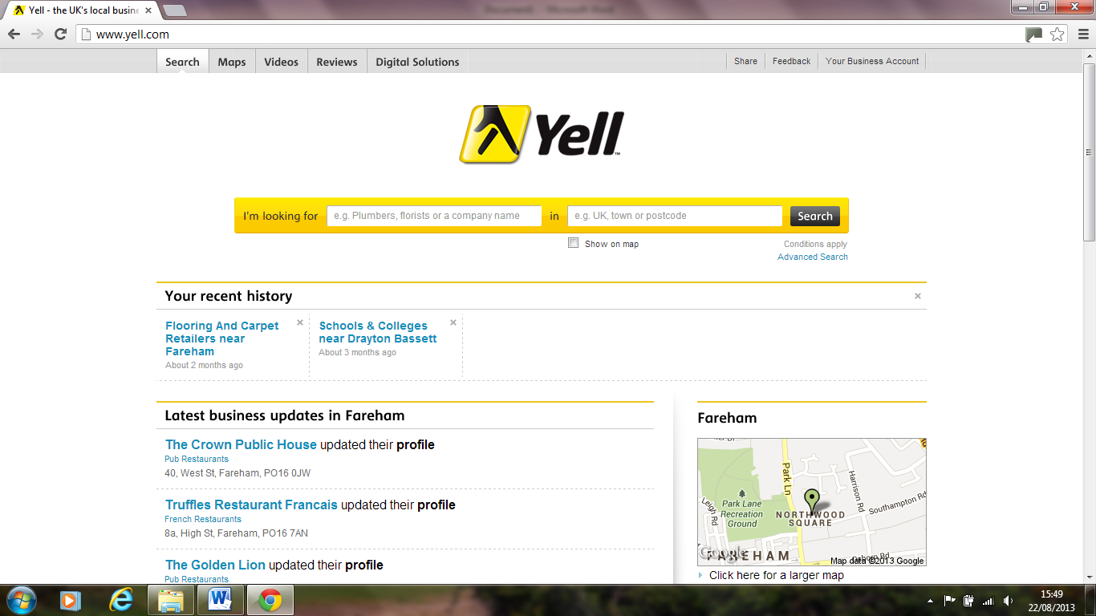
A list will appear detailing their address, phone and web site details which you can add to a short list and print out as well as look up on a map.
Look on the company websites to see if they have any suitable jobs or apprenticeship vacancies. Apply if interested.
A lot of companies nowadays like you to apply online using their company website.
If there are no suitable vacancies, but you are still interested in that company, contact them via email, post or in person with your CV and a covering letter asking about suitable opportunities.

General hints & tips
• Make sure your CV is up to date and get it checked by several people for mistakes. If you email a CV & covering letter don’t use a silly email address e.g. judeyjooyay@hotmail.com, be professional.
• When handing in your CV & covering letter in person, dress smartly just in case the manager is available to see you straight away. Make a good first impression.
• Apply for as many things as you can and then accept the best offer.
• Tell your friends and family what sort of job or apprenticeship you hope to get and they can help you look.
• Practice your interview technique before the real thing.
• Ask for help from a careers adviser, teacher or parent if you need help completing an application form.
• No idea what sort of apprenticeship or job you want— BOOK A CAREERS INTERVIEW NOW!
How to find an apprenticeship Option 5:
Local Authority Websites
Southampton City Council - www.access-southampton.co.uk/jobs

Hampshire County Council
- www3.hants.gov.uk/yourfuture/youthsupportcareers.htm

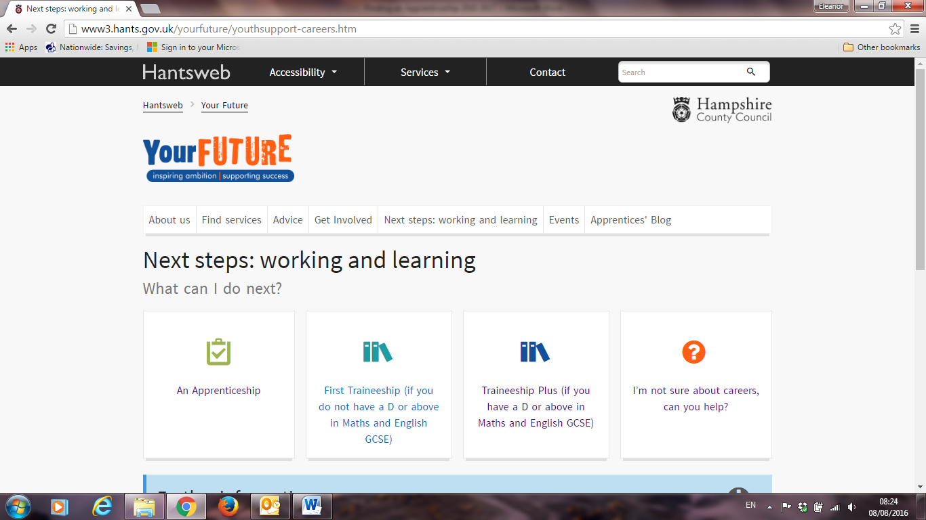

Portsmouth City Council - http://www.mfip.co.uk/Learner/index.html

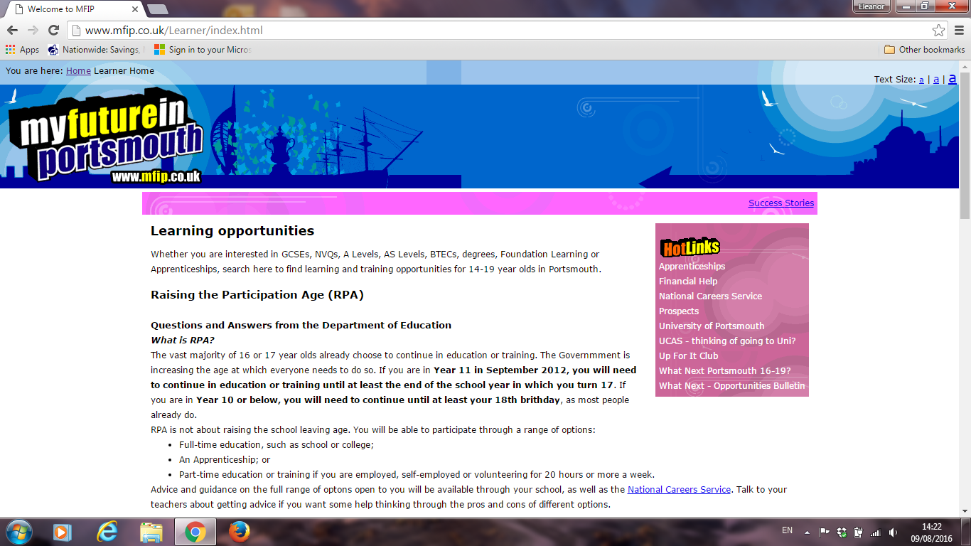
How to find an apprenticeship Option 6:

Other recommended websites:

http://www.alphi.org.uk/apprenticeships www.schoolleaverjobs.co.uk

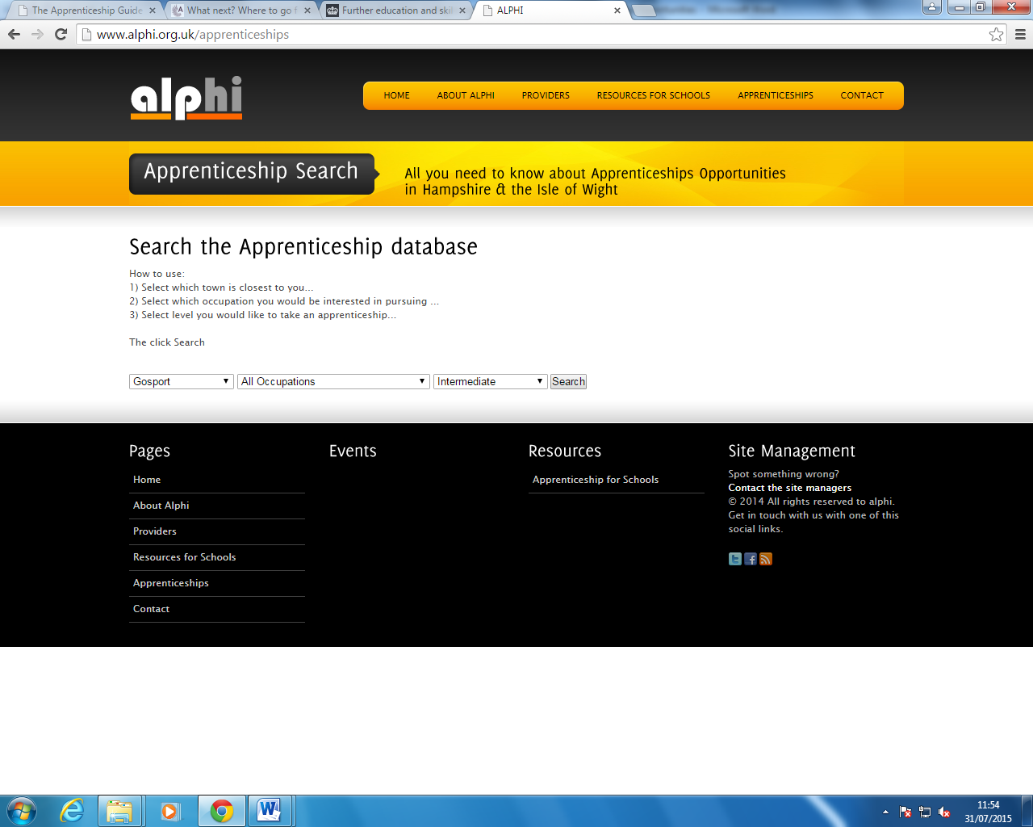

Job Search Websites:

Use newspapers, job search websites, vacancy bulletins and industry specific publications.

Most job vacancies come out on a Thursday.

If you feel you are not ready for an apprenticeship then another alternative to think about is

What is a Traineeship?
A Traineeship is an education and training programme with work experience that is focused on giving you the skills and experience that employers are looking for. At its core are work preparation training, English and Maths for those who need it, and a high quality work experience placement.
To check whether you are eligible and whether a Traineeship is the correct route for you talk to your school careers adviser or visit the NCS (National Career Service) website
https://nationalcareersservice.direct.gov.uk/aboutus/newsarticles/Pages/Spotlight-traineeships.aspx

Note: Many of the training providers on Pages 4 to 9 of this guide also offer traineeships; please visit their websites for details.

Through this document you are informed of other websites which are not under the control of EBP South. We have no control over the nature, content and availability of those sites. The inclusion of any links does not necessarily imply a recommendation or endorse the views expressed within them.
This document has been collated by EBP South Ltd www.ebpsouth.co.uk from information available in the public domain.
August 2016

Should you require this document in a larger font or format, please contact your
EBP South Careers Adviser or contact EBP South Ltd on www.ebpsouth.co.uk

